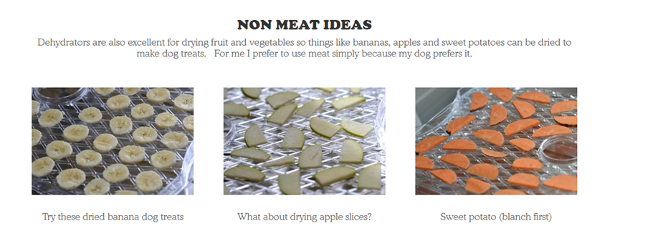

.

Please Note: Some Things to Watch Out For
When preparing homemade dog treats, make sure you take into account any allergies that your pet has to specific ingredients. You will want to avoid adding any ingredient that you know that your pet has reacted poorly to in the past. If you are experimenting with new flavours, feed the treat to your dog in a small amount to see how he reacts to it before distributing an entire treat.

