Frozen Watermelon Dog Treats
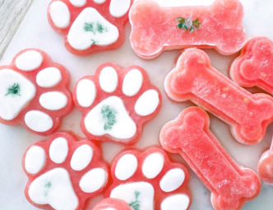
Make sure you are using seedless watermelon and don't include any of the rinds. Both of these can give your dog an upset belly.In addition to watermelon, I have included plain Greek yogurt. If your dog has trouble digesting dairy or has allergies, simply omit the yogurt and only use watermelon. Trust me; your dog won't know the difference.
Ingredients
- 2 cups seedless watermelon pureed
- 1/2 cup Plain Greek Yogurt
- 1 tbsp. parsley chopped
Directions
- Puree seedless watermelon in a blender.
- Chop parsley
- Place mould on baking tray. If you are using the paw moulds, first insert a small piece of parsley into the bottom then add a thin layer of plain Greek yogurt. Freeze for one hour. Next, fill the remaining mould with watermelon puree. Freeze overnight or at least 4 hours.
- For the dog bone mould, add a piece of parsley to the bottom of mould and spoon in a layer of watermelon puree. Freeze one hour. Next, add a layer of plain Greek yogurt. Freeze one hour. Finally, add another layer of watermelon puree and freeze overnight or at least 4 hours.
- Keep frozen until ready to serve.

Please Note: Some Things to Watch Out For
When preparing homemade dog treats, make sure you take into account any allergies that your pet has to specific ingredients. You will want to avoid adding any ingredient that you know that your pet has reacted poorly to in the past. If you are experimenting with new flavours, feed the treat to your dog in a small amount to see how he reacts to it before distributing an entire treat.

