Pumpkin Ginger Dog Biscuits

Ingredients
- 3 cups whole wheat flour
- 1/2 teaspoon ground ginger
- 1/2 cup pumpkin
- 1 large egg, beaten
- 1 tablespoon coconut oil, melted
- 1/4 to 1/2 cup water
Directions
- Preheat oven to 160°. Combine flour and ginger. In the bowl of a mixer, combine pumpkin, egg and coconut oil. Add the flour mixture and mix until crumbly. With the mixer on low, slowly add water 1 tablespoon at a time until dough comes together, but is not sticky. On a floured surface, roll dough to 1/4-in. thickness. Cut with a 3-in. cookie cutter. If using a bone shape, press holes in the center of the biscuit with a fork. If using a pumpkin shape, press lines into biscuit with the edge of a spoon.
- Place 2 in. apart on ungreased baking sheets. Bake until bottoms are lightly browned (tops may crack) and treats feel firm when pressed, about 2-1/2 hours. Cool on a wire rack. Store in an airtight container.

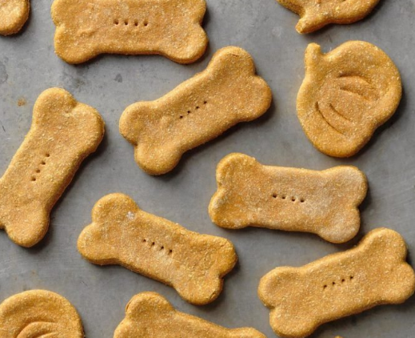

Please Note: Some Things to Watch Out For
When preparing homemade dog treats, make sure you take into account any allergies that your pet has to specific ingredients. You will want to avoid adding any ingredient that you know that your pet has reacted poorly to in the past. If you are experimenting with new flavors, feed the treat to your dog in a small amount to see how he reacts to it before distributing an entire treat. Store your homemade dog treats in an airtight container and place them in the freezer. Allow the treat to thaw for 10 – 20 minutes prior to serving to your dog. Treats can last for up to 6 months in the freezer.

