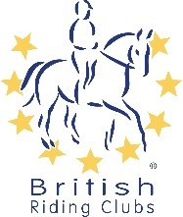 | British Riding Clubs  Non-Member COVID-19 Event  Declaration Form  - Fill in One Form Per Person -

EVENT:
DATE:
VECHICLE REG
Name of OBH member
You are with:
FULL NAME:
ADDRESS:
TELEPHONE NUMBER:
EMAIL:
By completing and submitting this form, I confirm I have read and agree to abide by the event rules in relation to this event. This includes any measures that are in place to make the activity COVID-secure.

I understand that any breach of these rules, will result in being asked to leave the site and may be subject to a ban from future British Riding Club activities.

Please Note: The event organiser will be holding these details for NHS Test and Trace purposes.

SIGNED:
(typing name is sufficient)
DATE:
FOR USE BY EVENT ORGANISER ONLY:
INSTRUCTION TIME:
EVENT ORGANISER:

