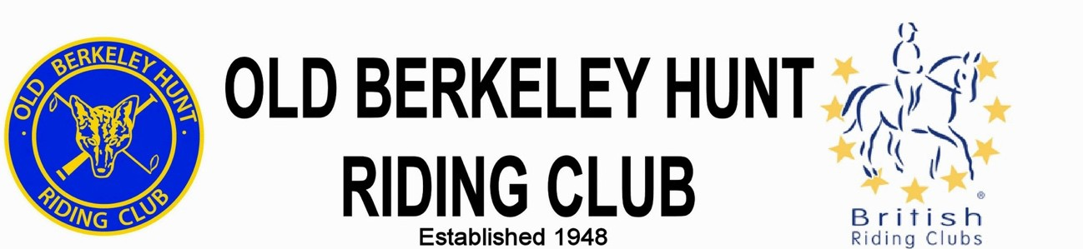

MEMBERSHIP APPLICATION FORM 2021
Membership 1st January – 31st December (18 yrs. and over)

YOUR DETAILS

Title: | Name: |  |  |  | Surname:
Email:
Mobile: |  |  |  | Land line:
Address:

Postcode:
Emergency contact name: |  |  |  | Emergency contact mobile:
Vet contact details:
Do you have a current First Aid/Paramedic certificate, BHS qualifications, or any other special skills e.g. judging, stewarding?
Do you have any suitable facilities; arena with parking for a few trailers/lorries, fields the club could use for training or events.
If yes please give details.
How did you find out  about OBHRC?  Please tick: |  | Word of mouth | OBHRC website |  |  | Social Media | Other

YOUR HORSE

Name in Passport |  | Stable Name
Passport No. |  | Microchip No.
Height | Year of Birth | Date of current Flu vaccination
Colour | Breed | If you have more than one horse please complete their details at the end  of this form.

EITHER print, complete and send your form to:
Elizabeth Rollinson, Canal Bank Farm, Watery Lane, Marsworth, Tring, Herts HP23 4LY liz.rollinson@btinternet.com

Membership fee £20 (For applications before 31st March 2021, £30 after 31st March)
Pay by bank transfer with Ref: ‘SUB+Surname’
Sort: 30-92-77 A/c No: 01474131 A/c Name: OLD BERKELEY HUNT RIDING CLUB
or pay by cheque payable to Old Berkeley Hunt Riding Club

(Please complete the information overleaf and sign.)

INTERESTS: Please indicate your interests:

Dressage | Show Jumping | Cross Country | Residential Camps
Training | Talks & Demonstrations (HKC) | Pleasure Rides | Social Events

TEAMS: If you would like to ride on club teams please indicate your discipline and level in the boxes below. Dressage at Intro to Adv. Medium levels. Eventing / XC / Arena Eventing at 70; 80; 90; 100cm.
SJ at 70; 80; 90; 100; 110cm CT with SJ at 75: 85cm & Dressage at Prelim; Novice.

Discipline: | Dressage | Dressage  to Music | Show Jumping | Eventing,  Arena Eventing | Combined Training
Level:

In order for the club to run shows and to take teams to BRC competitions we need to provide helpers at each event. To ensure we can meet these commitments we ask each club member to volunteer a minimum of half a day at one event in the year.
By signing this form you are committing to doing your helping duties for the club.

HELPING: Please indicate below which activities you would be prepared to help with.

Committee Member or  Admin assistance | Showing Show | Dressage | Show Jumping | Eventing, XC, CT  Arena Eventing
Team Helper | Pleasure rides | Catering | Talks & Demonstrations | Social

General Data Protection Regulation (GDPR) May 2018: To see the full BHS Privacy Policy go to https://www.bhs.org.uk/privacy
OBHRC holds details of its members’ names, addresses, email addresses and telephone numbers on a computer database in accordance with GDPR regulations. Personal information that you supply to us may be used in a number of ways to facilitate your riding club membership. It should be noted that as we are affiliated to the British Horse Society as a British Riding Club, your personal information will be shared with them in order to fulfil your BRC membership benefits and they may share with associates for the purpose of fulfilling your full membership benefits i.e. insurance providers.

Both OBHRC and BRC will automatically contact you about your membership: for example, to ensure you receive your membership benefits, to tell you about news, activities and events. This includes sending you a regular OBHRC e-newsletter, the BRC Rider magazine, email updates, information on other membership benefits, and publishing competition times and results in the public domain

Photography: OBHRC and/or BRC may wish to use images of you caught in photographs and/or video recordings taken at club and/or Area events. These images may be used on their social media pages and/or their websites. Please indicate your consent below.
Images taken of you may be used by OBHRC and/or BRC (Please tick as appropriate) YES NO By signing this membership form you consent to:-
• OBHRC and BRC holding the personal information given in this form

• To abide by the club's constitution and codes of conduct

Signature: …………………………………………………………… Date: ……………………
If you have more than one horse please complete their details below:

YOUR HORSE

Name in Passport |  | Stable Name
Passport No. |  | Microchip No.
Height | Year of Birth | Date of current Flu vaccination
Colour | Breed

YOUR HORSE

Name in Passport |  | Stable Name
Passport No. |  | Microchip No.
Height | Year of Birth | Date of current Flu vaccination
Colour | Breed

YOUR HORSE

Name in Passport |  | Stable Name
Passport No. |  | Microchip No.
Height | Year of Birth | Date of current Flu vaccination
Colour | Breed

