Day 1: Chamonix to Les Contamines (Le Pontet Campground)

- Take bus to Les Houches
- Start at: Office de Tourisme Les Houches
  - OR go to the Telepherique del Bellevue and take the ski lift.
  - 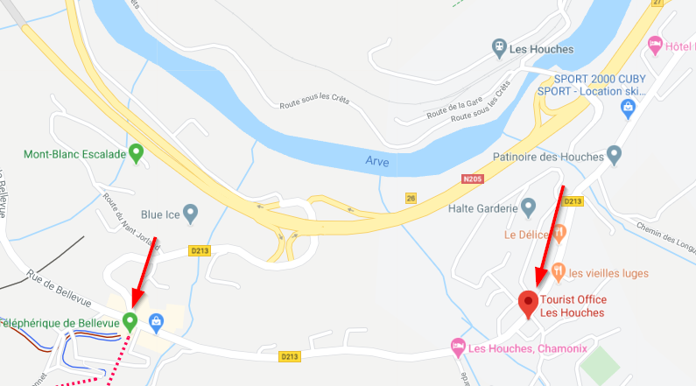
- Signs to follow: Bionnassay, Col de Tricot, Contamines.
- Elevation: +2200/-4200 after lift
- Distance: 10.3mi (~7mi after lift)
- Lunch/Beer Option: Refuge de Miage - 3.8 miles in. The have deli sandwiches and beer.
- Camp here: Campsite Le Pontet Night 1
- Cost: $20 - I know, that's expensive for camping. Welcome to Europe.

Day 2: Les Contamines to Les Chapieux
- Signs to follow: Col du Bonhomme (not the top!), Col de La Croix (this is the top), Les Chapieux
- Elevation: +4300/-3000 ft
- Distance: 11mi
- Lunch/Beer Option: La Croix du Bonhomme - right after the Col. Also sandwiches and beer. We were REALLY looking forward to some beers here but t was really crowded and slow so we continued on without alcoholic nourishment.
- Camp Here: You'll see tents in a valley at the bottom of the trail. It's hard to miss. If you start climbing again after 11 miles, you've gone too far.
- Cost: free

Day 3: Les Chapieux to Refugio Elisabetta
- Signs to follow: Col de la Seigne - this is where you cross into Italy, Refugio Elisabetta
- Elevation: +3300/-1100 ft
- Distance: 9.3mi
- Camp here: Camping is illegal in Italy so this is tricky. Refugio Elisabetta will let you camp about 500 feet higher than the refugio. It's pretty rugged terrain up there and not a lot of flat ground but it is possible if you have the energy. If you can, Elisabetta is the one you need to book ahead of time. It is illegal to wait until dark and pitch a tent quietly in the valley below and be gone before sunrise. Another option is to hike about 8 more miles to Refugio Monte Bianco
- Cost: $45

Day 4: Refugio Elisabetta to Courmayeur (Restock food in Courmayeur)
- Signs to follow: Courmayeur
- Elevation: +1500/-4500 ft
- Distance: 11mi
- Camp Here: We booked a hotel from the first bar we found when we arrived to Courmayeur. If you want to camp, you can go to Grandes Jorasses for about $8/person.
- Cost: $8 at Grande Jorasses or $80-$200/night for most reasonable hotels
- Shortcut: You can take the lift from Refugio Maison Vielle to Dolonne and save yourself about 2000 ft of switchbacks straight down. Our knees were aching so we were pretty pumped to take the ski lift down.
EAT ICE CREAM HERE: Creme Chocolate Gelateria. Piazza Brocherel, 2, 11013 Courmayeur AO, Italy

Day 5: Courmayeur to Refugio Bonatti
- Signs to follow: Bonatti
- Elevation: +2800/-300 ft
- Distance: 7.5mi
- Camp here: You apparently can't camp here either. This was probably part of our reasoning for the day-trip method out of Courmayeur. Book at Bonatti or do what we did but don't skip it because it was beautiful.

Day 6: Refugio Bonatti to La Fouly
- Signs to follow: Grand Col Ferret
- Elevation: +3000/-4000 ft
- Distance: 12.4mi
- Beer/Lunch: Refugio Elena is about an hour downhill after the Col and maybe 7 miles in.
- Camp Here: Camping Des Glaciers
- Cost: $8/person
Day 7: La Fouly to Champex
- Elevation: +1400/-2000 ft
- Distance: 9.3mi
- Beer/Lunch: You pass through a little town about 4.5 miles in. We had some pizza at Cafe Le Portalet.
- Camp Here: Camping Les Rocailles
- Cost: It says $8 on their website but that's per person PLUS $19 for a tent. Kinda a rip in my opinion.

Day 8: Champex to Col de La Forclaz via Fenetre de Arpette
This is an alternative route and much harder than the normal route. I highly suggest it - I was really against extending anything but it was worth it in the long run. Your only excuse not to do this should be weather-related or if you are afraid of heights. I'm a little scared of heights so I had to take it slow at the top - only a couple panicked moments.
- Follow signs for: Arpette, Col de la Forclaz
- Elevation: +3800/-3800 ft
- Distance: 10.5i
- Lunch: bring a lunch and eat it in the clouds.
- Camp Here: Camping Hotel Forclaz
- Cost: $8/person

Day 9: Col de la Forclaz to Tre Le Champ
From Col de Balme, you can head straight down or go up around the ridge to the right. I'd recommend going to the right along the ledge for the views. The picture below is on this alternate route and worth it.
- Follow signs for: Col de Balme, L'Aiguilette des posettes
- Elevation: +3000/-3000
- Distance: 10mi
- Lunch: Refuge Col de la Balme - this is the border between Switzerland and France
- Camping: We stayed across the street from Auberge La Boerne which is the first thing you see when you get to Tre Le Champ. If this is full you can take a bus to Argentiere and camp here.
- Cost: Camping isn't posted on their website and I can't remember.
Day 10: Tre le Champ to Plan Praz via Lac Blanc
This day is relatively shorter but there are ladders on the side of a cliff so it's not exactly easier. But you have to see Lac Blanc it's the Lake of the Trek's namesake.
- Follow signs for: Lac Blanc, Plan Praz
- Elevation: +4400/-2400
- Distance: 7.7mi
- Lunch: Refuge du Lac Blanc
- Camp here: I don't think there's much for camping along this route. There is a ski lift from Plan Praz down into Chamonix where you can easily get a hotel or camp here for the night. Take the Plan Praz lift right back up to where you came from to finish tomorrow.

Day 11: La Flagere to Les Houches
- Elevation: +2000/-5000
- Distance: 10.5mi

