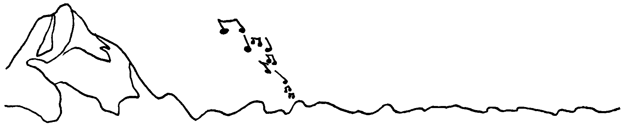2025-2026 SEASON CONCERT SCHEDULE
Inland Northwest
Musicians
Approved 6-28-25

SEPTEMBER
Wednesday Sept 10th--Wallowa Valley Young People’s Concert

OCTOBER

Saturday, Oct 18th—Enterprise
Inland NW Orchestra

NOVEMBER

Saturday, Nov 1st—Burbank
Inland NW Chorale

Saturday, Nov 15th—Heppner
Willow Creek Symphony

DECEMBER

Saturday, Dec 6th—Boardman
Sunday, Dec 7th— Connell
Inland NW Orchestra & Chorale

FEBRUARY

Saturday, Feb 21st—Athena
Inland NW Orchestra

All concerts subject to change

MARCH

Sunday, March 1st—Hermiston
Young Artist's Competition

Saturday, March 14th—Ukiah
Inland NW Chorale

APRIL

Tuesday, Apr 14th--Hermiston Young People’s Concert
Willow Creek Symphony

Saturday, Apr 18th—Arlington
Willow Creek Symphony

MAY

Sunday, May 3rd—Hermiston
Inland Northwest Orchestra
(Young Artists Competition Winners)

JUNE (or JULY 4TH?)

Saturday 13th or Sunday 14th—Location TBT
POPS Concert- Inland NW Orchestra and Chorale

