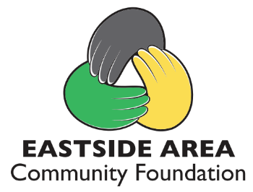
PLEDGE CARD
Name ___________________________________________
Address ___________________________________________
Phone ____________________________________________
My $500 Scholarship Donation is enclosed (one-time scholarship in 2023)
Scholarship Name ____________________________________________
Contact me to establish a named scholarship to award annually
Enclosed is a donation in the amount of $_____________

In 2023, the Eastside Area Community Foundation will celebrate 40 years of serving eastern DeKalb County. The Board of Directors is planning a year of celebration and you are invited to celebrate with us. Eastside High School 2022 graduates received $37,500 in scholarships from the Foundation. We would like to award $40,000 in 2023 and you can help make this a reality by donating $500 to sponsor a scholarship for 2023 Eastside graduates. You may also help sponsor grants and community programs with donations in any amount. Please complete the pledge card with your information and mail to the Eastside Area Community Foundation, PO Box 395, Butler IN 46721. Thank you for your continued support of eastern DeKalb County. You are making a difference in the lives of many.

