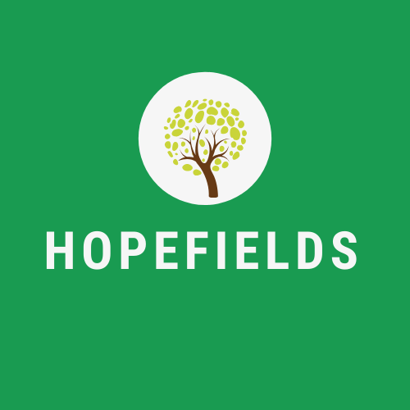

**Sunday, 1st November 2020**

Dear Parents, Care Givers and Visitors,

Following the Government’s lockdown briefing held yesterday evening, Hopefields felt it necessary to write to all those who may come into contact with our building, provision and each other during these uncertain times.

The Directors feel it imperative to remain open and to continue educating young people, as per Government guidelines. However, as of Monday, 2nd November, Hopefields have further measures in place to help stop the spread of CoronaVirus:

1. All users of the Hopefields building must wash hands frequently throughout the day, with 30 minute timers signaling where necessary.

2. Thorough ‘deep cleans’ will continue to take place twice daily.

3. All community projects will cease until further notice.

4. Risk Assessments have been completed across the business, and as such some visiting Tutors and Lecturers will not attend Hopefields during the Lockdown period.

5. Hand sanitiser must be used after each session.

6. Physical Contact must be kept to an absolute minimum.

Please be assured the education of our young people is paramount, and will not suffer as a result. To ensure continuity and quality teaching, Emily Greenhalgh, Director, will personally undertake the majority of the teaching timetable across the curriculum.

Hopefields are also aware we educate young people who, at times, may require physical contact or support. Please be assured the welfare of learners is paramount, and we will never deviate from our commitment to provide a therapeutic, holistic approach to educating young people.

May I also take this opportunity to introduce Susan Johnson, Office Manager, who joins us to provide administrative support to Hopefields. Susan is the first point of contact should you need to communicate with us in the future.

If you require any further information, please do not hesitate to get in touch using the above contact details.

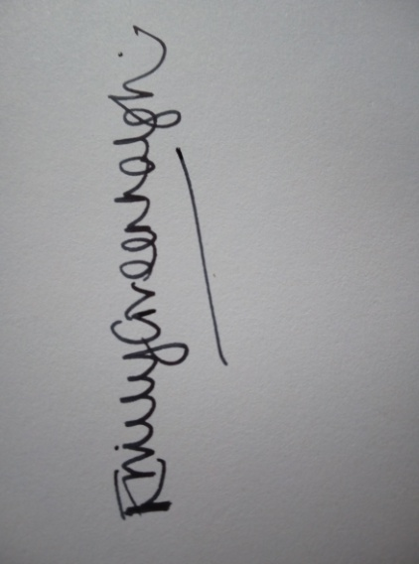

With the very best wishes to you all,

Emily Greenhalgh

Director