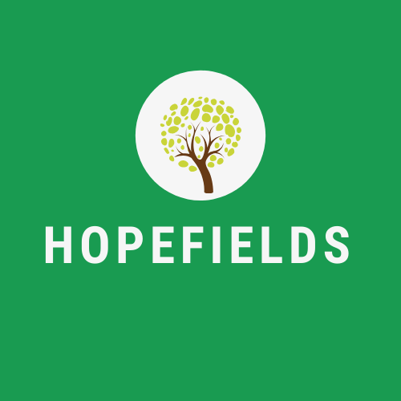
Wednesday 4th November 2020

Dear Parents, Carers and Friends,
I am writing to inform you that two members of staff have been in contact with a person who has recently tested positive for CoronaVirus. As a result, the two members of staff in question are in self-isolation, and will remain so until Saturday 14th November.
Both Emily and Callum are healthy and well, and show no symptoms of the virus currently. Thank you all for your well-wishes.
It is with deep regret that as a result of decreased staffing levels, Hopefields will be closed temporarily week commencing 9th November. Although we have a number of staff available who could ‘cover’ we don’t feel this is beneficial for our young people’s education or mental health at the current time.
Hopefields will be in contact with young people daily, and will provide work which we would ask you to return at your earliest convenience for marking and feedback.
We will re-open at 9.30am on Monday 16th November, with full pandemic control measures in place as detailed in our last correspondence.
Stay safe,

Emily Greenhalgh and Alison Laws
Directors

