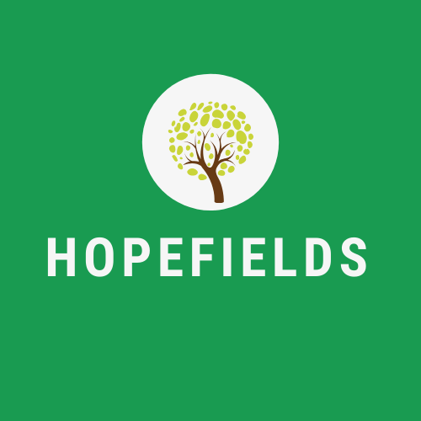
Thursday, 26th November 2020

Dear Parents, Care Givers and Friends,
After speaking to you over the last weeks, it is obvious that the system of reporting learner progress is not utilised to full potential. As a bespoke provision, we pride ourselves on our communication between Hopefields staff and care givers, which invalidates the weekly reporting system currently in place.
As a result, Hopefields have changed the monitoring and reporting system of our young people. The weekly reports will be phased out the week commencing 30th November, and replaced with assessment and monitoring data that will be shared to parents, carers and host schools on a half termly basis.
This method of reporting will be all encompassing, including attendance data, academic assessment and tracking data, positive behavior indicators, targets linked to the EHCP where necessary, and a learner voice piece of work.
Hopefields continue to heavily invest in tracking systems and training that identifies priority areas of development, enabling quality first teaching to take place at every opportunity.
We understand the importance of sharing images and information regarding the learning experiences of our young people. We urge you to follow us on twitter, with the information shown at the top of this letter. This will enable you to speak to your child about their day, and to praise them for their achievements.
With the warmest wishes,

Emily Greenhalgh
Director

