Introduction
Hopefields school has a vision to offer a bespoke package of education to some of the most vulnerable learners in the Teesside area. We offer a curriculum that is broad, ambitious and bespoke. Due to the nature of the curriculum we offer and the values and vision we have as a school, we appreciate that Hopefields is a school that will be the right fit for some students but not for others. Through this admission policy and our admission procedure we aim to offer our places to the right learners who will benefit the most from our core values and the educational package we can offer.
Aims & Objective
This policy is designed to ensure that, as a provision, we are ensuring that students are in the correct educational environment and we take every measure to ensure the process is as efficient as it can possibly be. The aim of the policy is to guard against short term placements and students bouncing from school to school or provision to provision, which can cause significant disruption and trauma.
We Aim :
- To provide a happy and secure place where students feel safe to attend and learn in the best environment possible
- To positively engage students with a bespoke educational package
- To develop students both inside and outside the classroom so they are ready and able to make the jump into post 16 education or adult life.
- To work with students on a post 16 pathway to limit the possibility of students leaving school with no post 16 pathway in mind or a plan to move into the working sector (NEET)
- To have a consist approach to the admissions of students into our school
At Hopefields, our learners are referred to us from a variety of different locations i.e. a number of local authorities in the area, schools, virtual schools or out of area authorities. There are no formal entry requirements to be accepted on a placement at Hopefields, however each referral is reviewed on an individual basis to take into account the learner’s needs. This policy will outline what documents Hopefields will require before the student can attend in order to guarantee it is the best environment for the learner to succeed and progress.
This document has been reviewed and approved by all SLT members in a team meeting. Staff have been made aware of its issue, including any updates/amendments to its appendix A, and where necessary appropriate training has been provided to those staff.

Our approach to admissions
Learning in an inclusive and nurtured way is at the forefront of what we do at Hopefields school. Each student is seen as an individual at Hopefields and gains education based around their individual needs whilst recognising that we are a collective and must consider the needs of all students. We strongly believe with the balanced, ambitious and broad curriculum on offer at Hopefields we give each student the tools to succeed in an educational setting and in the working world.
Hopefields provide and offer placements for students in both KS3 (Year 7, 8 and 9) and KS4 (Year 10 and 11). Whilst the school have an option and are agreed by the DfE to offer a post 16 educational package, there is currently no such offer in place due to funding constraints. Hopefields offer placements for permanently excluded learners who would therefore be referred by any of the local authorities that surround our school.
Full-Time placements
Hopefields offer full time placement only. Part time placement would be considered in extreme circumstances, but this would need to be supported by the Local Authority for medical reasons, generally. Full time placement is suited to students who have additional needs that cannot be met in a mainstream school setting. The small group size and personalised tuition, alongside a high staff to student ratio we offer at Hopefields helps learners to succeed.
Hopefields will always look to accept students into our school providing we have space and feel that our school can meet the need of the student. If the school is full, the learner will go onto a ‘waiting list’ whereby if an unexpected place becomes available, we would offer the place to the next person on the list. Stakeholders, parents and carers need to be aware that, as a school with only 40 places, the waiting list for Hopefields is long and it is not certain the child will ever be accepted due to the small number of students leaving the provision each year. Each student and the needs of that student will be assessed on an individual basis. In order to ascertain if Hopefields can meet the need of the student, we may ask for or require any previous documentation such as any previous risk assessments, any previous reports and the students Education, Health and Care Plan (EHCP), These documents will supplement the Hopefields referral form.

Key Contacts
Emily Greenhalgh | 01642 205233 | Headteacher / Director /DDSL
Alison Laws | 01642 205233 | Director and The Montana Project Lead
Craig Fletcher | 01642 205233 | DSL / Assistant Head teacher
Rachel Campbell | 01642 205233 | Assistant Head teacher / DDSL/DTCIOC
Susan Johnson |  | Office Manager / PA

Admissions Procedure
Stage 1 – Enquiry
A school or local authority will express an interest in sending a student to Hopefields. This can be undertaken via a phone call or an email to the school. Within this email or phone call, it is an opportunity for the local authority or school to find out about what we as a school can offer but also an opportunity for the school to get to know about the learner to start shaping if we can meet the need of that learner.

Stage 2 – Documentation
Due to Hopefields offering a student a place on a waiting list even if we are full, we will ask for certain documentation to be completed before anything further happens. This documentation will be anything that the student in question already has in place such as an EHCP, a risk assessment or reports from the previous or current school. These documents will supplement the referral form Hopefields school will ask the refer to complete.

Stage 3 – Review of documentation
Once all the paperwork has been received by school this will get reviewed by members of SLT. The review of documentation is the first part of establishing if we as a school feel we can meet the need of the student. This can be the need of the student both on a personal level and educationally. We aim to respond within 5 working days with a decision/further information/meeting arrangements.

Stage 4 – Interview/Meeting
This is the second part of establishing if we as a school can meet the need of the student in question. We will arrange a meeting with the student, the student’s parents/carers and a member of staff from the referring school or local authority. This is an opportunity to chat with all parties around past educational experiences, current/ expected attainment levels and gives us an opportunity to discuss the offer at Hopefields school. The curriculum will be discussed and the non-negotiable rules we have in place at our school. The student and parents will have the opportunity of a tour of the building and to drop into lessons to see how we work. Stage 4 may also include and observation of the young person in their current educational setting.

Stage 5 – Safeguarding meeting (referring school/ authority)
Hopefields generally won’t receive a CTF (common transfer file) and CPOMS information until a student is officially accepted onto our school roll. To ensure we get the full background of a young person to better inform a decision to offer placement, our safeguarding lead (Craig Fletcher, AHT) will arrange a thirty-minute meeting with the relevant member of staff at the referring organisation to gain a better understanding of that young person’s safeguarding background/ needs.

Stage 6 – meeting in the child’s home/care provider
A member of SLT will then visit the child’s main care residence and meet with the parents/carers and the child. More information surrounding the home visit can be found in the ‘Hopefields Home Visit Policy.’

Stage 7 – Decision
This is the stage where members of SLT will meet and make a decision to if we can meet all the needs of the student in question. All aspects such as the paperwork received and the actual meeting will be considered when deciding to offer a student a placement at Hopefields school. The ultimate reason as to if a student will be offered a placement or not is if feel we can meet every need that student has in both the supporting documentation and subsequent meetings. The final decision lies with the Headteacher.

Stage 8– Collection of uniform and completion of induction forms
If all of the above have undertaken well, and a placement is agreed, the next step will be for the parent/guardian to collect the students uniform so that on the first day of placement the student is already arriving wearing the attire we expect. Uniform can be purchased at an cost of £5 per T-shirt and £10 per sweatshirt. The full uniform policy can be found on the school website and must be adhered to at all times. The parent or guardian will also be required to complete an induction form with up to date and relevant information that Hopefields will need.

Stage 9 – Taster days
If Hopefields feel we can meet the need of the student (and are looking to offer a place) we will offer the student ‘taster days.’ This will be agreed with the parents and referring local authority/ school and will suit the student and be tailored to each specific students’ needs. We would generally look to offer 2 half days which would progress into 2 or 3 full days. This gives the student a better sense of how the school runs and Hopefields a chance to see the student in a school environment.

Stage 10 – Placement Starts
A start date will be agreed between Hopefields school and the referring local authority or school for the student in question. It is important to note that a start date can provisionally be agreed but a learner will not start the placement with Hopefields until the relevant documentation is received, this will include CTFs (Common transfer file) from the previous school and any relevant safeguarding information such as CPOMS logs.

Stage 11- Trail period
Every student that comes to Hopefields goes through an initial six-week trial period. Within the trial period the students’ behaviour & engagement will be monitored to see if Hopefields is the right fit for the student and if the student is the right fit for Hopefields. If, for whatever reason, the placement doesn’t suit both parties in the six week trial period, we withhold the right to end provision with immediate effect.

Stage 12 – Placement ongoing
If the students’ trial period is successful, the student will now be a permanent member of Hopefields school (as either a part time or full time learner). Each student will undergo regular reviews which will consist of parent events, termly reports, half-termly postcards (sent to parents/carers and referring schools) and regular review meetings with the referring school or local authority if applicable. Hopefields school will also keep in close contact with the parents/guardians of the students, so they are also aware of how the student is progressing in school. Hopefields will send a postcard to the child at their home address to welcome them to the school family.

It is important to note that, without satisfactory completion of all stages of the admission process, the child will not be offered a place within Hopefields School.

Withdrawal of learner placements

There may, on occasion, be the need to end a student’s placement at Hopefields due to the school no longer being able to meet the need of the student or dependent on the students behaviour. This may be due to a change in the students SEND needs, to where that need cannot be met by our school environment or the curriculum we offer. In this case we reserve the right to end a student’s placement and remove the learner from our roll, after communication with the local authority or host referrer by ‘giving notice’ which is usually a period of 28 days, including weekends and holidays.

Hopefields will treat each case of withdrawing a learner independently and offer what we deem as reasonable support to the referring school or local authority. We will endeavor to offer the students placement until the end of the half term in which the decision to end placement has been made. If behaviours shown by the student are so extreme and are endangering other learners, or distracting others from their right to learn, we do have the right to end the placement with immediate effect.
No placement will be ended without a meeting to discuss the student with all members of SLT present and then later a meeting with parents/guardians and the referring school/local authority.

Horizons Juniper

When a student’s placement has been agreed all the relevant paperwork will be added to Horizons (Hopefields’ MIS). The paperwork in question will include the completed referral form, any previous risk assessments or school reports. The CTF will be requested from the previous school, alongside any safeguarding information/CPOMS logs. Horizons is password protected and only members of SLT have the credentials to edit the information on the platform. Horizons is our main tool for marking and monitoring attendance. Each student has their own record on Horizons and the attendance can be checked and monitored via the attendance tab to the left hand side of the screen.

Admissions Register

The schools admissions register can be found on Horizons MIS. Members of the SLT will have access to this and it shows all learners past and present who are (or have been) on roll at Hopefields school. This can be found on Horizons via the following procedure students tab > Filters > Entire school. We also have the option to alter the data set we see on Horizons via the ‘choose column’ tab. Information such as student’s full name, school, year group and contact details will be stored and available via Horizons.

Parents/guardians and referring schools/local authorities have access to school policies and any information regarding the school via the school website www.hopefields.org.uk . Alternatively, any questions or information required can be obtained by calling the school landline phone on: 01642 205233 or email the main school office: admin@hopefields.org.uk

Assessments

Hopefields recognize that students who attend us may not have been educated in a school or provision for some time. It would therefore not be pertinent to assess them immediately as they ‘walk through the door’ as we would rather build up a relationship with the child that is nurturing and supportive. Assessing a child immediately, inducing more stress, would not be conducive to fostering a positive working relationship, or breaking down the barriers that require them to access school on a more frequent basis. We do, however, recognize the important work we need to do, as educators, to enable the children we serve to live a life of hope and opportunity. As a consequence, we believe in children partaking in accredited offers, which involve the sitting of examinations and assessments.

Upon entry into Hopefields School, when it is deemed appropriate by school staff, students will undertake the following assessments:
1.
2.
3.

Forms

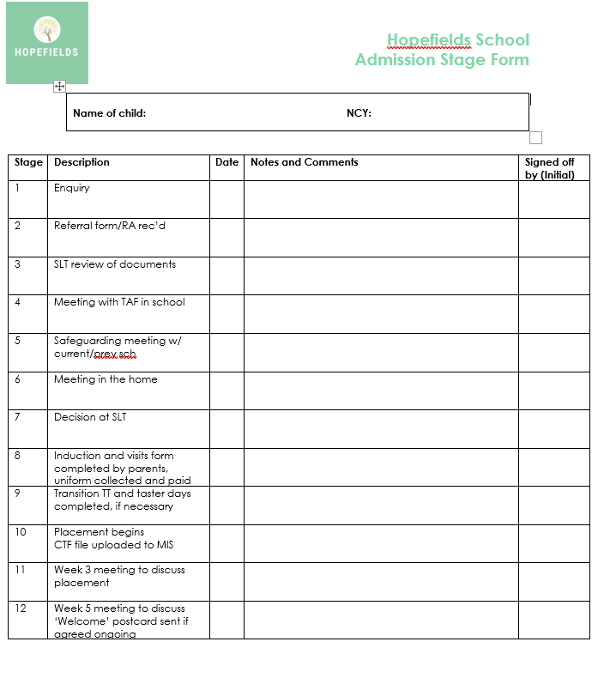
The following documentation or forms will be used throughout the admissions process and will be available to view on request via teams or Horizons :-

- Hopefields referral form (Located on the front page of the website, then the referral tab along the top of the page)
- Learner induction booklet

Appendix A – changes/updates/amendments

Date | Change made | Action to complete | Staff name
21.03.23 | Reviewed and incorporation of the learner induction booklet. |  | CF
29.09.23 | Reviewed and incorporation of new admission rule regarding gaining CTFS and CPOMS prior to start date. |  | CF
21.11.23 | Review | Format Update | AL
07.06.24 | CF added a new stage to the referral process linked to safeguarding |  | CF
01.09.25 | Flowchart added  General update, some grammatical and word changes  Upon admission added to assessment process | Completed and shared on website and with staff key staff. | ERG

