**Hopefields Education CIC**

**Curriculum**

Sept 2022

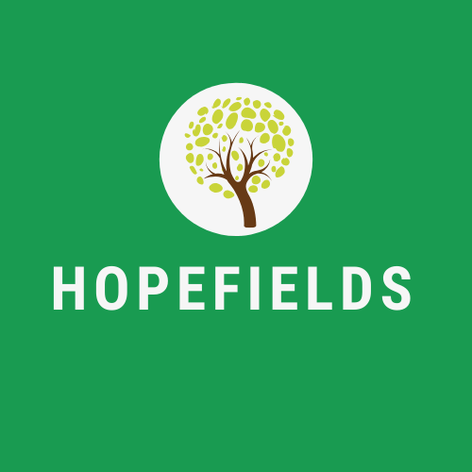

**Compiled by**

Emily Greenhalgh, Director of Teaching, Learning and Curriculum

Hopefields Education CIC provides quality first teaching across all subjects to enable fulfilling life chances for all young people. The curriculum is thematic, project-based and innovative, encompassing learner need and tailored to the interests of the young person. Our vision is simple: Hopefields help young people learn how to learn by positively attuning and differentiating to individual needs.

**Hopefields:**

**S**upports all learners in an inclusive, aspirational environment using quality first teaching and interventions where necessary.

**T**rust all learners to engage in their bespoke curriculum, promoting achievement, confidence and positive behaviours.

**A**chieve and hold high expectations, aspiring to the highest possible academic outcomes, preparing learners for their pathway to adulthood.

**R**espect all in a unique environment which celebrates success; challenging learners to make a positive contribution to their community.

**Intent**

Hopefields strive to overcome barriers, being outcome focused and outcome led. Hopefields aim to provide learners with the ability to become confident readers and develop increased mathematical and literary fluency. There is a clear, shared passion in English, Maths, Culture and the Arts, which underpins our ambitious curriculum design. All programmes provide progression and accreditation for future learning pathways. The Hopefields intention is for learners to:

-Become global citizens who care about the world around them

-Possess the skills to face an ever-changing world

-Engage in learning and the pursuit of knowledge

-To question and consider the wider world

**Implementation**

Leadership and staff voice drive the curriculum across the Provision, ensuring it meets learner need. The curriculum is reviewed regularly, ensuring depth and coverage of knowledge and key skills. Quality first teaching is at the heart of the curriculum, differentiated to meet young people’s needs. Hopefields learners take ownership of their own curriculum in the NOCN sessions, opting for a broad variety of modules on an accredited pathway. Appropriate resources are selected, and staff professional development is research and experience led.

**Impact**

The Hopefields curriculum improves learner motivation, self-confidence, attendance, engagement and positive behaviours within education. Learners make accelerated progress from their point of entry in line with their needs, achieving appropriate accreditations from KS3 onwards. Young people’s transition to adulthood is fundamental to the Hopefields approach, with full support tailored to destinations such as local colleges and apprenticeship providers.

**Our Curriculum**

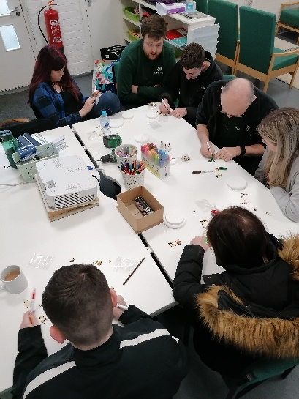

**Core**

Our core curriculum consists of English, Mathematics, Science (from Entry 1 to GCSE) PE, Historical and Cultural Studies (Humanities – incorporating RE, History and Geography), NOCN Personal and Social Development (PSHCE) and The Montana Project (Equine Facilitated Learning). ArtsAward is taught across both key stages. In all of these subjects Hopefields directly mirrors the curriculum delivered in all mainstream schools, highly differentiated to individual need. Currently KS3 are taught as a mixed group on a three year programme with bespoke intervention as necessary.

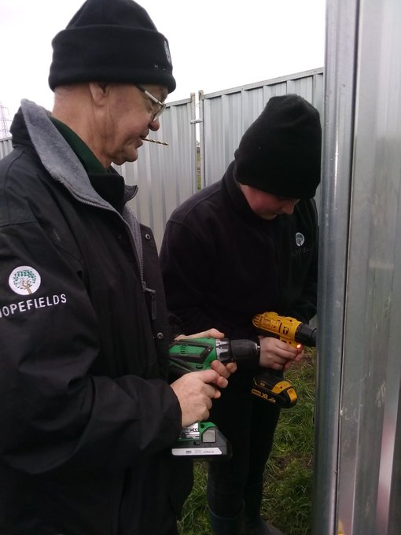

**Optional**

NOCN Level 1 SETPD - Award (6 credits) or Certificate (13 credits) Each of these subject areas have a number of options for pupils to choose. All options lead towards accreditation. The employability skills qualification contains a number of units that are tailored directly to individual needs and interests. AQA Unit Awards are also utilised for learners with specific interests during timetabled independent study.

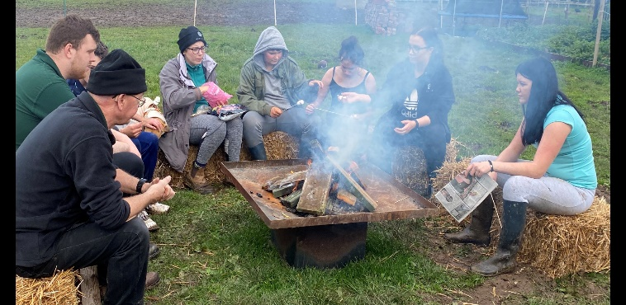

**Enrichment**

Every term Hopefields have two curriculum Enrichment Days, one for Religious Education and one for PE. These days consist of a carousel of activities to ensure all aspects of the RE and PE curriculum are fully covered and investigated.

**Thematic and project-based Curriculum**

**English**

Every lesson, and therefore every project topic, learners will engage in SPaG, reading, writing, speaking and listening elements of the English/Literacy curriculum. Hopefields have a two year, rolling KS4 curriculum.

|  |  |  |  |  |  |  |
| --- | --- | --- | --- | --- | --- | --- |
|  | **Autumn** |  | **Spring** |  | **Summer** |  |
|  | **1** | **2** | **3** | **4** | **5** | **6** |
| **KS 3** | Women and War | Local Interest – being Teesside | We are all different | Gothic Horror | Rights and Responsibilities | Celebration and gratitude |
| **KS 4** | Conflict | Local Interest – being Teesside | Awe and Wonder | Gothic Horror | Speech and Voice | Celebration and gratitude |

What qualification will learners gain in this subject?

Alongside their studies, students will focus on accreditation at their appropriate level, which can be from Entry Level 1 Functional Skills to Level 2 and, if successful, learners will continue on a GCSE Pathway, culminating in a final exam held at their host school.

What would the next steps be?

We aim for students to become independent and competent in their studies, detailing a transition into the pathway for adulthood onto the next level identified.

For example, a learner who passes Level 1 Functional Skills in English in year 10 would enter Y11 on a Level 2 Functional Skills or GCSE pathway.

**Specific references to texts below:**

|  |  |  |  |  |  |  |
| --- | --- | --- | --- | --- | --- | --- |
|  | **Autumn** |  | **Spring** |  | **Summer** |  |
|  | **1** | **2** | **3** | **4** | **5** | **6** |
| **KS 3** | The Diary of Anne Frank  Zlata's Diary  I am Malala  Poppies  The Darkness Out There  The Hunger Games -focusing on fight for survival | Local famous people - fact files, research using ICT  Steve Gibson  Armistice Day - local heroes  History of Railway  The Man With the Yellow Face | Explore setting and characters – Of Mice and Men  Purpose of text  Social and historical context  Analyse language, grammar and punctuation  Write a review | The Woman in Black  The Raven poem  Creative Writing  A Christmas Carol  Room 13 | Greta Thunberg  Comparison with Attenborough speech  Leonardo Di Caprio speech  Climate Change study  Rights and responsibilities - UN  What does it mean by rights and responsibilities? | Alice in Wonderland  Simon Armitage – ‘We may allow ourselves a brief period of rejoicing’  Festivals – descriptive writing  Presentational devices |

|  |  |  |  |  |  |  |
| --- | --- | --- | --- | --- | --- | --- |
| **KS 4** | Non fiction skills  Creative Writing  Out of the Blue  Remains  The war on heroin  Belfast Confetti  The Disturbance  Mo Mowlam  Dulce est Decorum Est  Charge of the Light Brigade  War Horse | Local famous people - fact files, research  Successful women of Teesside - their 'journeys'  Armistice Day - local heroes  Adele Parks /Catherine Cookson  David Almond short story | MLK – I have a Dream  Suffragette  Winston Churchill – inspirational racist?  Nelson Mandela  Bush - following 9/11 speech  Obama  speech  Maya Angelou | Dracula  Frankenstein  The Red Room  Comparisons with Twilight  Jekyll and Hyde  Creative Writing | Explore setting and characters  Purpose of text  Social and historical context  Analyse language, grammar and punctuation  Write a review | Simon Armitage – ‘We may allow ourselves a brief period of rejoicing’  Festivals – descriptive writing  Review writing  Presentation, form and layout |

**Mathematics**

|  |  |  |  |  |  |  |
| --- | --- | --- | --- | --- | --- | --- |
|  | **Autumn** |  | **Spring** |  | **Summer** |  |
|  | **1** | **2** | **3** | **4** | **5** | **6** |
| **Y7 & 8** | Number re-cap  Analysing and Displaying data  Calculations | Expressions, functions and formulae    Graphs | Factors and Multiples  Decimals and Measures | Angles and lines | Measures and shapes  Fractions, decimals and percentages | Transformations |
| **Y9** | Number | Algebra | Graphs, tables and charts  Fractions and percentages | Equations, inequalities and sequences | Angles  Averages and range | Perimeter, area and volume |

What qualifications will learners gain in this subject?

Students are following the 5-year SOW in mathematics – which will transition students from the KS3 maths framework as shown above on towards the KS4 GCSE or the Functional Skills Curriculum. White Rose Maths is used to teach and support students in their learning pathway.

What would the next steps be?

To ensure all students can work independently or with limited support, so that they are prepared for the GCSE or Functional Skills Maths exams at KS4.

**Personal and Social Development (SETPD)**

|  |  |  |  |  |  |  |
| --- | --- | --- | --- | --- | --- | --- |
|  | **Autumn** |  | **Spring** |  | **Summer** |  |
|  | **1** | **2** | **3** | **4** | **5** | **6** |
| **KS3** | Environmental awareness  **04** | Identity  -Who am I?  **02, 18** | Using leisure time to keep healthy  **07** | SRE  **23, 05**  Community Action  **01** | Rights and Responsibilities  -individual and collective  **06, 16** | Substance misuse  -alcohol and drugs  Careers, advice and guidance |
| **KS4** | Environmental awareness  **04**  Problems in everyday life  **03** | Identity  -Who am I?  **02, 18** | Managing Money/the economy  -local, national, the wider world  **08** | SRE  **23, 05**  Community Action  **01** | Rights and responsibilities – individual and collective  **06,16** | Substance misuse  -alcohol and drugs  **20, 11**  Careers, advice and guidance  Transition |

What skills are developed in this subject?

Personal, Social, Health, Care and Economic (PSHCE) education is a subject through which students develop the knowledge, skills and attributes they need to manage their lives; now and in the future. These skills and attributes help pupils to stay healthy, safe and prepare them for life and work in modern Britain.

This subject also focuses on universal human rights, responsibilities and values.

What qualification would be gained in this subject?

NOCN Level 1 qualification in Social, Employability Skills and Personal and Social Development (Award or Certificate)

What would the next steps be?

The Level 1 qualification is a good stepping stone to a further, subject specific L1 qualification or a Level 2, portfolio based programme of study in college or post 16 education.

**Art, Design and Technology and Creative Media**

What topics will be covered?

Steel pan drums, singing and voice, photo editing, woodworking, design, painting and drawing, graphic design and advertising.

Learners will have numerous opportunities to visit galleries, exhibitions, the theatre, cinema and other arts venues throughout their time at Hopefields.

What skills will be developed in this subject?

Hopefields aim to give every student the access to high quality music production opportunities through the curriculum and enrichment of life opportunities through music. All genres of music will be experienced, from classical to steel pans. As music stimulates various senses and helps young people in learning and it is an excellent form of expression.

In art, a wide range of topics are covered, including sensory art meeting student requirement and need. Graphic products/advertisement and promotional merchandise is studied, how to draw in perspective and lettering styles including fonts and personalised design work feature heavily.

Students will use a variety of tools such as a lathe and woodworking equipment to create various wooden items such as personalised items, a jewellery box, turned bowls and student’s own design features.

By studying arts, design and technology, students are able to build creativity, problem solving, planning, and evaluation skills.

What qualifications will be gained in this subject?

ArtsAward Bronze and/or Silver.

All Art and Design work features in NOCN SETPD Level 1.

**Historical and Cultural Studies**

Hopefields follow a thematic curriculum, structured around fundamental thoughts and ideas of British history and geography and that of the world around us.

Religious Education remains a statutory subject in all maintained schools across the United Kingdom. The religious education offer at Hopefields covers Christianity and other faiths, including all and none.

The aim of the Historical and Cultural Studies curriculum is not only to learn about different religions, faiths and beliefs, but also to help young people understand cultural differences and similarities, and to promote greater respect and tolerance of others.

Hopefields use festival and belief as a time for thought, reflection and celebration. It is therefore regarded as a valuable teaching and learning opportunity, striving for an atmosphere of trust and respect where learners can examine, question and further develop their philosophical thinking.

Universal Human Values are threaded through all pathways of the curriculum.

Hopefields support and teach explicitly the four areas of British Values which are detailed as follows:

• Democracy – this can most clearly be seen through sharing ideas, turn taking, respecting others’ ideas and working together.

• Rules of Law – this includes managing own behaviour and emotions, looking after the environment, looking after and respecting each other and learning about right and wrong.

• Individual Liberty – having a go, developing self-esteem, trying their best and taking risks.

• Mutual Respect and Tolerance – this includes celebrating cultures, valuing all and their opinions.

**The Montana Project**

The Montana Project develops life skills through both theory and practical sessions. Certificated courses have proved very popular and major life changing improvements in Communication, Confidence, Relationships, Teamwork, Responsibility and Personal Achievement are prevalent at the end of the course.

The Montana Project aims to help young people to:

* accept responsibility
* deal with frustration and anger
* develop patience and understanding of themselves and others
* experience humility and empathy
* improve self worth, self belief and confidence
* engage with mindfulness

The task of catching a horse may seem fairly simple and straight forward.

At the Montana Project, our young people develop an understanding and knowledge of what the horses require from them to enable this to be successful -  correct body language, confidence, empathy and care, are all required for the horse to accept the human without fear or worry; everyday skills we require to deal with each other, throughout life.

**Why Horses?**

‘Horses change lives. By just simply being themselves, using all that they have and that nature has given to them, they help people evolve into more than they ever thought possible, they allow self-development in a positive and consistent way. They provide peace and tranquillity to troubled souls; they give us hope.'

Horses are prey animals and have a heightened sense of flight behaviour that is instinctual to their survival. Because of this, horses are sensitive to the stimulus of each participant. They react to the stimulus through body language and participants must adjust their feelings and behaviours appropriately in order to work successfully with the animal.

Utilising objectively driven exercises involving the horses, participants learn critical life skills and develop a heightened self-awareness that has parallels to their everyday lives. Self-awareness can reveal patterns of negative behaviour and gives participants the opportunity to think in a new way, while improving non-verbal body language that may be negatively impacting them in their everyday life.

The horse provides an unconditional, non-judgemental and honest platform that is fundamental to helping young people develop with confidence.