Hopefields School

Curriculum



Our Convictions

We believe knowledge matters.
We believe learning is lifelong.
We believe education fundamentally affects society.
We believe some people don’t change. But some people do.

“We believe in a life of hope and opportunity for every child”

Our Vision
Our vision is simple: Hopefields enables young people to learn how to learn by positively attuning the curriculum and scaffolding for success to meet the individual needs of all learners.
Everything we do is in pursuit of excellent outcomes for students. These include academic, personal and social outcomes, as we believe that to enjoy lives of hope and opportunity involves all aspects of life. With this in mind, we work to prepare our students for their entire school career through carefully planned relationship connection, curriculum and character development. We currently plan our curriculum in small steps – in other words, we focus on the skills and knowledge needed to pursue subjects in post 16 education and work backwards to make sure all learning, scaffolding and opportunity for progression is present in each previous year. For those learners with specific knowledge gaps, the curriculum is planned forwards to ensure all contextual areas have narrowed gaps. We constantly focus on improving the curriculum so that students know more and can do more over time. Hopefields believe that knowledge matters.
We place a high emphasis on attendance in order to provide children with the best education possible, which, in turn, in creates a culture of teamwork and contribution.
When recruiting staff, we make sure to employ a range of people from different backgrounds and with different areas of expertise. When thinking about how to best serve our students and community, we place our staff based on their unique skills and characteristics. We have increased INSET days and Professional Learning and Development time to ensure dedicated staff time for curriculum and assessment analysis, reflection and re-design. We also respond to current affairs, learn from past internal data and learn from colleagues within our school and from other schools.
We communicate the importance of reading and literacy in bringing success in core subjects. We also offer a breadth of options and extra-curricular activities in order to find children’s passion for their life and well-being.

Our curriculum
Hopefields School:
- Supports all learners in an inclusive, aspirational environment using quality first teaching and interventions where necessary.
- Provides a thematic, project-based and innovative curriculum, encompassing learner need and tailored to the interests of the young person where possible.
- Trusts all learners to engage in their curriculum, promoting achievement, confidence and positive behaviours.
- Holds high expectations, aspiring to the highest possible academic outcomes, preparing learners for their pathway to adulthood.
- Respects all in a unique environment which celebrates success; challenging learners to make a positive contribution to their community.
We believe strongly in the transformative power of education and knowledge.
Intent:
Hopefields’ intention is for learners to:
- become global citizens who care about the world around them.
- possess the skills to face an ever-changing world.
- engage in learning and the pursuit of knowledge.
- question and consider the wider world and their place within it.

Hopefields strives to overcome barriers, being outcome-focused and outcome-led. Our curriculum is subject based and progression in these subjects is the most reliable way of defining the individual development of our students.
We have taken the National Curriculum for core subjects as the minimum standard and added elements such as outdoor learning, global perspectives and immersion days to enhance the scope of our curriculum offer to students.
We support learners to become confident readers and develop increased mathematical and literary fluency. There is a clear, shared passion in English, Maths, Culture and the Arts, which underpins our ambitious, knowledge rich curriculum design. Programmes provide progression and accreditation for future learning pathways. Hopefields learners take ownership of their own curriculum in ASDAN sessions, opting for a broad variety of modules on an accredited pathway.
Hopefields’ vision for education is about more than passing examinations. Learners are exposed to diverse and distinctive experiences through a range of curricular and co-curricular activities which develop positive skills, knowledge and lifelong interests.
Implementation
Leadership and staff voice drive the curriculum across the provision, ensuring it meets learner need. The curriculum is reviewed regularly, ensuring depth and coverage of knowledge and key skills. Quality first teaching with high expectation is at the heart of the curriculum, scaffolded to meet young people’s needs.
Schemes of work are in a consistent format with consideration given to threshold concepts, knowledge, skills, prior learning, misconceptions, gaps in knowledge, improving vocabulary, embedding SMSC, careers, extra-curricular activities, and assessment.
A twice-yearly cycle of curriculum review meetings has been created to ensure we have a high-quality curriculum that continues to develop over time. In review meetings, we explore the coherence of the curriculum as a whole and within each subject, making thematic cross-curricular links that are more than a passing reference, but ground learners in knowledge, closing gaps and constructing more in-depth learning opportunities.
Our partnerships with both local and national schools have helped us plan a curriculum that builds on the prior knowledge of learners in a progressive and challenging way. All learners are assessed on entrance to Hopefields, with staff planning to ‘close the gaps’ of learners by teaching a curriculum that is specific and structured. We believe every student has the right to access the full curriculum and we support learners in order to achieve this.
Structure
Hopefields has a one-week timetable with 25 lessons. There is some slight movement and flexibility within these to accommodate student needs, such as intervention packages offered in Occupational Therapy etc.
KS3 | Eng | Ma | Sci | Tech | Arts | B&V | PE | TMP | PSHCE | Key Skills
Periods | 5 | 5 | 2 | 2 | 4 | 1 | 2 | 2 | 1 | 1

KS4 | Eng | Ma | Sci | B&V | PE | Opt | ASDAN | PSHCE
Periods | 5 | 5 | 3 | 1 | 2 | 6 | 2 | 1

Accreditation
Core accreditation
- English – AQA Entry 1 to GCSE (inc NOCN L1 and 2 functional skills)
- Maths – AQA Entry 1 to GCSE (inc NOCN L1 and 2 functional skills)
- Science – AQA Entry 1 to GCSE (Trilogy, Dual Award)
- PSHCE, careers and employability, ASDAN (COPE / AOPE awards)
- Arts Award Bronze (KS3) and Silver (KS4)
- Humanities – ASDAN short courses in Geography, History and Beliefs and Values

Not accredited
- TMP (The Montana Project) at KS3 (AQA unit awards and NOCN accredit KS4)
- Animal and Equine therapies and facilitated learning
- Physical Education
- ICT – within the curriculum offer
- Forest Schools
- PSHCE

Optional – KS4
Alongside the core offer, students choose from the following options:

- Level 1 Extended Diploma in Small Animal Care and Equine Studies
- GCSE Art and Design and/or ArtsAward Bronze/Silver
- Level 1 / 2 Catering and Hospitality
- GCSE Business Studies
- BTEC Level 1 / 2 Award Health and Social Care

Delivery
Core KS3 and KS4:
Literacy and vocabulary acquisition is the fundamental part of our curriculum model. As well as giving careful consideration to the development of the subject specific vocabulary and use of academic language, we enhance our curriculum with a focus on reading quality and diverse texts. Lexonik and Sounds-Write are utilised to enable all learners to leave us being able to read: this is our core concept and focus for all children to live a life of opportunity.
Numeracy is focused on ensuring that students develop confidence and fluency in dealing with mathematical concepts and subject specific vocabulary. We link the mathematics taught in lessons to how they will use their skills in real life situations and in other subjects such as science. Our focus is to ensure that all students leave us with a functional level of numeracy so that they can sustain a life of opportunity upon leaving compulsory education.
Science enables learners to gain an understanding of the fundamental aspects of biology, chemistry and physics through an approach which links it to their own experiences. At KS4 learners study all three sciences (AQA Trilogy, Dual Award or Entry Level).
PSHCE (including Fundamental British and Universal Human Values) is taught using dedicated morning and afternoon ‘join up’ sessions as well as being embedded across the curriculum and explicitly taught through ASDAN Key Skills in KS3 and ASDAN A/CoPE in key stage 4. We consider the values that make us human, improving communication and developing learners spiritually, morally, socially and culturally.
First-hand visits and immersive experiences within the surrounding area enable learners to appreciate the diverse communities in which they live.
Humanities studies the wider world from a geographical, historical and cultural perspective enabling learners have awareness of others whilst recognising their own place in the world. There are close links with the PSCHE and Fundamental British and Universal Human Values curriculum. This is now accredited via the ASDAN short courses in Geography, History and Beliefs and Values.
PE provides an opportunity to engage in a range of different sports, changing each half term to provide variety and building each year on previous skills. Engaging in PE enables students to lead active and healthy lives.
ICT is delivered through the subject curriculum at KS3 and 4 with learners developing the skills to use ICT appropriately in a range of contexts. Internet safety is an important element of the PSCHE provision. ICT is embedded across the curriculum within all subjects and enables learners to deepen their understanding of key software and gain confidence in researching and presenting their work.
The wider curriculum offers a range of fully subsidised educational trips, visits, fieldwork, conservation and sporting events which broadens students’ experience, develops their self-confidence and social skills and broadens their understanding of the multi-faceted, multi-cultural society in which we live.
Key Stage 3
Arts Award enables learners to experience a range of different media including sculpture, photography, drama, music and performance and to consider the work of a range of artists across different cultures.
TMP and Forest School provides learners with a taster of what they will experience during the accredited course in KS4. They have the opportunity to learn the basics of animal care and get familiar with the animals at the farm. For many of our students this is also a therapeutic experience and a positive environment in which to develop greater sensitivity towards the needs of others and understand the impact of their own behaviour.
Key Stage 4
Hopefields unashamedly pursues accredited modules and externally set examinations to ensure students leave school with qualifications appropriate to their working level. In addition to the subject areas detailed above, optional subjects are:
Level 1 Diploma in Small Animal Care and Equine Studies

At KS4 through TMP, students complete a Level 1 Diploma in Small Animal Care and Equine Studies. This enhances the skills developed in KS3 and will enable them to progress to level 2 post-16, generally at Askham Bryan or Houghall College. This course mixes theory and practical components, cumulating in a portfolio of evidence, assessed by the awarding body, NOCN.
GCSE Art and Design
Following on from a full arts curriculum in KS3, learners extend their practice in KS4, furthering detailed work in a number of mixed media options.
Component 1: A portfolio that, in total, shows explicit coverage of the four assessment objectives. It must include a sustained project evidencing the journey from initial engagement to the realisation of intentions and a selection of further work undertaken during the student’s course of study.
Component 2: (Exam) Students respond to their chosen starting point from an externally set assignment paper relating to their subject title, evidencing coverage of all four assessment objectives.
GCSE Business Studies
Studied over two years, the Business Studies GCSE is a dynamic course which helps to develop an understanding of the world of business. During the course there will an examination of how a business operates both internally and externally including in response to changes in the wider world. Drawing on skills and knowledge from the wider curriculum, learners will develop a range of skills in marketing, finance, operations and human resources.
The course includes visits to businesses and discussions with local entrepreneurs to help bring the theory to life.
The course is assessed through two terminal exams at the end of the second year of study.
Level 1 / 2 Award in Catering and Hospitality
The WJEC Level 1 / 2 vocational award in Hospitality and Catering is a Technical award which allows learners to experience the many aspects of Hospitality.
Unit 1 enables learners to gain and develop comprehensive knowledge and understanding of the hospitality and catering industry including provision, health and safety, and food safety. Unit 2 enables learners to develop and apply knowledge and understanding of the importance of nutrition and how to plan nutritious menus. They will learn the skills needed to prepare, cook and present dishes.
Assessment for the qualification comprises of a 1 hour 20 minute written examination paper requiring short and extended answers as well as a 12 hour controlled assessment where the students individually - plan, create and evaluate two meals for a chosen client.
Level 1 / 2 Food Hygiene certificate can also be achieved by studying this qualification.
Level 1 / 2 Award in Health and Social Care
The BTEC qualification taught over two years gives an insight into the health and social care industry, factors affecting growth and development, health services and career opportunities.
The course entails significant coursework completion and an examination at the end of the programme of study.
Summary
Hopefields provide students with an education that develops all four aspects of the SMSC agenda to embed it into in our ethos. This ensures all students are treated equally and as individuals, allowing learners to enjoy their time at school and celebrate their achievements. Twice a year, parents, carers and stakeholders are brought together in our ‘awards afternoon’ whereby academic success is celebrated for all learners in a personalised way.
Transition to prepare our students for adulthood is a key aim of our provision. A work experience offer for some learners in the summer term of year 11 mean that leavers are well supported to move into their pathway to adulthood through education and training and where necessary within adult social care. We work in partnership with local colleges, training providers, universities and employers to provide a detailed visit and transition programme.

Year on a page (YOAP)
Hopefields believe that there are fundamental opportunities to enhance student understanding by identifying common links between subjects and ensure that when similar knowledge is taught in different subjects, it is coherently presented to learners. Learners then receive a ‘grounding’ and have a deeper understanding of context within and around a subject, ensuring they can develop deeper mastery and skills across the theme or topic by being immersed in the learning journey.
The YOAP is a planning document to help teaching staff relate the learning in their subject to the whole of the curriculum over the years and how their subject specifically fits into that curriculum.
Example YOAP are included as Appendix 3.
Schemes of Work
Mid-term planning is the basis of what is taught in Hopefields’ classrooms. ‘Year on a page’ is divided into half term modules of around 6-8 weeks and each half term is then planned in a weekly overview. Subject specialist teachers then use the weekly plans to plan individual lessons based on the needs of their learners. Teachers therefore have full autonomy as to how they teach the required curriculum to their learners, as they are the adults who know them best, in their subject.
In the mid-term planning schemes of work, subjects set out the substantive knowledge that students learn, alongside the disciplinary knowledge that will be developed through the teaching of the curriculum. It identifies the prior knowledge to be built upon from prior key stages, the key vocabulary that learners need to acquire (in order to reduce the vocabulary gap and improve literacy_ and will also identify likely misconceptions from previous learning or that may possibly be developed in the learning of the topic. Assessment points are added for clarity and moderation purposes throughout the half term planning.
Impact
Hopefields’ model is one of transformation, not just improvement.
- The Nurtured Heart Approach is embedded across our curriculum, impacting on transforming young people’s mental health, confidence and self-worth.
- Enabling learners to understand how to stay healthy, empowers them to make the right choices in order to achieve a life of hope.
- The focus on an active lifestyle ensures that learners enjoy the life-changing benefits both physically and mentally: a calm and disciplined mind and a brighter, healthier and long-lived future.
- Our learners are safe, content and valued. They feel well supported and have a sense of belonging to their school community, and the community around them.
- The culture of calm, structure, discipline and dignity through clear expectations for all learners, enables young people feel safe within school and thus to learn more effectively.
- Early intervention and referral to outside agencies (including our in-house Occupational Therapy team) means that students are well supported, and professionals are on hand to enable teachers to obtain the best possible outcomes for all young people.
- The Hopefields curriculum improves learner motivation, self-confidence, attendance, engagement and positive behaviours within education. Learners make accelerated progress from their point of entry in line with their needs, achieving appropriate accreditations.
- Functional literacy and numeracy is a key strand, woven into every possibility within the curriculum, means learners leave school with improved scores in reading, writing, oracy and numerical skills.
- Links to key providers and a careful transition programme provide our learners with the opportunity to take a positive next step on leaving Hopefields.

Appendix 1: Fundamental British and Universal Human Values
These values are embedded across the curriculum, considering the values that make us human, improving communication and developing learners:
spiritually to:
- use their imagination and creativity in their learning
- gain an understanding of feelings and emotions and their likely impact
- explore beliefs, religious or otherwise and have respect for different people’s beliefs and values
- experience moments of stillness and reflection
- reflect on, consider and celebrate the wonders and mysteries of life
- develop curiosity in their learning
- foster an enjoyment and fascination in learning about themselves, others and the world around them
- prepare themselves for the challenges of independent living.

morally to:
- recognise the unique value of each individual
- listen and respond appropriately to the views of others
- take initiative and act responsibly with consideration for others
- make appropriate and informed decisions and choices
- show respect for the environment
- manage their own behaviours
- develop and apply an understanding of right and wrong in their school life and life outside school.
- understand the consequence of their actions.

socially to:
- consider their place in the world and the impact they have within their communities
- develop a positive self-image and an awareness of their rights and responsibilities
- learn to be effective communicators (including the use of augmentative systems) necessary for living and working together
- help others in school and the wider community
- develop personal qualities valued in society e.g. honesty, consideration, independence and self-respect
- exercise leadership and responsibility
- form and maintain worthwhile and satisfying relationships
- take part in a range of activities requiring social skills
- work co-operatively and collaboratively.

culturally to:
- recognise the value and richness of cultural diversity in their local area and across Britain
- Recognise their own place and self-awareness of their own area and culture
- develop an understanding of Britain’s local, national, European, Commonwealth and global dimensions
- extend their cultural awareness through visits and residential trips
- respond positively to a range of artistic, sporting and other cultural opportunities provided by school.

Appendix 2: Full details of the provision are provided in a separate document.
The Montana Project:
- Supports all learners in an inclusive, aspirational environment using quality first teaching, high expectations and interventions where necessary.
- Provides learners with opportunity to engage with the wider world and their closer communities, experiencing employment and disciplined progress through an ambitious curriculum and opportunities to learn outside of the classroom.
- Holds high expectations, aspiring to the highest possible academic outcomes, preparing learners for their pathway to adulthood and the transition to adult social care.
- Respects all in a unique environment which celebrates success; challenging learners to make a positive contribution to the world of work, providing volunteering opportunities where possible.
Students follow an accredited pathway at Level 1 standard in either Equine Studies or Small Animal Care alongside a full study programme including PSHCE, Careers Education, Maths and English and a bespoke timetable which could include ArtsAward, and topics of personal interest. The subject is taught at our farm location in Wolviston, Billingham.
Learners live our values within school every day and are supported in small group settings to be successful in their chosen pathway of animal care.
Appendix 3: YOAP KS3 Year 1 - Example
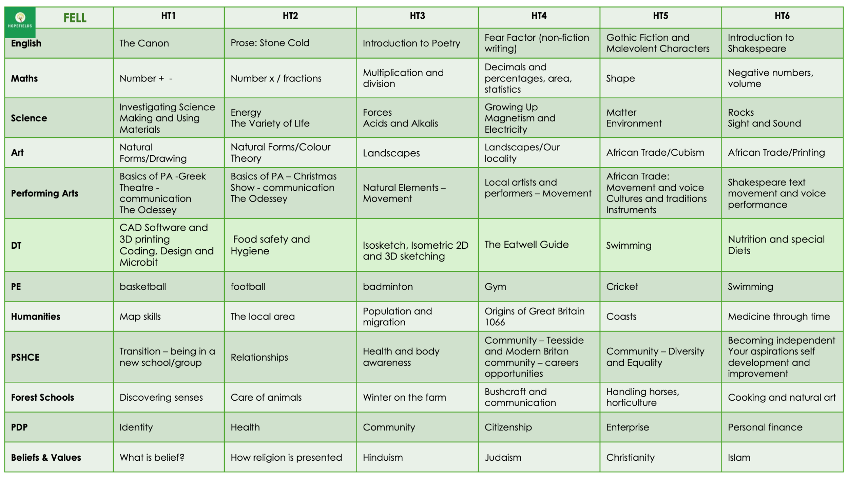

Appendix 4: YOAP KS4 Year 1 - Example
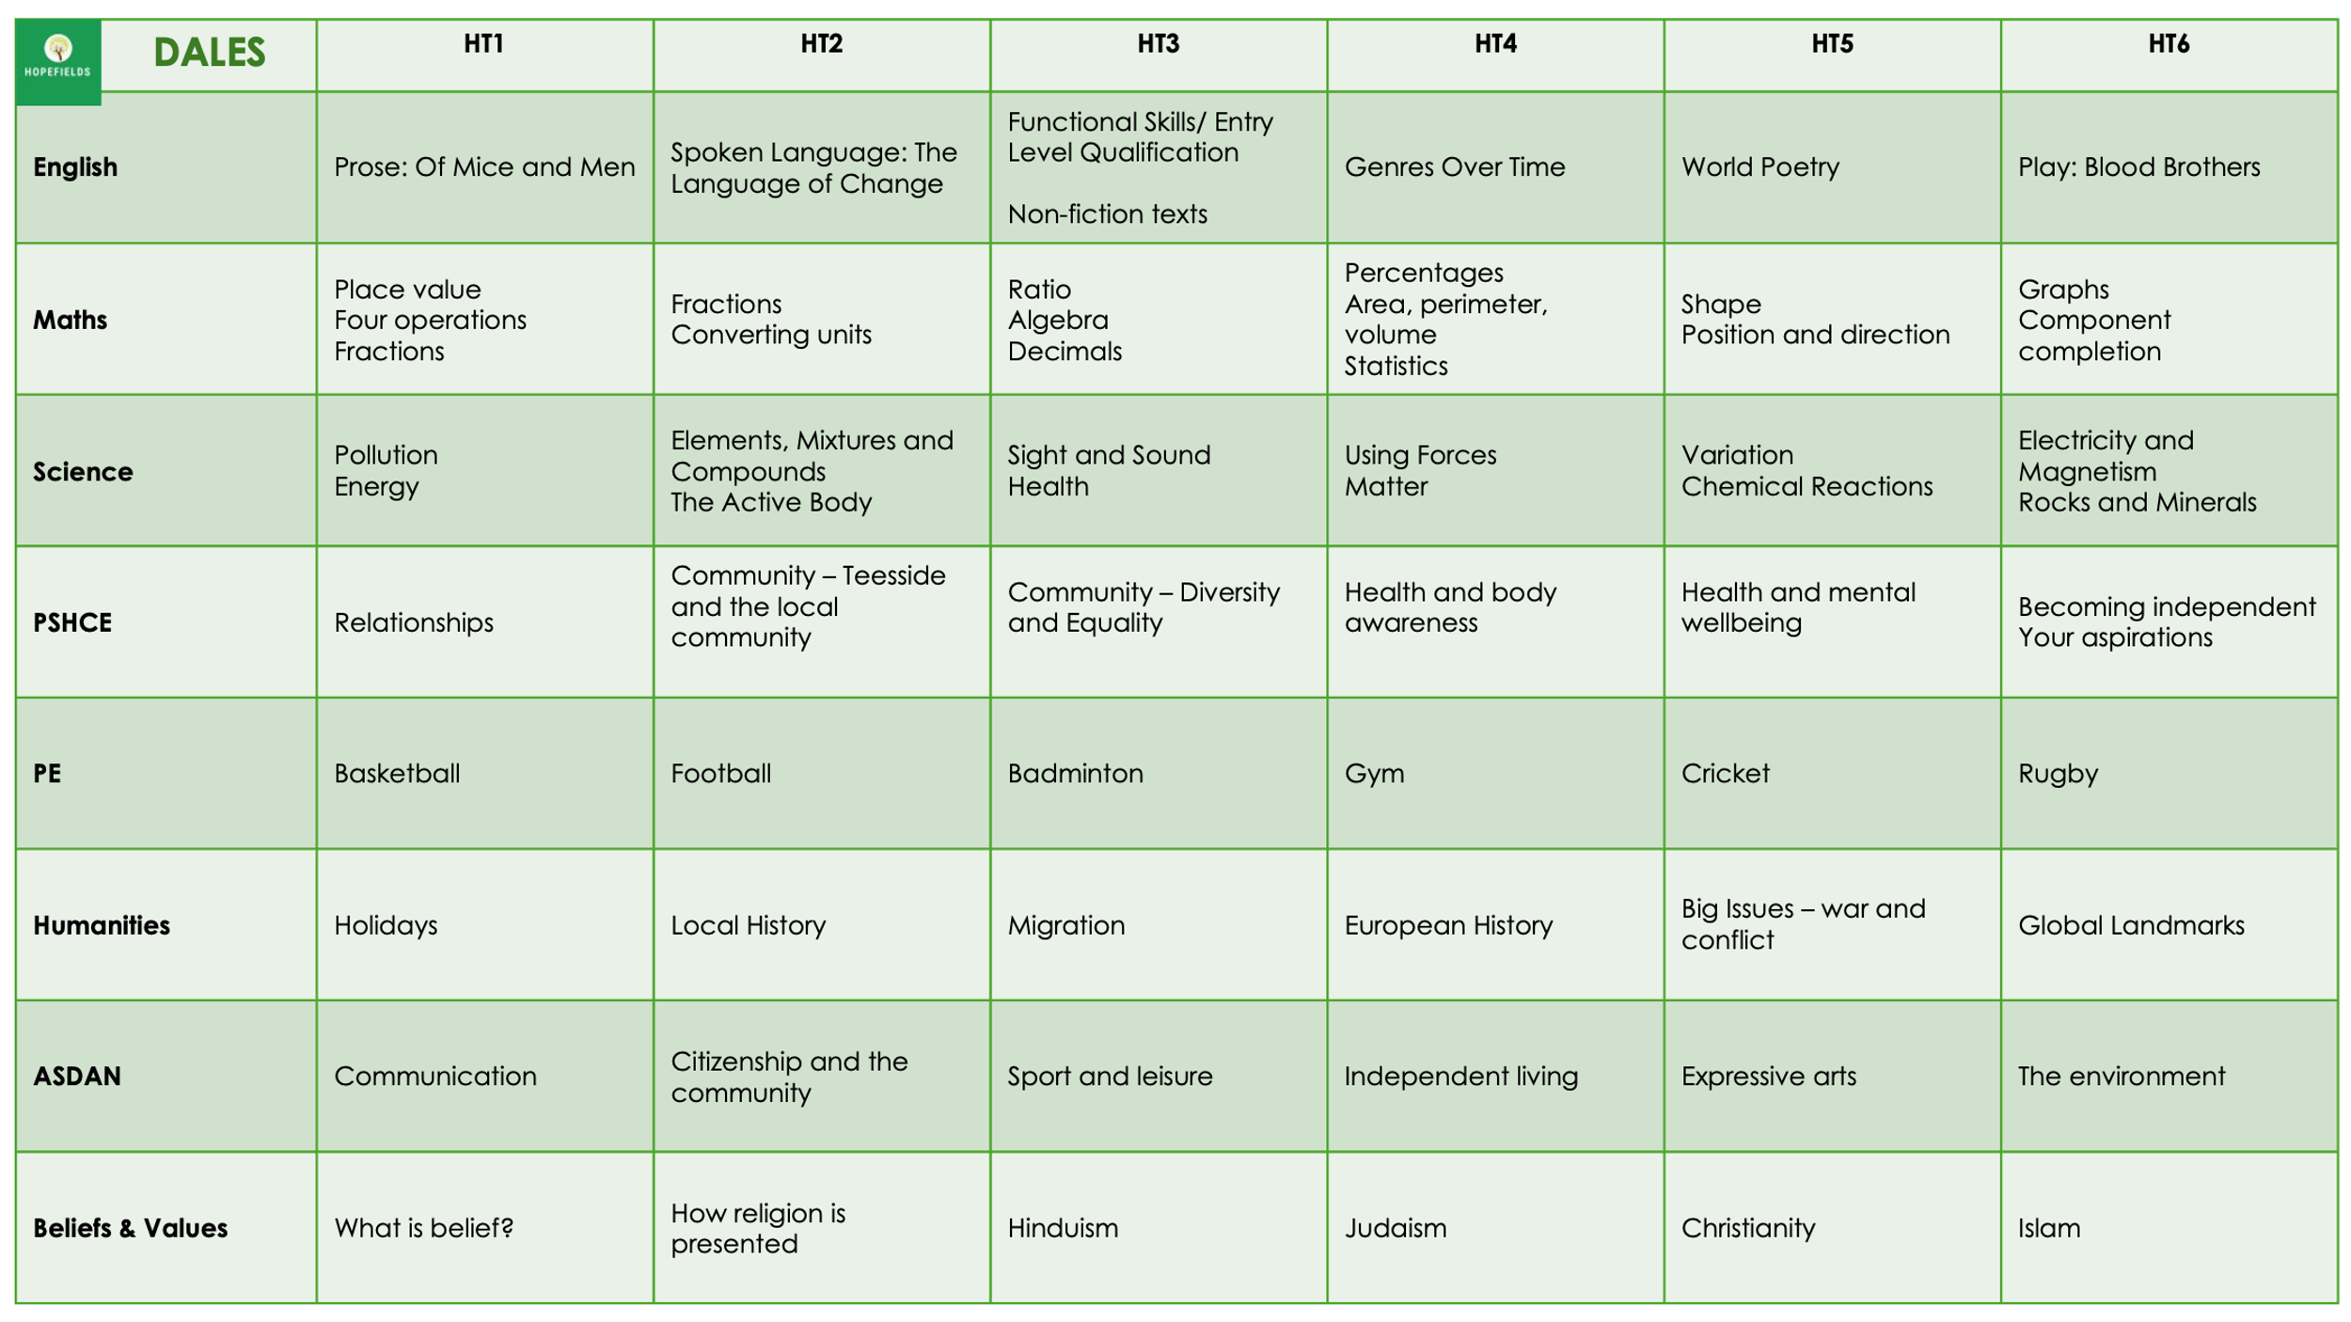
Appendix 5: Exemplar Schemes of Work
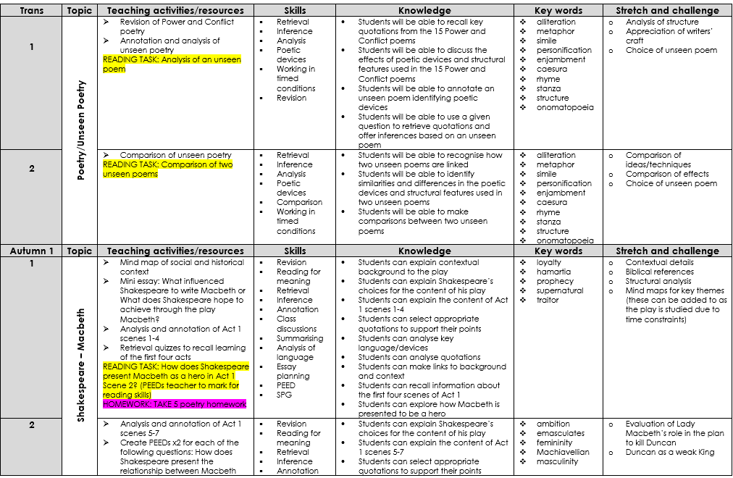

KS4 Equine Studies / Small Animal Care - Example
