Purpose
Hopefields believe that the purpose of the wider PSHCE curriculum is to gradually build up students’ level of knowledge and understanding across all aspects of Personal, Social, Health and Economic education and then be able to apply wider learning in a thoughtful and considered manner to suit the demands of any given task.
We aim to develop students’ ability to create and maintain healthy and nurturing relationships and understand key elements of safe and healthy sexual relationships in the future. We believe that all students should have the right to high-quality and comprehensive relationships and sex education, which promotes equal and enjoyable relationships and good sexual health. We believe the teaching of RSE should be founded on trust and mutual respect. We aim to develop our students into responsible citizens who can make informed decisions based on secure knowledge and understanding. Hopefields promote all of the protected characteristics withing class and social times.
Definition
RSE is about the emotional, social and cultural development of students, and involves learning about relationships, sexual health, sexuality, healthy lifestyles, diversity and personal identity. RSE involves a combination of sharing information and exploring issues and values; it is not about promoting sexual activity.
Aims and ambition
This policy provides an overall framework for the Hopefields action plan to help students learn about:
● Different types of relationships, including friendships, family relationships, intimate
relationships, marriage or other kinds of committed relationship
● How to recognise, understand and build healthy, nurturing relationships, including
self-respect and respect for others, commitment, tolerance, boundaries and consent,
and how to manage conflict, and how to recognize unhealthy relationships.
● How relationships may affect health and wellbeing, including mental health
● Healthy relationships and safety online
● Factual knowledge, and the law around sex, sexual health and sexual orientation,
gender identity, set firmly within the context of relationships
● Grooming, sexual exploitation and domestic abuse, including coercive and controlling
behaviour
● Female Genital mutilation (FGM), honour-based violence and forced marriage
Planning and teaching
Hopefields have ensured that the curriculum is designed with student learning at the core. Directors have thought carefully about what students should know, understand and be able to do at various stages in their educational life in relation to Relationships and Sex education.
Our RSE curriculum is progressive and challenging as we are committed to meaningful learning rather than superficial coverage of curriculum content, recognising that the materials taught should develop our students as informed citizens able to make well informed decisions as they progress to young adulthood.
At the planning stage of pulling together the RSE curriculum, parents are consulted at the induction meeting for their child. We gather views and concerns, if any, in relation to any of the planning content, and request parents speak to us in relation to withdrawal, removal of their child form the lessons, if required, and are influential in the curriculum intent and content. Hopefields will contact parents on a yearly basis, sharing this policy with them and requesting they contact us to inform our future planning, including any specific concerns they have in relation to their own child and sex/relationships, so that we can endeavour to teach and educate young people to maintain safe relationships.
Hopefields focus on ensuring that staff have strong RSE subject knowledge to underpin their teaching. We value and emphasise creating positive relationships in classrooms as we believe this enables great teaching to flourish. We are committed to offering a broad and balanced RSE curriculum that is accessible to all students across all key stages.
The specific content will be taught in an age appropriate and developmentally appropriate way. Topics will be taught sensitively and inclusively, with respect to backgrounds and the protected characteristics of students, while always providing students with the knowledge they need of the law.
Teaching will build on the knowledge acquired at primary school (Appendix 1) and develop further students’ understanding of health, with an increased focus on risks such as drugs and alcohol, as well as introducing knowledge about intimate relationships and sex (Appendix 2 & 3)
Commitment to Equalities and Diversity
The Equality and Human Rights Commission (EHRC) is the enforcement body for equalities legislation and may serve an education facility with a Compliance Notice if it fails in its specific duties under the Acts. If a provision was found wanting in any respect it would be provided with the opportunity to put this right within 3 months.
Hopefields is fully committed to discharging its equalities duties for all students, employees and visitors to the site. Procedures are in place for dealing with allegations of sexual or other forms of harassment or discrimination and for recording incidents which challenge equality.
We will ensure that the RSE policy and accompanying documentation are accessible by publishing them on the website. Complaints or concerns can be raised with the Directors through the Complaints Procedure, which is also available on the website.
RSE delivery is designed to comply with the Equality Act 2010 and will include LGBT+ content in the programme. This will include talking about LGBT+ families and teaching about sexual orientation and gender identity.
The religious backgrounds of all students will be considered when planning teaching and comply with the relevant provisions of the Equality Act 2010, under which religion or belief are amongst the protected characteristics.
Teaching will reflect the law as it applies to relationships so that students clearly understand what the law allows and does not allow, and the wider legal implications of decisions they make.
Under the Equality Act, the school will not unlawfully discriminate against students because of their age, sex, race, disability or belief, gender reassignment, pregnancy or maternity, marriage or civil partnerships or sexual orientation.
Students with Special Educational Needs and Disabilities (SEND)
We are committed to RSE being accessible for all students. This will demand that high quality teaching is both differentiated and personalised. Hopefields will also be mindful of the preparing for adulthood outcomes as set out in the SEND code of practice, when preparing these curriculum areas for students with SEND,
Statutory Requirements
The Relationships Education, Relationships and Sex Education, and Health Education (England) Regulations 2019 are made under sections 34 and 35 of the Children and Social Work Act 2017. Relationships Education is compulsory in all primary schools in England and Relationships and Sex Education compulsory in all secondary schools. Health Education is compulsory in all state-funded schools.
Parents’ Right to Withdraw
Parents have the right to withdraw their children from the non-statutory components of RSE (intimate and sexual relationships, including sexual health), up to and including three terms before the child turns 16. Parents cannot withdraw their child from Relationships or Health Education.
Requests for withdrawal should be made in writing to the Director. A copy of withdrawal requests will be placed in the student’s file. DfE guidance states that, ‘except in exceptional circumstances, the school should respect the parent’s request to withdraw their child, up to and until three terms before the child turns 16. After that point, if the child wishes to receive sex education rather than be withdrawn, the school should make arrangements to provide the child with sex education during one of those terms.’ Appropriate alternative work will be given to students who are withdrawn from RSE. The host school/referrer is expected to provide work for students withdrawn from RSE at Hopefields.

Working with external agencies
To support and enhance the delivery of RSE, Hopefields works with external partners to draw on specialist knowledge and implement different ways of engaging with our students. Where external agencies are used, the provision will ensure that all necessary checks (of the visiting organisation) are completed and any visitors linked to those agencies are also DBS cleared.
The provision will work with external agencies to ensure that content delivered is age appropriate and accessible for all students. Any materials that are used must be approved by the provision in advance of the session. Hopefields will ensure that visitors are aware of aspects of confidentiality and understands how safeguarding and disclosure reports should be dealt with in line with the Safeguarding Policy.
Safeguarding, Reports of Abuse and Confidentiality
We recognise that at the heart of RSE, the focus is on keeping children safe, and acknowledge our significant role in preventive education. RSE will provide an open forum to discuss potentially sensitive issues. Such discussions can lead to increased safeguarding reports therefore students will be made aware of the processes to enable them to raise their concerns or make a report including how this will be handled. This will also include processes when they have a concern about a friend or peer.
In line with the document Keeping Children Safe in Education (2023), all staff are aware of what to do if a child or vulnerable adult tells them they are being abused or neglected. Staff are also aware of the need to manage the requirement to maintain an appropriate level of confidentiality. This means only involving those that need to be involved, such as referring the matter to the Designated or Deputy Safeguarding Lead.
Informing and Involving Parents, Staff and Students
Parents and carers are key educators of their children and their role in education concerning relationships and sex education is seen by Hopefields as extremely important. This policy has been designed to consider and reflect the views of parents whilst meeting our statutory obligations.
All staff play an important role in planning, delivering and reviewing RSE. Student views will be gathered through Student Voice activities, formally and informally, and their views will be used to improve delivery of RSE lessons.
Policy review
The PSHE curriculum including RSE is reviewed regularly to ensure that the content and teaching materials are fit for purpose. The review process identifies what is working well and any elements that need to be altered to provide a better-quality learning experience for our students. This review process is informed by students, staff and Directors and will also consider views shared by parents and carers
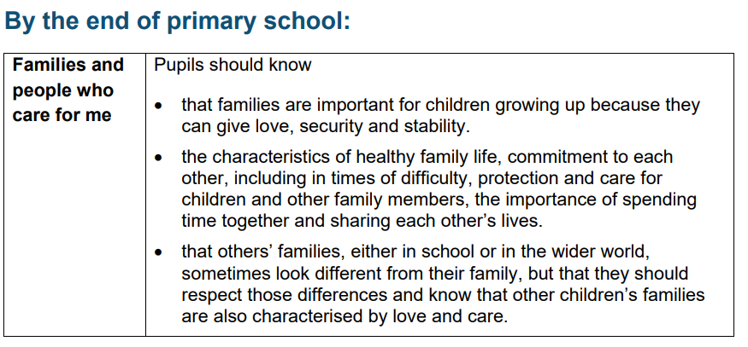
Appendix 1

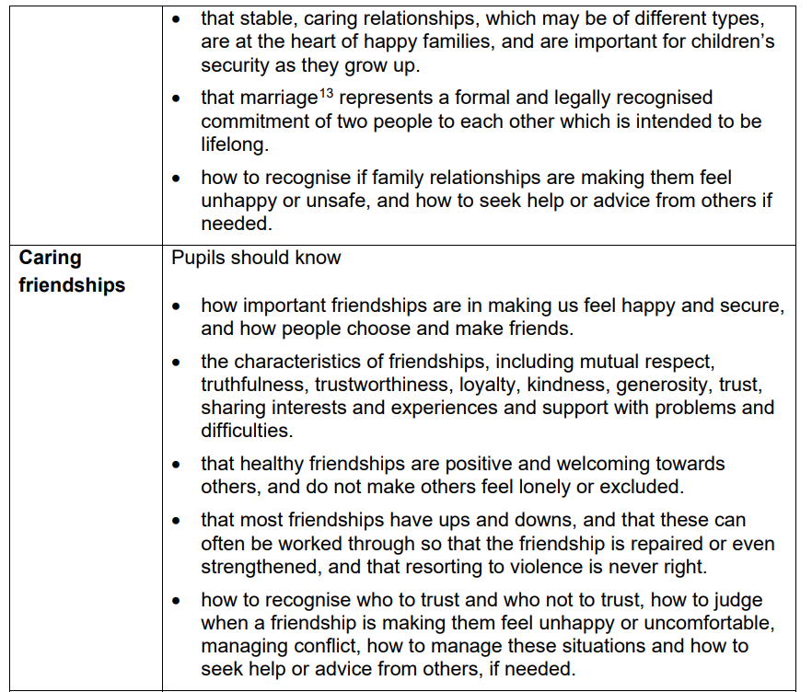

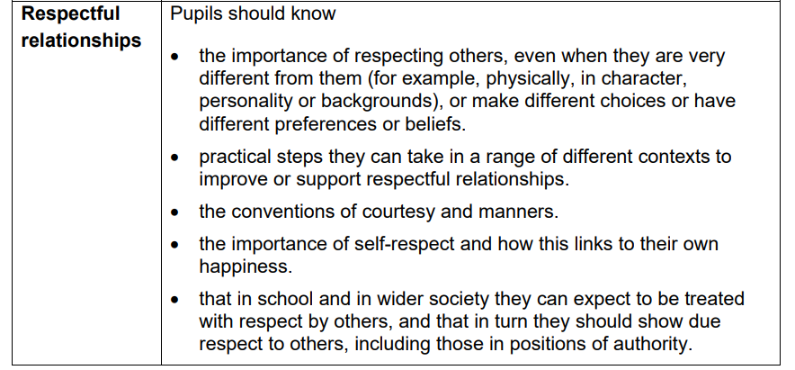

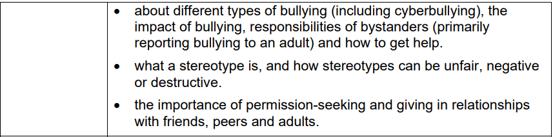

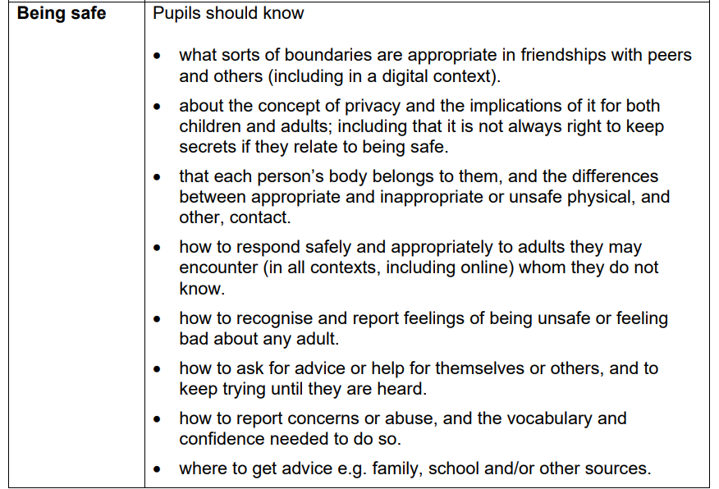
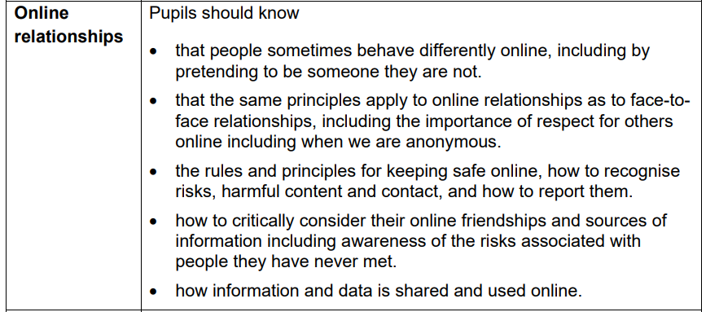

Appendix 2

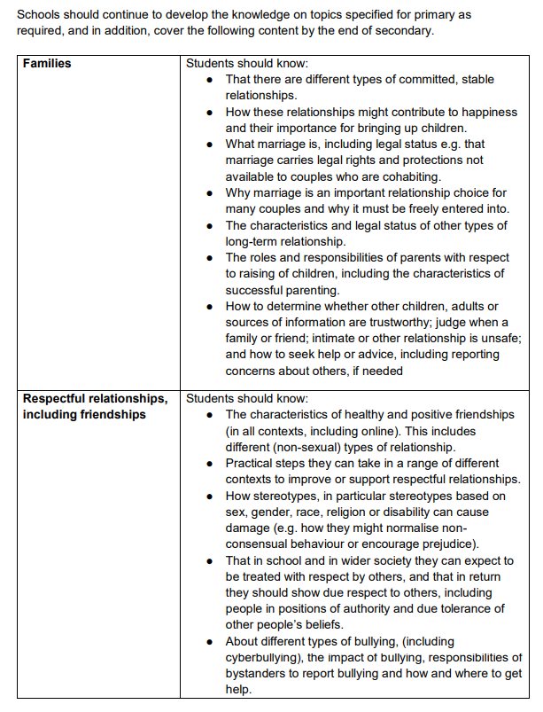

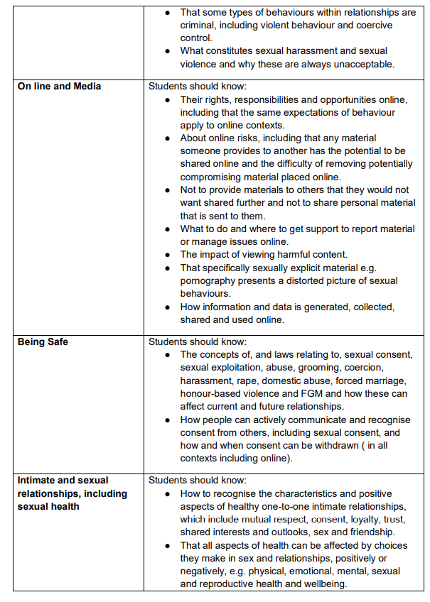

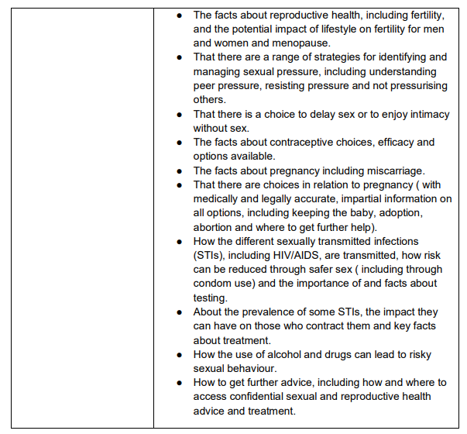

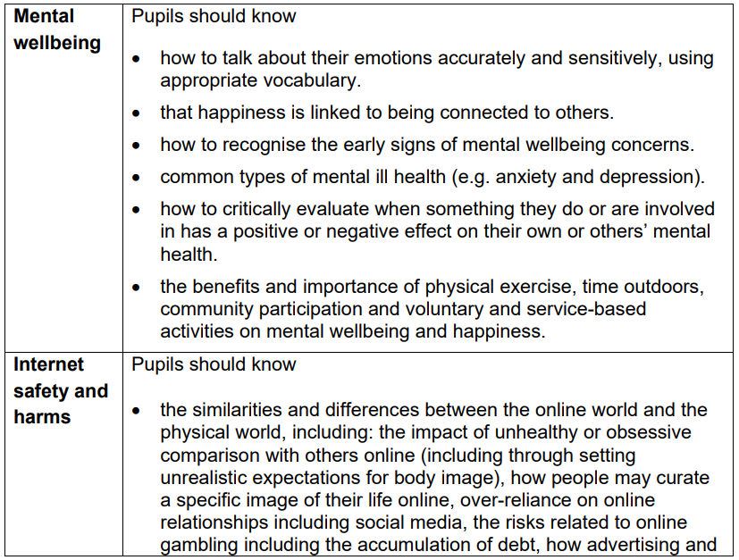
Appendix 3

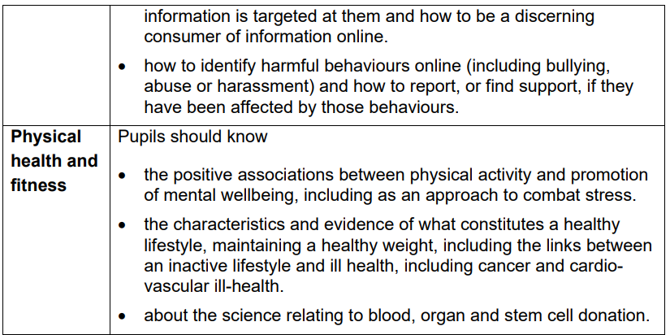

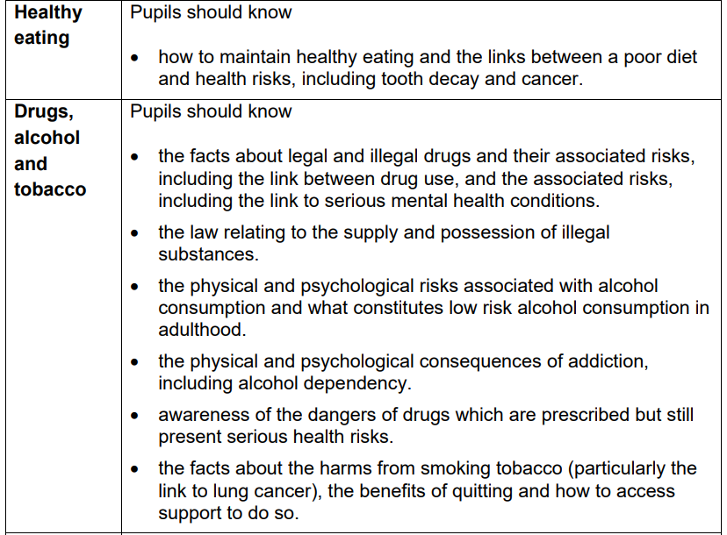

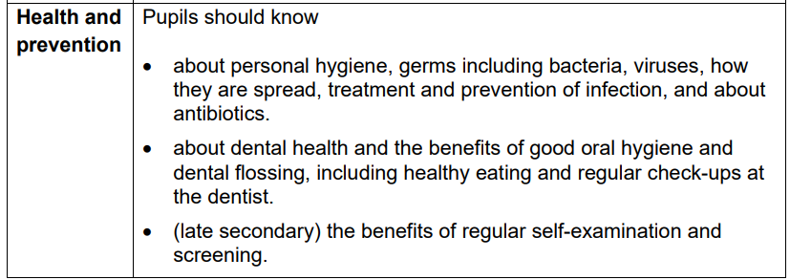

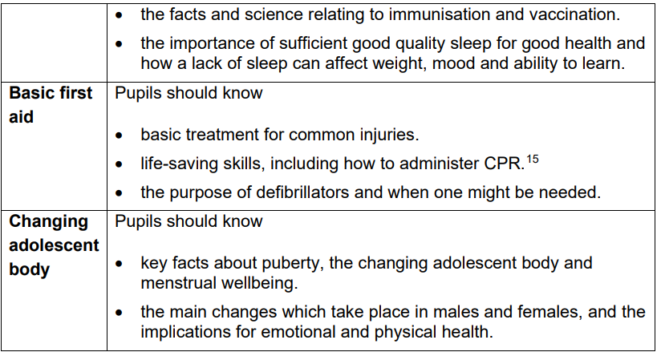

Appendix A – changes/updates/amendments

Date | Change made | Action to complete | Staff name
20.03.23 | Change of name in regards to the DSL and DDSLs. |  | EG
06.07.23 | Insertion of para in ‘planning’ section to comply with standards of consultation | Letter to parents and focus group meeting set and sent | EG
13.11.23 | Review |  | CF
1.12.24 | Review |  | AL
01.05.25 | Inclusion of Appendix 2 & 3 (DFE guidance to cover in secondary schools) |  | CF
04.08.25 | Policy Review. Changes to wording. |  | CF

