Scholarship Opportunity for Seniors going into the Medical Profession!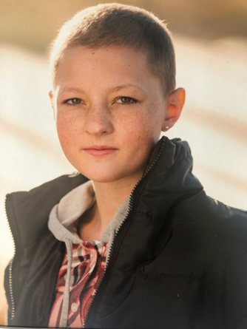
Award:
- $500 - $2500 Scholarship
- Award check will be sent directly to post-secondary educational institution
- Deferrable for ecclesiastical or military service
Eligibility Criteria:
- High School Senior
- Resident of Utah
- Minimum GPA of 3.0
- Accepted to a post-secondary educational institution (College/University or Vocational/Technical school)
Requirements:
- Pursuing a career in the medical field
- Completion of Livelikemak scholarship application
- Completed and submitted essay (1500 words or less) meeting the following criteria:
  - Why you have chosen a career in the medical field
  - Outline of your 5 to 10 year goals
  - 2 letters of recommendation from non-family related individuals

APPLICATION, ESSAY, AND RECOMMENDATION LETTERS MUST BE RECEIVED BY: April 1, 2021
Application can be found at www.livelikemak.org
Submission can be done at shelli@livelikemak.org

