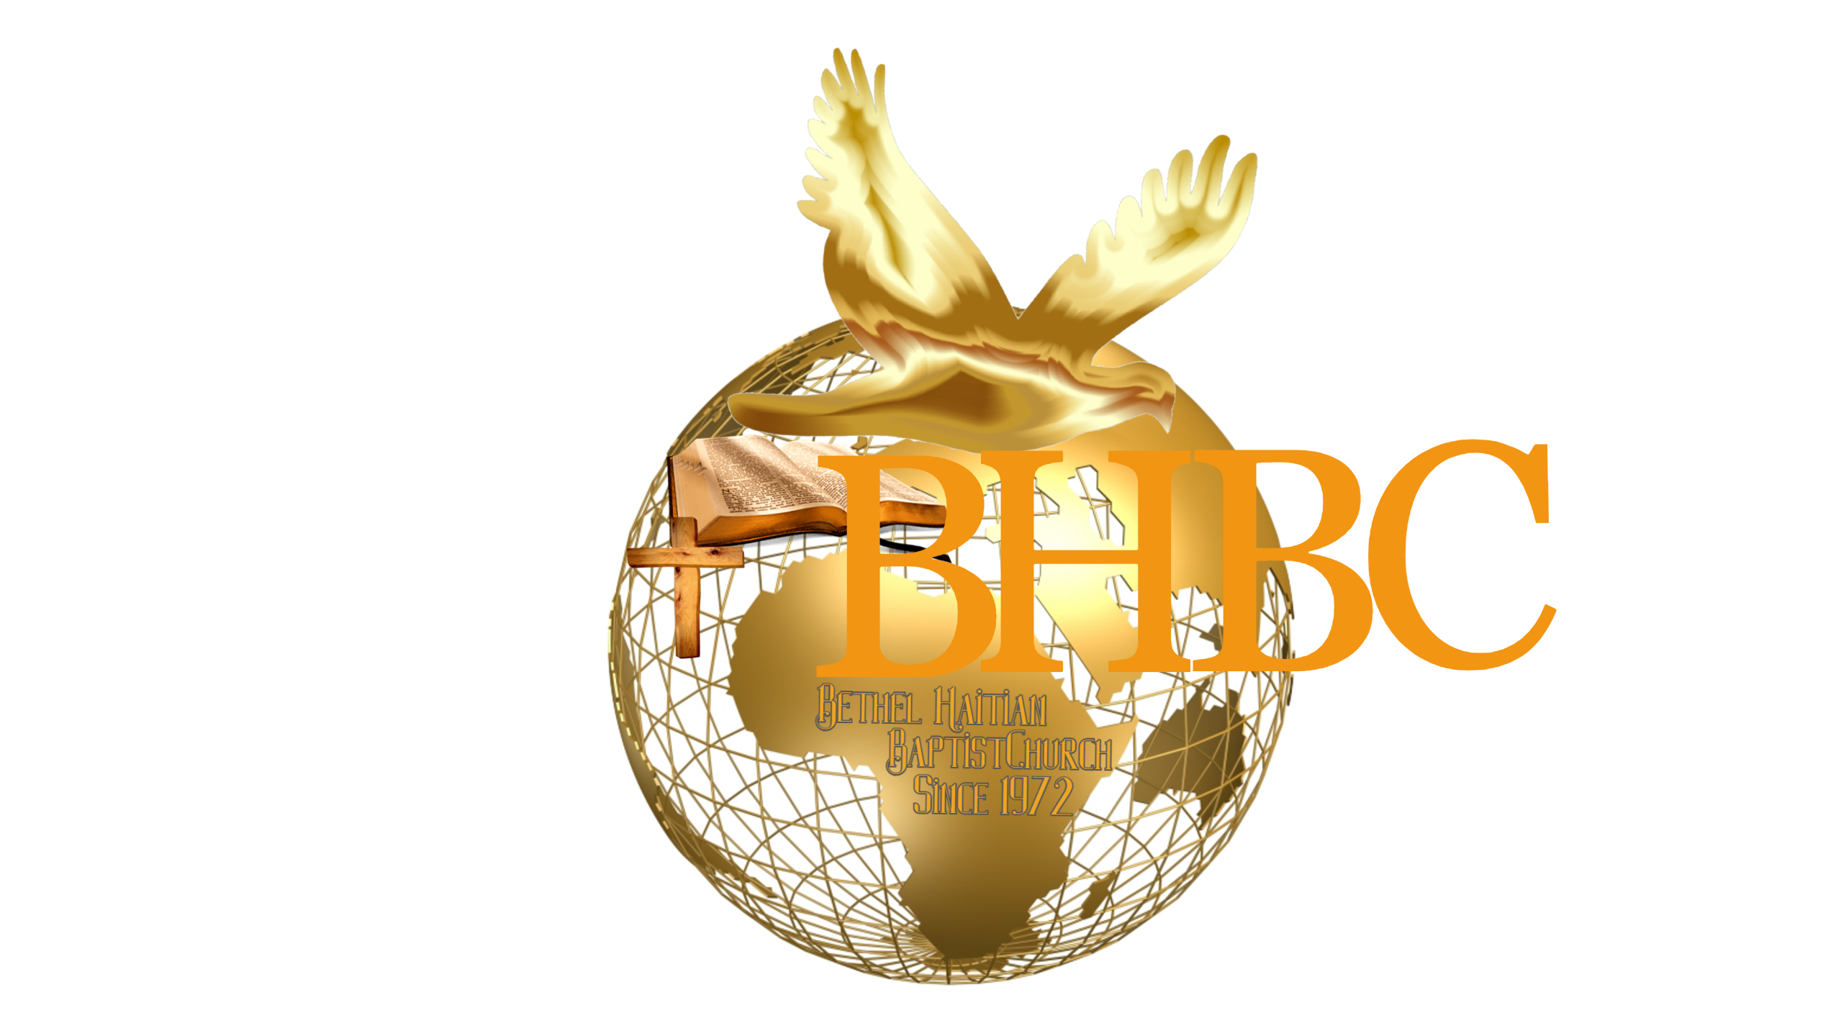Déclaration de Foi = Statement of Faith

AT THE BHBC WE BELIEVE:
- That The BIBLE is the inspired written Word of GOD (John 1: 1; 2 Tim. 3; 16; 2 Peter 1: 16 -21).
- In the Triune GOD eternally existing in three persons: The Father, The Son, and the Holy Spirit. Thus, we profess a Trinitarian faith (Num. 6: 23-26; Mat. 28: 19; Jude 20-21).
- That Jesus Christ is the only Son of the Father conceived/begotten by the Holy Spirit and born of the virgin Mary; that He was crucified, buried and raised from the dead on the third day (John 3: 16; Mat. 1: 23; Mat. 28: 6).
- That all (men and omen) have sinned and come short of the glory of God, and that repentance is the only way God gives humankind to obtain forgiveness of its sins (Acts 2: 38; Rom. 3:23; 5:12-21).
- That the tithe is the payment of one tenth (1/10) of the believer’s revenues into the church treasury without expecting any favor in return (Genesis 14: 18-20; Genesis 28: 20-22; Malachi 3:10; Mat. 23:23; Luke 11:42; I Cor. 16:6-9; Hebrews 7: 1-21).
- In the sanctification subsequent to the new birth obtained by faith in the blood of Jesus Christ (Acts 15: 9 I Cor. 6:11).
- That justification and regeneration subsequent to the new birth be obtained by faith in the shed blood of Jesus Christ (II Cor. 5:17; Rom. 31: 24; John 3: 3 and 4).
- That Salvation involves the redemption of the whole man, and is offered freely to all who accept Jesus Christ as LORD and Savior, who by His own blood obtained eternal redemption for the believer.
- In the ministry of forgiveness and reconciliation among GOD’s people (I John 1:9; Luke 23:34; Eph. 4:31 & 32; Col. 3:13; mat. 6:12; Numb. 14:18; Psalm 86:5)
- That holiness is a standard of life that God provides for His people (Eph. 5:26 & 27; I Thess. 4: 3; Heb. 12: 14).
- In the baptism of the Holy Spirit which is a gift of GOD not of men (Mat. 3:11; Mark 1: 8; Luke 3: 16; John 1: 29-33; Eph. 5:18).
- In the ordinance of the Water Baptism by full immersion that all who repent are to be baptized in the name of the Father, of the Son, and of the Holy Ghost (Mat. 8:19; Mark 10:46); other forms of baptism (aspersion & sprinkling) may be applied in some specific cases due to physical and emotional state of the believer.
- In the ordinance of the Eucharist which is the Holy Communion Celebration or the Lord’s Supper (Mat. 26: 26-28; I Cor. 11:20; Acts 20: 7; John 13:4 & 17).
- That the LORD’s Day is the first day of the week. It is a Christian institution for regular observance. It commemorates the resurrection of Christ from the dead and should include exercises of worship and spiritual devotion, both public and private.
- In the second pre-millennial coming of Jesus Christ first to resuscitate (resurrect) the dead in Christ and remove them as well as the living saints, and then to reign with Him for a thousand years (I Thess. 4:13, 18; Rev. 20: 2).
- In the bodily resurrection, in eternal life for the righteous and everlasting punishment for the wicked (I Cor. 15; Mat. 8: 12; Mat. 7: 22 & 23).
- That the Bible expressly forbids getting drunk on intoxicating drinks. (Prov. 20;1; Prov. 23:29 -32; Isaiah 28: 7; I Cor. 5:11; 6:10; Gal. 5;21; Eph. 5:18).
- That the use of tobacco and the habitual use of narcotics are addictions that defile the body, the temple of the Holy Spirit (Isaiah 55:2; I Cor. 10:31 and 32; II Cor. 7:1; Eph. 5: 3-8; James 1:21)
- That God’s perfect plan for marriage is between one man (born as a man) and one woman (born as a woman) [Gen. 1:27 & 28; Mal. 2:14 & 15; Col. 3:14; Mark 10:9; Eph. 5: 25 – 33].
- That the Second Coming of Christ includes the rapture of the saints followed by the visible return of Christ with His saints to reign on the earth for 1,000 years (1 Thessalonians 4; 16 & 17).

