Quality Management Policy
Version: 1

Name of originator / author:
Karen Hewinson MSc ACP (SHU), PG Dip SCPHN (ARU), PG Cert HCL (Open)

Date issued: September 2023
Review date: September 2024
Available on site

Version | Section /  Paragraph /  Appendix | Version / Description of Amendments | Date | Author /  Amended by
1 |  | New Policy | September 2023 | Karen Hewinson
2
3
4
5
6
7
8
9
10

Copyright © 2023 Skin Solutions Aesthetic Clinic Ltd, All Rights Reserved. Not to be reproduced in whole or in part without the permission of the copyright owner.

1 Introduction

Skin Solutions Aesthetic Clinic Ltd (SSACLTD) acknowledges the importance of audit as a quality improvement process and as significant mechanism for providing assurance in relation to the provision of safe and effective patient care. SSACLTD is therefore committed to delivering effective audit in all aspects of the services it provides and is a framework for
- the conduct of clinical audit
- the promotion of a culture of learning and continuous service improvement delivering demonstrable improvements in patient care

2 Purpose

This policy aims to support a culture of best practice in the management and delivery of audit to improve the safety of patient/client care
2.2 Improvement and assurance
Quality in the NHS was defined in High quality care for all: NHS next stage review, led by Lord Darzi, and enshrined in legislation through the Health and Social Care Act 2012. This set out three dimensions which must all be present to provide a high-quality service

Diagram 1 The three dimensions of a high-quality healthcare service

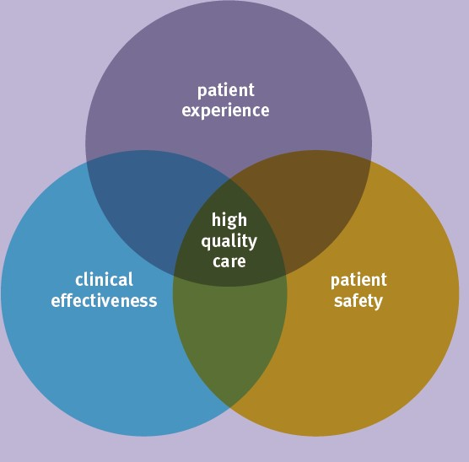

Quality improvement in healthcare is:
- a process that seeks to enhance patient experience and individual health outcomes, through measuring and improving the effectiveness and safety of clinical services.
- the planned and systematic monitoring of activity to ensure that the standards for safe, clinically effective services and positive patient experience are met.
While clinical audit is fundamentally a quality improvement process that provides the opportunity for ongoing review and service development, it also plays an important role in providing assurance on the quality of services.
SSAACLTD is committed to:
- Facilitating effective clinical audit activity through robust governance systems
- Demonstrating compliance with requirements of regulators and commissioners.
“Clinical audit is a quality improvement cycle that involves measurement of the effectiveness of healthcare against agreed and proven standards for high quality and taking action to bring practice in line with these standards so as to improve the quality of care and health outcomes"

3 Improvement and assurance
Quality in the NHS was defined by Lord Darzi and laid out in “High quality care for all: NHS next stage review”. This was enshrined in legislation through the Health and Social Care Act 2012 and set out three dimensions which must all be present to provide a high-quality service

The three dimensions of a high-quality healthcare service

Audit fundamentally allows the opportunity for quality improvement through ongoing review and service development and providing assurance on the quality of services.
Quality improvement in healthcare is:

- a process that seeks to enhance patient experience and individual health outcomes, through measuring and improving the effectiveness and safety of clinical services.
- the planned and systematic monitoring of activity to ensure that the standards for safe, clinically effective services and positive patient experience are met. Quality assurance aims to provide confidence and certainty in the quality of services.
SSACLTD is committed to demonstrating compliance with requirements of regulators and commissioners through rigorous audit processes.

3. Definition
Clinical audit is a quality improvement cycle that involves measurement of the effectiveness of healthcare against agreed and proven standards for high quality and taking action to bring practice in line with these standards so as to improve the quality of care and health outcomes.
Clinical audit cycle:

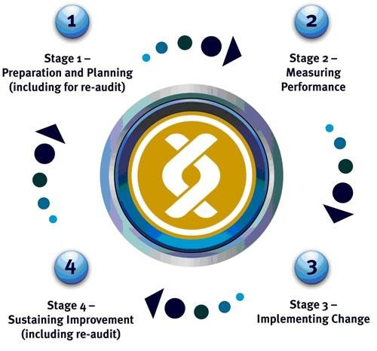
The Plan, Do, Study, Act cycle is a separate quality improvement tool used to drive and increase compliance with a standard against which there is an identified shortfall, or to investigate the impact of changes to practice within a defined timeframe which will also be utilised by SSACLTD in the event it is required.
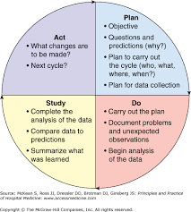

4. Involving patients and the public
SSACLTD is committed to involving patients, carers, and members of the public in the process. This will primarily be through patient feedback, either directly within the clinic or using media such as feedback on google (app in use within the clinic that clients can tap on their exit from the clinic) or on social media accounts.
It is recognised that a patient or client’s view of the quality of care is viewed differently to healthcare professionals, and their views are important in the design services to meet their needs.
Incident investigations, RCAs and complaints are all interrogated and will input into the quality improvement plans

5. Duties, roles and responsibilities

Owner/Lead Clinician/Clinic Manager Is accountable for the quality within the clinic, and takes overall responsibility for this policy

6. Equality and diversity

SSACLTD aims to ensure that its healthcare services and facilities are not discriminatory and, wherever possible, attend to the physical, psychological, spiritual, social, and communication needs of any patient or visitor, showing no discrimination on the grounds of ethnic origin or nationality, disability, gender, gender reassignment, marital status, age, sexual orientation, race, trade union activity, or political or religious beliefs.

7. Information governance: collection, storage and retention of data and confidentiality
All audits will adhere to information governance standards including the Data Protection Act and the Caldicott Principles. Data will be:
- Adequate, relevant, and not excessive
- Accurate
- Processed for limited purposes
- Held securely
- Not kept for longer than is necessary.

9. Identifying risks

In the event of the identification of a risk through either audit or an emerging risk, an entry will be made on the risk register and mitigations put in place until the risk can be rectified and closed.

10. References
High quality care for all: NHS next stage review Health and Social Care Act 2012.
.
Available in clinic
Risk register
Templates of all clinical audits completed
Patient feedback report
Lessons learned

