Anaphylaxis Treatment Policy

Version: 1

Name of originator / author:

Karen Hewinson MSc ACP (SHU), PG Dip SCPHN (ARU), PG Cert HCL (Open)

Date issued: September 2023

Review date: September 2024

Available on site

# Version Control Sheet

|  |  |  |  |  |
| --- | --- | --- | --- | --- |
| **Version** | **Section /**  **Paragraph /**  **Appendix** | **Version / Description of Amendments** | **Date** | **Author /**  **Amended by** |
| 1 |  | New Policy | September 2023 | Karen Hewinson |
| 2 |  |  |  |  |
| 3 |  |  |  |  |
| 4 |  |  |  |  |
| 5 |  |  |  |  |
| 6 |  |  |  |  |
| 7 |  |  |  |  |
| 8 |  |  |  |  |
| 9 |  |  |  |  |
| 10 |  |  |  |  |

Skin Solutions Aesthetic Clinic Ltd

**Background Statement**  Any treatment can cause anaphylaxis and the treatment

|  |  |
| --- | --- |
|  | Treatment needs an approach based on guidance from the Resuscitation Council (UK) and NICE Clinical Guideline 134 recommendations. |
| **Key words** | Anaphylaxis, adrenaline |
| **Responsibilities** | All staff must be competent at recognising the signs of anaphylaxis and dealing accordingly. |
| **Training** | All staff must ensure they are trained on the use of adrenaline for use in the case of an emergency. |

|  |  |
| --- | --- |
|  |  |

# 1. Introduction

Anaphylaxis is a clinical diagnosis defined as: "A serious systemic hypersensitivity reaction that is usually rapid in onset and may cause death”.

# 2. Purpose

To provide guidance for the immediate emergency treatment of anaphylaxis

# 3. Recognition & Diagnosis

## Recognition

Anaphylaxis is caused through exposure to an allergen also known as a trigger. A person develops a sudden illness (usually within minutes of exposure) with rapid progression including skin changes: mottling, redness, swelling, hives and potentially life-threatening airway and/or breathing and/or circulation problems.

## Allergens

Anaphylaxis can be caused by many things, but commonly food, drugs and venom.

## Identification

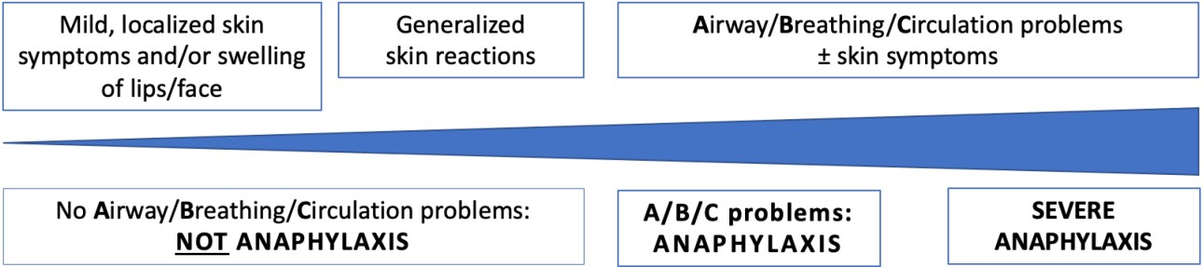

Follow an **ABCDE** approach and treat life-threatening problems as they are recognised. Patients can have either an A or B or C problem, or any combination.

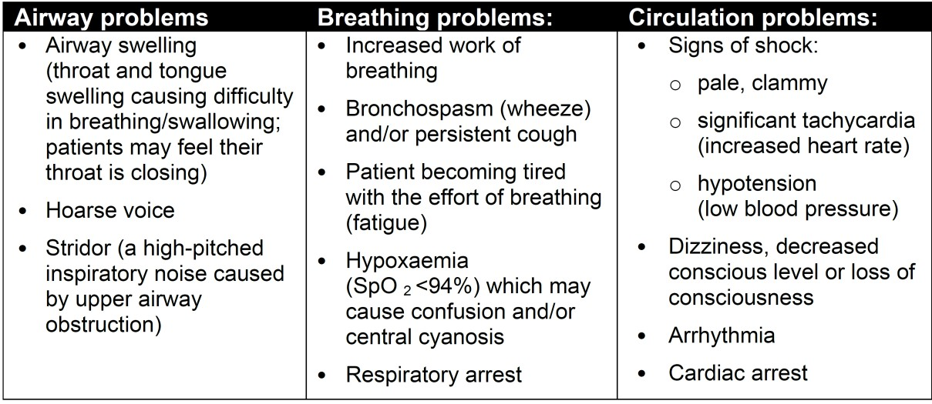

Anaphylaxis can also affect a patient’s neurological status (**D**isability problems) because of decreased brain perfusion or the effect of local allergic mediators in the central nervous system There may be confusion, agitation and loss of consciousness. Patients are usually anxious and may experience a “sense of impending doom”. Skin changes are part of E (Exposure) and are often the first feature of allergic reactions and are present in over 80% of anaphylaxis.

# 4. Initial treatment of anaphylaxis

**Initial treatments should not be delayed by the lack of an incomplete history or definite diagnosis**.

Use an **ABCDE** approach to recognise and treat anaphylaxis. The basic principles of treatment are the same for all age groups.

The key steps for the initial treatment of anaphylaxis are shown in the Resus Uk algorithm.

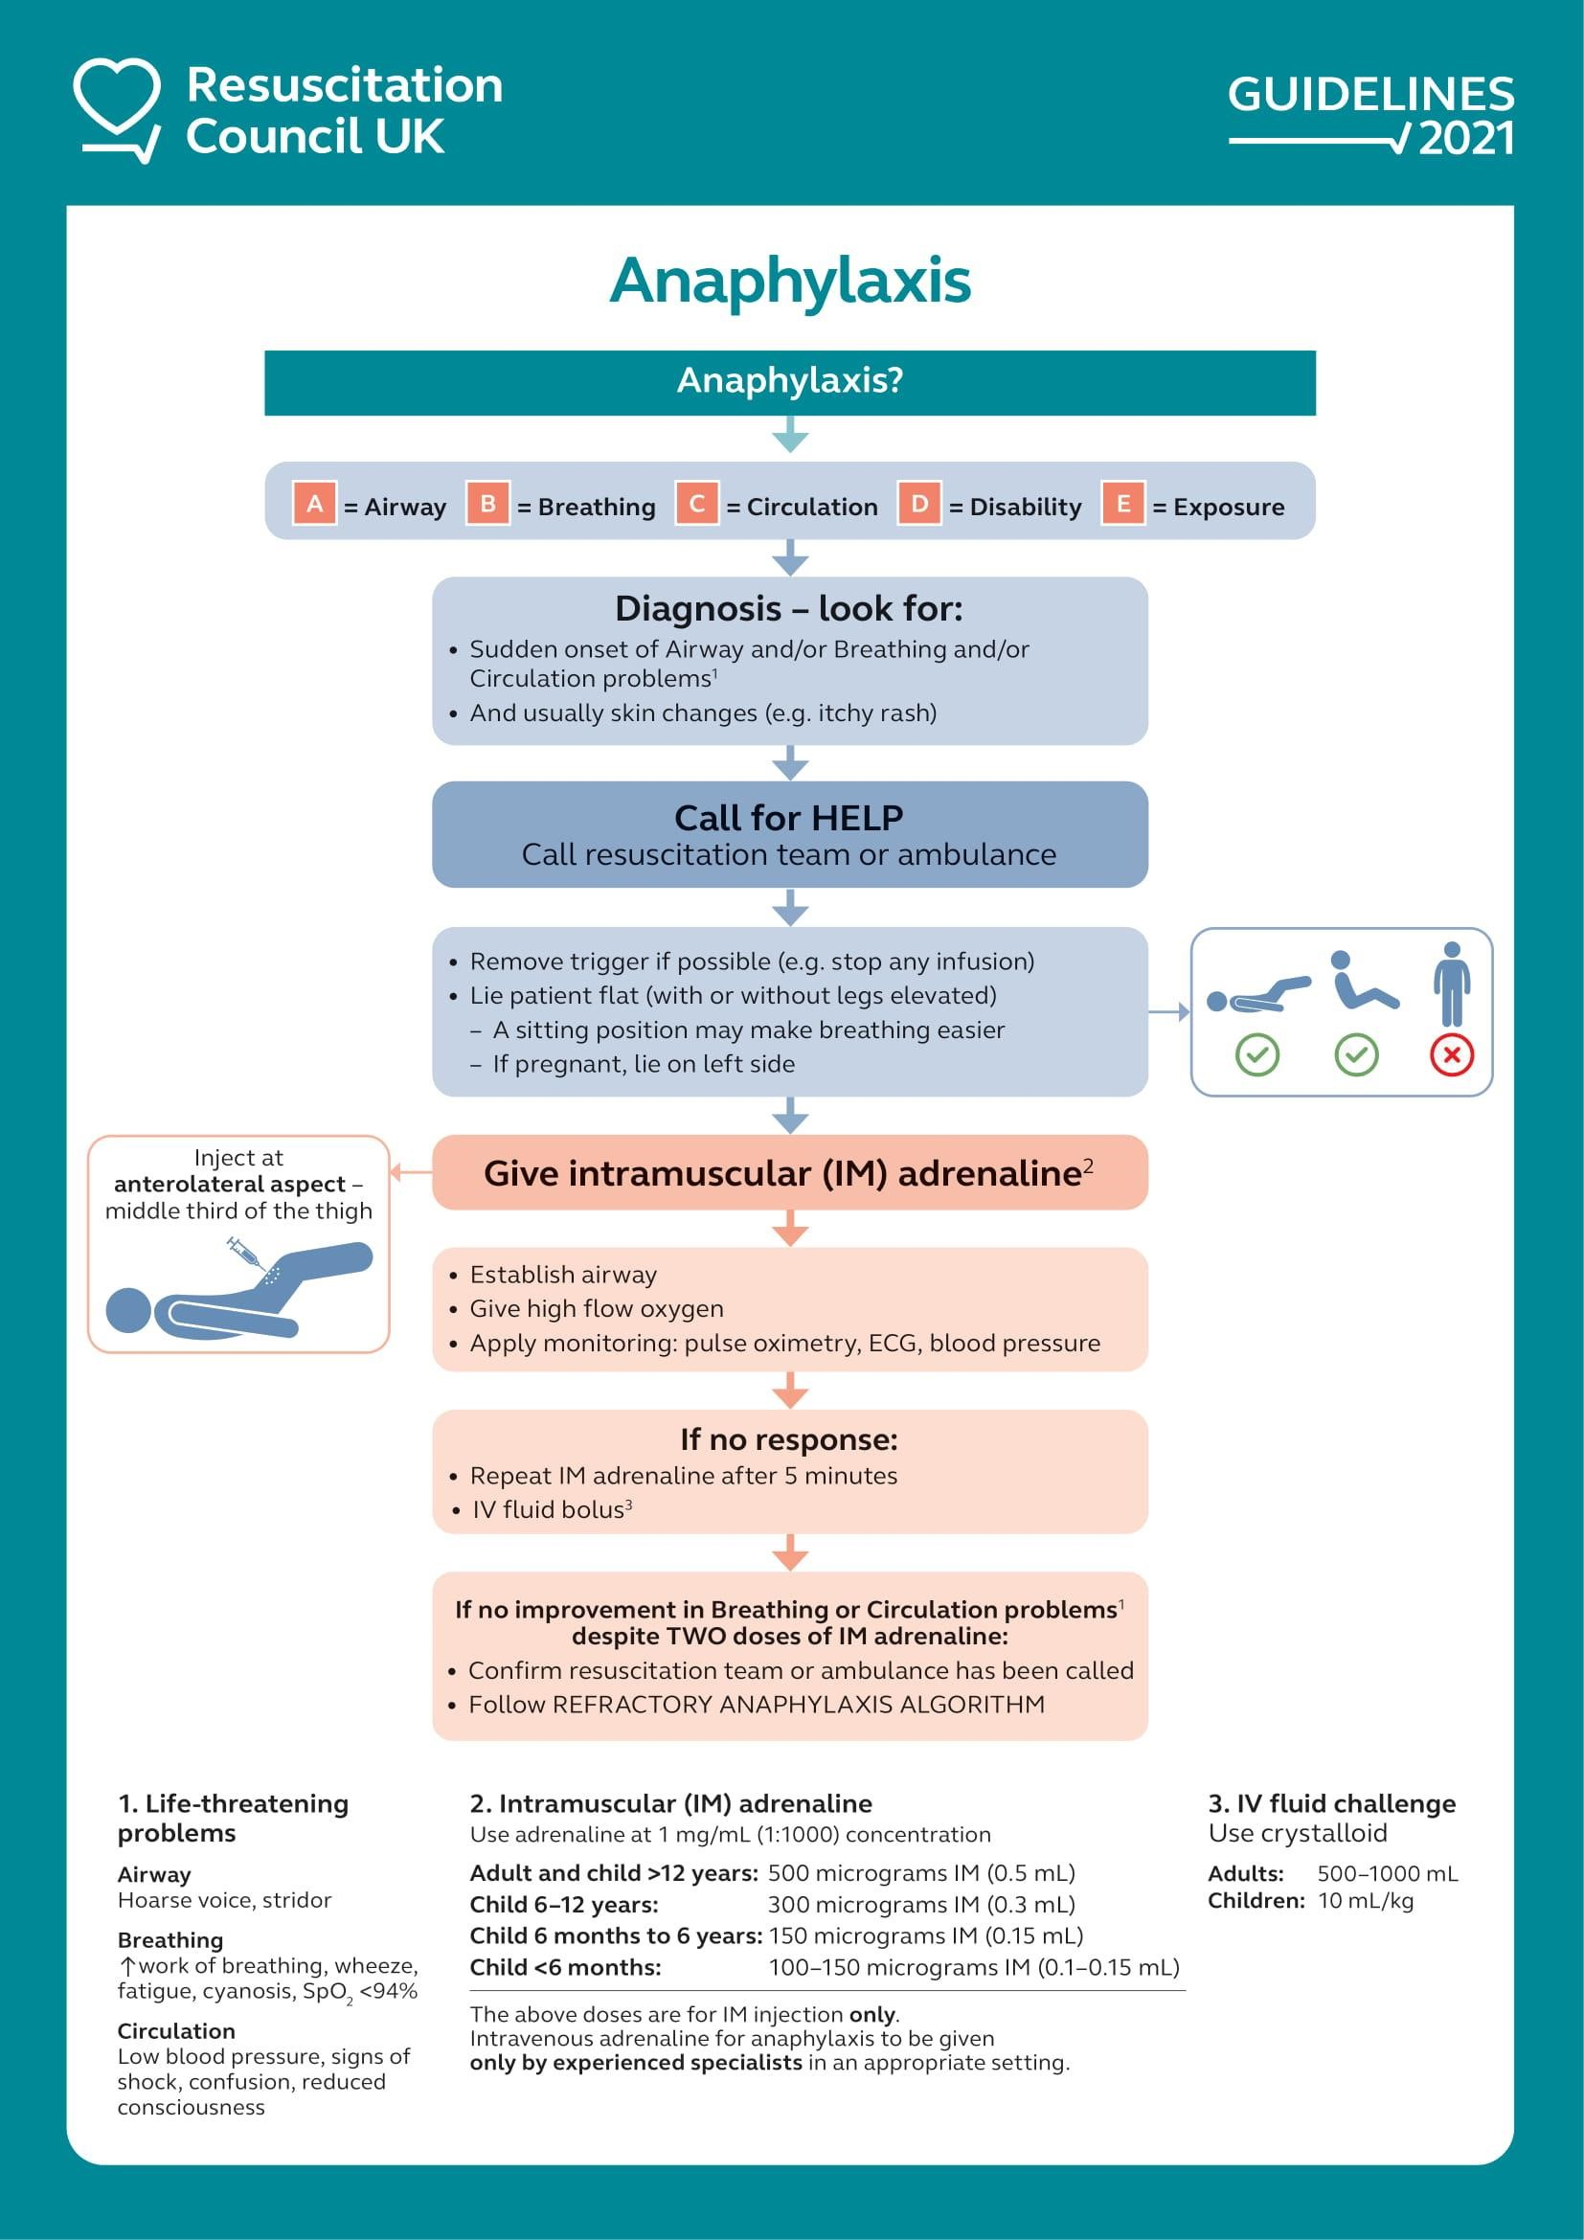

**999 to summon help**

An early call for emergency assistance stating “suspected anaphylaxis” is important.

**Patient positioning**

Patients should be placed in a comfortable position.

* Fatality can occur within minutes if a patient stands, walks or sits up suddenly. Patients must **not** walk or stand during acute reactions. Use caution when transferring patients who appear to have been stabilised.
* Patients with **A**irway and **B**reathing problems may prefer to be in a semi- recumbent position, as this will make breathing easier.
* Lying flat, with or without leg elevation, is helpful for patients with low blood pressure (**C**irculation problem).
* Patients who are breathing normally and unconscious should be placed on their side (recovery position). Monitor breathing continuously and prepare to intervene if this changes.
* Pregnant patients are best laying on their left side to reduce aortocaval compression.

**Remove trigger if possible**

* Stop the administration of any drug suspected of being the cause of the anaphylaxis
* Do **not** try to make a patient vomit if an ingested allergen is suspected.
* Do not delay definitive treatment if removing the trigger is not feasible.

**Adrenaline administration**

Adrenaline is the most important drug for the treatment of anaphylaxis. Adrenaline appears to be more effective when given early after the onset of anaphylaxis symptoms. Any delay in administration can cause protracted reactions such as hypotension and fataity

Adrenaline should be given to all patients with life-threatening features ie where there is evidence of reduced Airway/Breathing/Circulatory involvement.

**IM Adrenaline**

Intramuscular (IM) adrenaline is the first-line treatment for anaphylaxis in all healthcare settings. A single dose of IM adrenaline is well-tolerated and poses minimal risk to an individual having an allergic reaction.

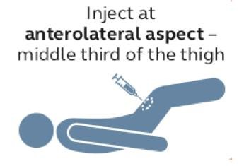**The route of administration within SSACLtd is IM injection.**

**The administration point is the anterolateral aspect of the middle third of the thigh.**

**The needle used for injection must be sufficiently long to ensure that the adrenaline is injected into muscle: use a green (21G) or blue (23G).**

**Within SSACLtd there is an emergency red drug bag in the emergency drug cupboard that holds the adrenaline and appropriate syringes for use.**

**Adrenaline IM Dose** Use 1mg/mL (1:1000) adrenaline

Adult & child* > 12yrs: 500 micrograms IM (0.5 mL of 1mg/ml)

6 – 12 years: 300 micrograms IM (0.3 mL)

6 months – 6years: 150 micrograms IM (0.15 mL)

< 6months: 100 – 150 micrograms IM (0.1 – 0.15mL)

*Give 300 micrograms IM (0.3 mL) in a child who is small or prepubertal

The scientific evidence for the recommended doses is weak. The recommended doses are based on what is considered to be safe and practical to draw up and inject in an emergency, and have been used for many decades, as per international guidelines.

Measure vital signs (respiratory rate, oxygen saturations, heart rate, BP, level of consciousness) and auscultate for wheeze to monitor the effect of treatment and assess if further doses of adrenaline are required.

**Repeat the IM adrenaline dose after 5 minutes if there is no improvement in the patient’s condition.**

**Patients Own Adrenaline Medication**

If patient carries their own prescribed pre-filled adrenalin autoinjector device, eg.

EpiPen, Jext, Emerade, **anyone can assist the patient to take his or her medication**.

These are single use devices and once used must be sent with the patient to secondary care.

**Auto-injectors are not recommended in healthcare settings for administration of adrenaline in patients needing more than one dose of adrenaline.**

**If the only available adrenaline preparation is an auto-injector, this can be used in the first instance.**  If further doses of adrenaline are needed, give these from an ampoule by syringe and needle.

# 5. Legal aspects of administering adrenaline for anaphylaxis in an emergency

There is no legal problem in any person administering adrenaline that is either prescribed for a specific person or in administering adrenaline to an unknown person in a life-saving situation.

Specific exemptions in the Human Medicine Regulations 2012 allow for a number of drugs, adrenaline for anaphylaxis included, to be excluded from normal administration regulations.

**Adrenaline in the clinic is held as an emergency drug** (and not prescribed) so any person competent to do so may administer (using 1 mg/mL strength) at the doses recommended in this guideline

Currently, the law does not allow a non-prescriber to administer an adrenaline autoinjector, which has been specifically prescribed to a named person, to another individual.

.

## Oxygen

Oxygen is not available in the clinic

## Antihistamines & corticosteroids

Antihistamines are not recommended as part of the initial emergency treatment for anaphylaxis

Whilst it is hoped that early recognition and call for emergency services support will mean that assistance for management of ongoing persisting respiratory or cardiovascular symptoms is available it should be recognised that a failure to support patients in this situation may lead to cardiac arrest.

As IV fluid is not held within the clinic, should symptoms, either cardiovascular or respiratory continue **IT IS APPROPRIATE** to continue **IM** adrenaline every 5 minutes until emergency service assistance arrives.

## Intravenous fluids

If appropriate skills and competencies allow, in the presence of hypotension/shock, or poor response to an initial dose of adrenaline:

* Secure IV access and give a rapid IV fluid bolus (10 mL/kg in a child or 500 – 1000 mL in an adult) and monitor the response.

➢ Use non-glucose-containing crystalloids that contain sodium in the range 130 – 154 mmol/L (e.g. 0.9% sodium chloride, Hartmann’s) for initial resuscitation.

* Give further fluids as necessary. A large volume (up to 3 – 5 litres in adults) may be needed for severe anaphylactic shock (see section 6). Use a non- glucose-containing crystalloid (e.g. Hartmann’s) rather than 0.9% sodium chloride to reduce the risk of causing hyperchloraemia.

It is recognised these actions are not possible in the clinic.

## Cardiac Arrest

Recognise that cardiac arrest has occurred if the person becomes unresponsive or unconscious, and breathing is absent or abnormal.

In adults, start chest compressions early in the peri-arrest patient.

Recommendations for the treatment of peri-operative anaphylaxis are to start chest compressions if the non-invasive (i.e. measured with a blood pressure cuff) systolic BP remains below 50 mmHg, especially in the presence of bradycardia.

**Cardiac arrest following anaphylaxis is a situation when prolonged CPR should be considered likely. This is because these patients have usually arrested from a sudden and potentially reversible cause, having been previously well.**

## Equipment

Auto-injectors are often prescribed to patients at risk of anaphylaxis for early selfadministration or injection by a carer or family member in the event of an anaphylactic reaction. Depending on the brand, they are available in three doses of adrenaline:

150 micrograms (0.15 mg), 300 micrograms (0.3 mg) and 500 micrograms (0.5 mg). Healthcare professionals should be familiar with their use.

**In all healthcare settings, giving adrenaline from an ampoule by syringe and needle is preferred in an emergency, since auto-injectors will not allow delivery of an age/weight-appropriate dose in most patients.** In addition, concerns have been raised as to whether auto-injectors will deliver an IM dose correctly in some patients. If the only available adrenaline preparation is an auto-injector, this can be used in the first instance.

**Expiry**

All packs are sealed and marked with an expiry date and a central register of the issue of packs to staff will be held by each Team Lead.

**Daily Checks**

Checking of drugs for anaphylaxis are included in processes to check expiry date, maintenance of seal and include appropriate storage conditions.

Where resuscitation equipment is held in clinical areas it should be considered along with cardiac arrest drug packs within the regular equipment checking process. A record of the check on the Resuscitation Equipment Daily Check Sheet.

 

# 6. Record Keeping

Document the acute clinical features of the suspected anaphylaxis and record the time of the onset of reaction. This is the time that symptoms are first noticed.

Record the circumstances immediately before the onset of symptoms to help identify any potential trigger.3

A full record must be kept of adrenaline administered paying particular attention to timings.

Should the circumstances involve any medicine, whether prescribed or otherwise, herbal or homeopathic treatment the reaction must be reported to the MHRA (Medicines and Healthcare products Regulatory Agency) using the Yellow Card scheme. <https://yellowcard.mhra.gov.uk/>

# 7. Competence

If not treated successfully anaphylaxis can quickly lead to cardiac arrest. All clinical staff are required to complete Basic Life Support training

All staff administering Adrenaline (Epinephrine) by the drawing up from ampoules using syringes and needles must be registered and working within the guidelines and Code of Conduct of their professional body.

# 8. References

1. Resuscitation Council UK (2008, 2012, 2021) Emergency treatment of anaphylactic reactions. Guidelines for healthcare providers. [Emergency treatment of anaphylactic reactions: Guidelines for healthcare providers | Resuscitation Council UK](https://www.resus.org.uk/library/additional-guidance/guidance-anaphylaxis/emergency-treatment)

1. Resuscitation Council (UK) (2021) Management of anaphylaxis in the vaccination setting. [RCUK publishes anaphylaxis guidance for vaccination settings | Resuscitation Council UK](https://www.resus.org.uk/about-us/news-and-events/rcuk-publishes-anaphylaxis-guidance-vaccination-settings)

1. NICE (2011, 2020) Clinical Guideline 134 Anaphylaxis: assessment to confirm an anaphylactic episode and the decision to refer after emergency treatment for a suspected anaphylactic episode. [https://www.nice.org.uk/guidance/cg134/evidence/anaphylaxis-full-guideline-pdf184946941](https://www.nice.org.uk/guidance/cg134/evidence/anaphylaxis-full-guideline-pdf-184946941)
2. UK Health Security Agency (2013, 2021) Immunisation against infectious disease.  [UK Health Security Agency Greenbook title page and index (publishing.service.gov.uk)](https://assets.publishing.service.gov.uk/government/uploads/system/uploads/attachment_data/file/1034373/Greenbook-cover-Nov21.pdf)

# Refractory Anaphylaxis

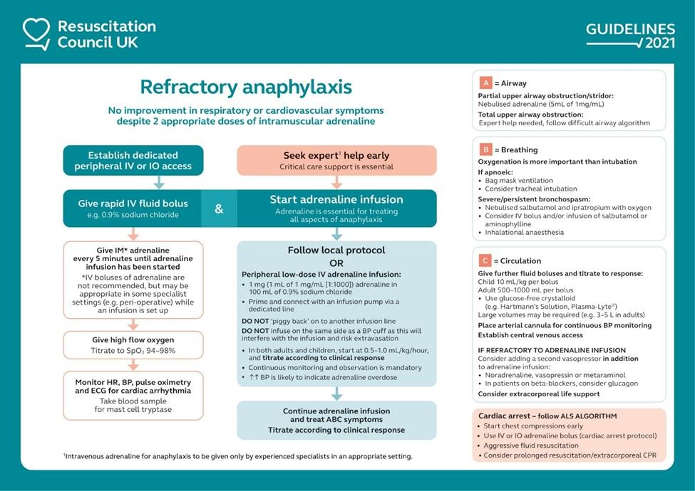

Staff must consider the contents of this algorithm within the context of the clinical location. Whilst **IV** fluid administration may not be possible **IT IS APPROPRIATE** to continue **IM** adrenaline every 5 minutes until emergency service assistance arrives if cardiovascular or respiratory symptoms persist.

**Choice of needle and technique for IM injection**

There is no specific evidence for using any particular technique of IM injection when treating anaphylaxis. This guidance is based on the recommendation of IM injections for vaccination4 but considers the increased perfusion and therefor absorption rate available by utilising the thigh.

For IM injections, the needle must be long enough to ensure that the drug is injected into the muscle.

A 25mm needle is best and is suitable for all **ages.**

In pre-term or very small infants, a 16mm needle is suitable for IM injection. In some adults, a longer needle (38 mm) may be needed.

|  |  |  |
| --- | --- | --- |
| Standard UK needle gauges and lengths | |  |
| Brown | 26 G | 10 mm |
| Orange | 25 G | 16 mm or 25 mm |
| Blue | 23 G | 25 mm |
| Green | 21 G | 38 mm |

The optimum site for IM injection is the anterolateral aspect of the middle third of the thigh.

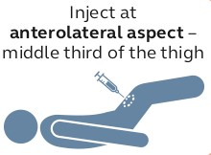

# SACLtd Adrenaline Packs

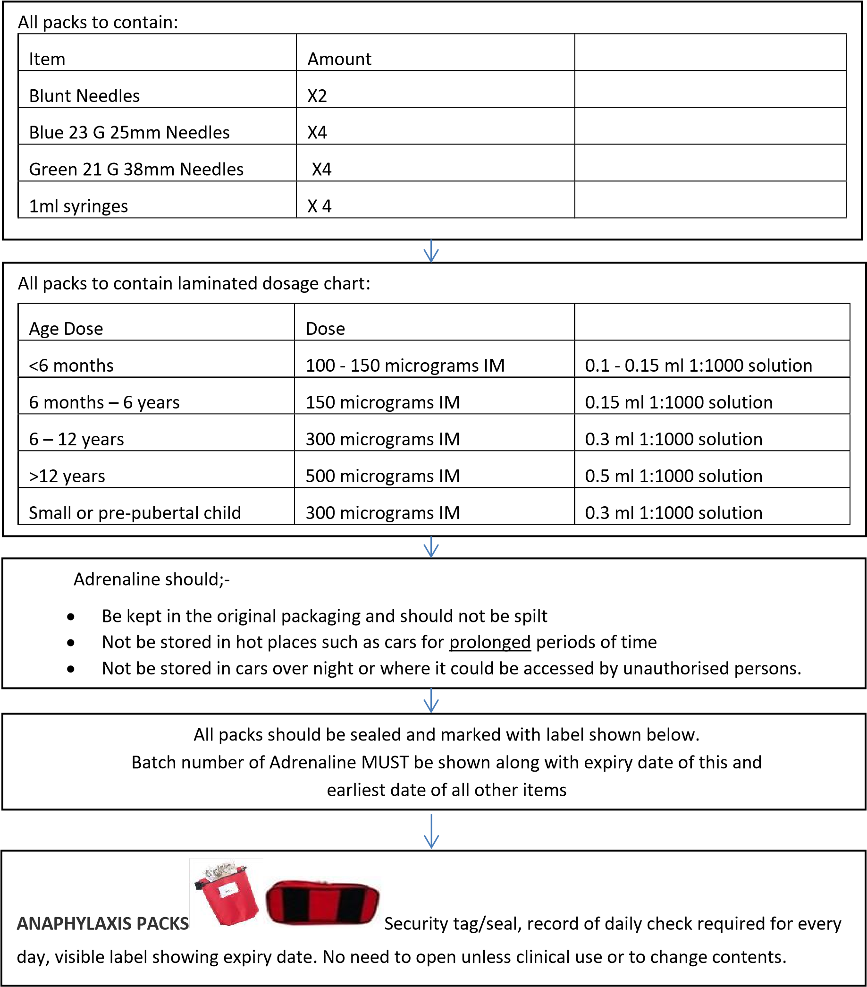

|  |  |  |  |  |  |  |  |  |  |
| --- | --- | --- | --- | --- | --- | --- | --- | --- | --- |
| Anaphylaxis Pack   |  |  |  | | --- | --- | --- | | Adrenaline 1:1000 1mg/ 1ml | Batch Number: | Expiry Date: | | Other items, earliest expiry date: | |  | | Date Sealed | Signature |  | |

# Daily Monitoring Chart

SSACLtd STOCK RECORD…. MONTH …………

Drug…………………………………………………… Dose…………………………………………………...

Batch Number……………………………………..… Expiry date of Stock…………………………………

|  |  |  |  |  |  |
| --- | --- | --- | --- | --- | --- |
| Date | Description | Stock In | Stock out | Stock level | Initials |
|  |  |  |  |  |  |
|  |  |  |  |  |  |
|  |  |  |  |  |  |
|  |  |  |  |  |  |
|  |  |  |  |  |  |
|  |  |  |  |  |  |
|  |  |  |  |  |  |
|  |  |  |  |  |  |
|  |  |  |  |  |  |
|  |  |  |  |  |  |
|  |  |  |  |  |  |
|  |  |  |  |  |  |
|  |  |  |  |  |  |
|  |  |  |  |  |  |
|  |  |  |  |  |  |
|  |  |  |  |  |  |
|  |  |  |  |  |  |
|  |  |  |  |  |  |
|  |  |  |  |  |  |
|  |  |  |  |  |  |
|  |  |  |  |  |  |
|  |  |  |  |  |  |
|  |  |  |  |  |  |
|  |  |  |  |  |  |
|  |  |  |  |  |  |