

Business Management Structure and Governance

Version: 1

Date issued: March 2023
Review date: March 2025
Target audience: All

Version Control Sheet
Version | Section /  Paragraph / | Version / Description of Amendments | Date | Author /  Amended
1 | New | 1 | 01/09/2023 | K Hewinson
2
3
4
5
6
7
8
9
10
11
12
13
14
15

Copyright © 2023 Skin Solutions Aesthetic Clinic Ltd. All Rights Reserved. Not to be reproduced in whole or in part without the permission of the copyright owner.

Service Name |  | Skin Solutions Aesthetic Clinic Ltd
1 | Name of Author: | Karen Hewinson
2 | Job Title of Author: | Owner/Manager
3 | Author telephone and e-mail: | Work Mob: 07917 638447  Karen@skinsolutionsacltd.co.uk
4 | Date: | 27/09/2023
5 | Business Continuity Lead: | Karen Hewinson

Business Interruption
ACTIVITIES (MAXIMUM PERIOD OF TOLERABLE DISRUPTION (MPTD)
The organisation may use these scores to assign an overall impact or priority score to each service, or use the activity lists to prioritise functions
6 | ESSENTIAL  Activities  Class 0  MTPD: None Permissible  Activities which cannot tolerate any disruption. If activities are not resumed immediately it may result in the loss of life, significantly impact patient outcomes, significant impact on other NHS services | HIGH PRIORITY  Activities  Class A  MTPD: 24hrs  Activities which can tolerate very short periods of disruption. If activities are not resumed within 24hrs patient care may be compromised, infrastructure may be lost and/or may result in significant loss of revenue. | MEDIUM PRIORITY  Activities  Class B  MTPD: 48hrs  Activities which can tolerate disruption between 24hr & 48hr. If service / functions are not resumed in this time frame it may result in deterioration in patient(s) condition, infrastructure or significant loss of revenue. | LOW PRIORITY  Activities  Class C  MTPD: 72hrs+  Activities that could be delayed for 72 hours or more but are required in order to return to normal operation conditions and alleviate further disruption to normal conditions.
6 | List activities | List activities | List activities | List activities
6 | nil | nil | nil | All treatments offered

LOCATION OF SERVICE(S)
7 | Name and description of building/service and location (Define existing work area e.g. Clinic/ward/building name): | Skin Solutions Aesthetic Clinic Ltd, Enterprise House unit 7 & 8, Priory Road, Freiston, Boston. PE22 0JZ
7 | Alternative location of usual work location is lost (Indicate where you might relocate to if available): | n/a
7 | Estate Provider(s) and Contact Details (List relevant estate Provider(s) along with in hours and out of hours contact details): | Stone Treat  Sharon Smith 07411 404973

STAFFING RESOURCES
8 | Essential Positions & Clinical and non-clinical skills required to maintain activities (Some services depend on specific skill sets. List only those essential to maintain service delivery): | Manager and senior Clinician  No further staff
8 | Define how you would reorganise to maintain your services and which (if any) of your activities would be reduced/ceased (Some staff may be redeployable to support a higher class of activity): | In the event of business disruption, services could be postponed.
8 | Location of staffing contact details (Does a contact list exist? Where is it?): | n/a

INTERNAL SUPPLIERS
9 | List internal services which your activities rely upon
9 | Service | Service Classification | Contact Details
9 | Lease of premises | Business premises | Sharon Smith 07411 404973

EXTERNAL SUPPLIERS
10 | List external suppliers which your activities rely upon (include utility suppliers)
10 | Supplier | Contact Numbers  (in hours & Out Of Hours) | Other relevant information
10 | Waste Management  (PHS)
10 | Highways | Laura Hunt  laura.hunt@lincolnshire.gov.uk

IT REQUIREMENTS
Define your business critical software applications and define how a loss of software or a general IT failure would affect your service. Indicate how your service would operate pending its restoration
11 | Business Critical Software Applications | Faces consent
11 | IT Failure | Paper based documentation as back up

COMMUNICATION REQUIREMENTS
Define your business critical communication systems/hardware (VOIP/mobile phones), including those which are patient and none patient facing
Define how a loss of communication failure would affect your service. Indicate how your service would operate pending its restoration, and alternative ways of working that may be required
12 | Business Critical Communication Systems/Hardware | Laptop and mobile phones
12 | Loss of Communications | Mobile phones

EQUIPMENT REQUIREMENTS
13 | List equipment that you regard as activity critical.
13 | Equipment | Provider | Contact | Alternative Provider  (if Appropriate)
13 | AED | Own Purchase

MEDICATION REQUIREMENTS
14 | List Medication (including Medical Gases) that you regard as activity critical.
14 | Medication | Provider | Contact | Alternative Provider  (if Appropriate)
14 | Anaphylaxis kit | Self acquired/prescribed | pharmacy

RECOVERY TIME OBJECTIVES
15 | Activity | Recovery Priority  (1 being highest priority  4 being lowest) | Classification of Service | Maximum time Period to recovery  (in hours)
15 | Aesthetics Clinic and ear care | 4

FINANCE
16 | Full Replacement Costs of Business Critical Infrastructure – buildings and utilities (Estimate £ item by item) | n/a
16 | Replacement Costs of Business Critical Equipment (consider availability and time to deliver) (Hire/replacement) | 10,000
16 | Additional Staff costs  (Consider availability of skill set requirements, Overtime/additional staff numbers/other contractors etc.) | n/a
16 | Punitive charges – fines/penalties/compensation | n/a

Estate

17 | Power failure | There is no generator back up
17 | Water | Any issues with the water must be escalated immediately to landlord
17 | Toilets | Any issues with the toilets must be escalated immediately to landlord
17 | Sewage | Any issues with the drains must be escalated immediately to landlord
17 | Heating | Any issues with the heating must be escalated immediately to landlord
17 | Fire Alarm | There is a fire evacuation procedure
17 | Security issues | Lanlord for local issues to rectify, 101/999

Adverse Weather

18 | High Wind | The site is not exposed
18 | Flooding | The site is not in a flood risk area  Services could be disrupted if water was to enter the building
18 | Ice and snow | Gritting to front carpark by landlords

Responsible Officers
19 | 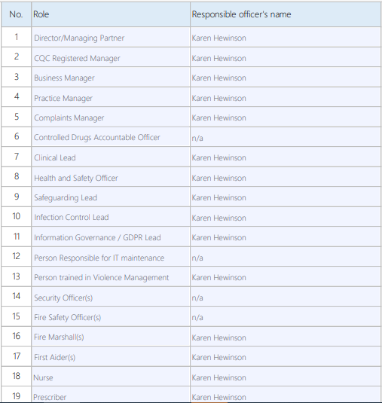

Governance
Policies (available to view in clinic)
Infection Prevention and Control

Data Protection. Information Governance and Records Management

Anaphylaxis Recognition and Management

Medical Devices

Venepuncture, Cannulation and Administration of IV fluids

Clinical Audit

Cold chain

Health and Safety

Manual Handling

Complaints

Safeguarding

Prescribing and Management of Medication Errors

Daily/weekly/monthly checks and Audit (available to view at clinic)
Health and Safety Managers Workplace Audit

Medicines Management

Fire Warden

Cleaning

Stock check (adrenaline)

Cleanliness

Sharps

Temperature monitoring

All above included on a monthly completed ‘RAG’ rated summary

Patient Feedback
Monthly feedback report highlighting:

No. of patients
No of feedback (gained through social media/feedback app)
Response rate (rolling 12 month of data)

No of Positive/negative/unsure ratings

Feedback
Recurrent themes

Action taken from feedback

Risk and Incident
Live risk register

Incident report / serious incident
Reported to (if applicable) eg RIDDOR / yellow card
Investigation
Lessons Learned
Embedding into practice

Accident Book

