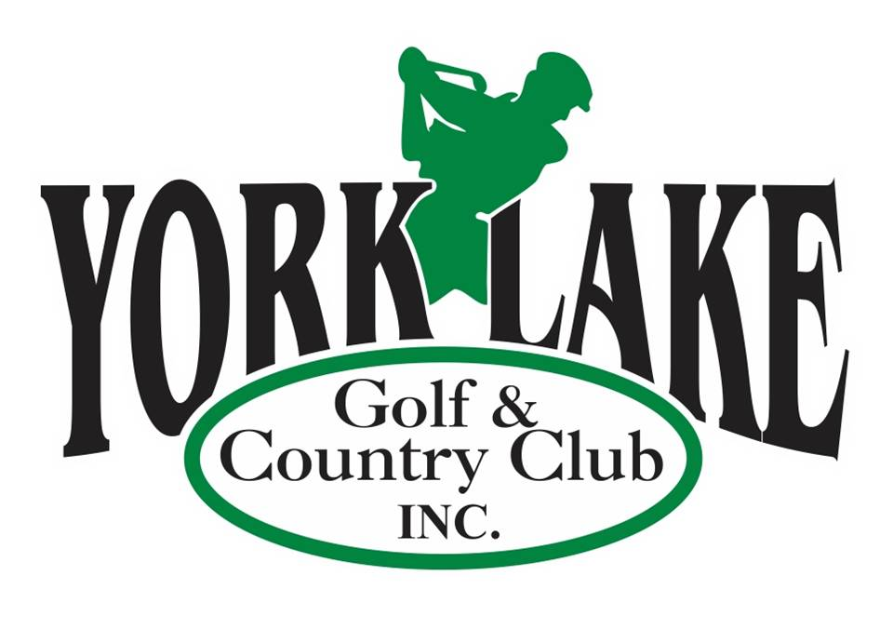
2025 York Lake Golf & Country Club
Tournament Menu Options
(Only one Menu Plan per Tournament or event)
(All Prices are Per Person Plus GST & PST)

Meat Selections Potato Selection

8 oz Striploin Steak $18 Baked Potato $3.00
½ Rack of Ribs $14 French Fries $3.00
Chicken Breast $13

Salad Selections $3.50 Specialty Salads $4.00

Tossed Salad Spinach/Strawberry/Pecans
Cole Slaw Cucumber & Onion
Caesar Salad Cauliflower & Broccoli
Watermelon/Basil
Potato

Vegetable Selections Dessert

Mixed Vegetable $1.50 No Bake Cheesecake $3.00
Corn (Kernel or ½ Cob) $1.50 with Fruit Topping
Carrot Cake $3.00
Pork & Beans $1.50 Butter Tart with Ice Cream $2.50
Baked Beans $2.00 Black Forest Cake $3.00
(with Pineapple & Bacon) Ice Cream Sundae $1.50
with Chocolate Sauce & Fruit

(All Meals served with French Bread & Butter)

Additional Options Additonal Sides

Loaded Burger $10.00 Mushrooms $2.00
Loaded Hot Dog $8.00 Garlic Bread $1.50
Sausage & Perogies $12.00 (Substitute for French Bread)

For a custom Menu please contact the Club House for Prices 306-783-8424
- Gratuity Not Included but is Appreciated–
Events without golf will be an additional charge of $2.00 per plate plus a minimum 10% grauity for groups over 10 people.

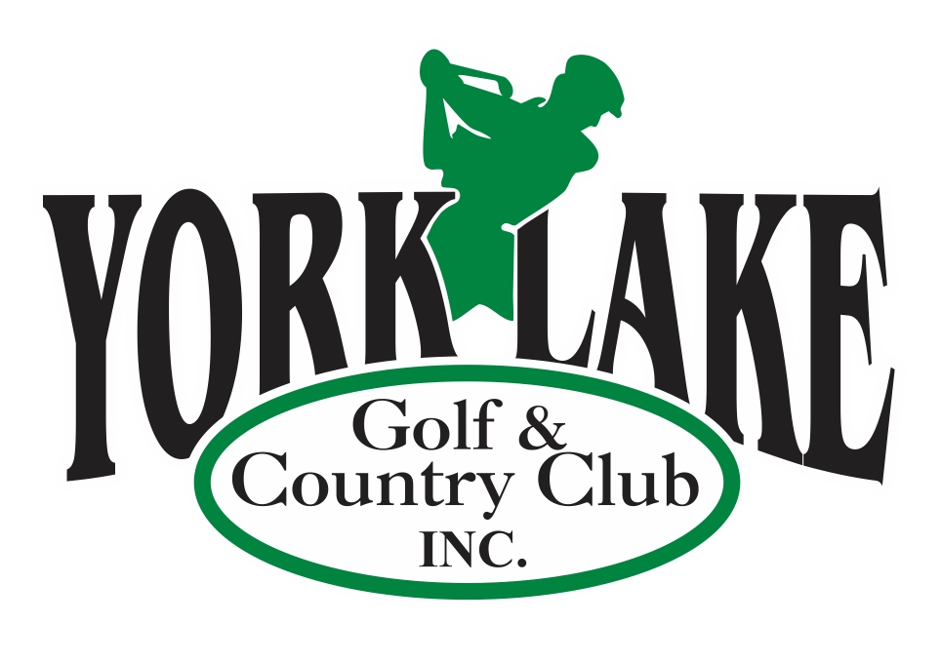

2025 Tournament Prices
(Only one Menu Plan per Tournament or event)
(All Prices are Per Person Plus GST & PST)

Steak Dinner - 8 oz BBQ Steak, Baked Potato, Caesar Salad, Brown Beans, French Bread, Dessert

12 Holes of Golf with ½ Cart $80.00 per person
9 Holes of Golf with ½ Cart $70.00 per person

OR

Chicken Dinner – BBQ Chicken Breast, Baked Potato, Caesar Salad, Brown Beans, French Bread, Dessert

12 Holes of Golf with ½ Cart $75.00 per person
9 Holes of Golf with ½ Cart $65.00 per person

Full Shotgun - 48 Golfers or more
Modified Shotgun (We assign holes) Less than 48 Golfers
Less than 24 golfers - Tee times assigned from Hole 1

