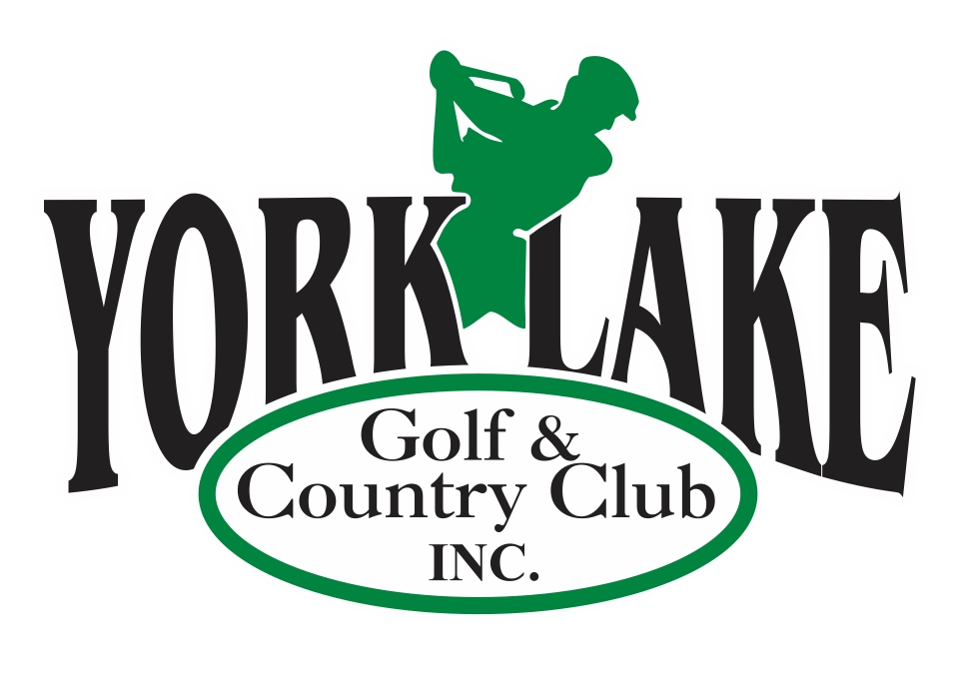
York Lake Golf & Country Club Inc.

GOLF COURSE LABOURER

York Lake Golf & Country Club is seeking a grounds person for the 2025 season. Employment will be from May to October; however actual dates are weather dependent. All employment positions with YLG&CC are probationary for no less than 30 days. This position reports to and is supervised by the Golf Course Superintendent. The ideal candidate will have experience in a variety of tasks in golf course and grounds equipment and maintenance.

Duties will include but may not be limited to:
- Operation of grounds maintenance equipment
- Operation of golf course irrigation
- Maintenance of cart paths and other grounds repair
- Daily golf course set up including changing greens pins, tee markers, etc.
Qualifications:
- Previous golf course work experience is an asset
- Possess and maintain a valid Saskatchewan Class 5 driver’s license
- Self-starter and able to work with minimal supervision
- Be able to work shifts

Term, Salary and Hours of Work:
Seasonal Term: May1st to October 31st 2025
35-40 hours/week, Salary based on experience
Bonus hours are given – typical work time 6:00am to 2:00pm with a paid lunch break

Application:
Please email resume to admin@yorklakegolf.com
While we appreciate your interest, only those candidates considered for the position will be contacted.
Application deadline: April 4, 2025

.

