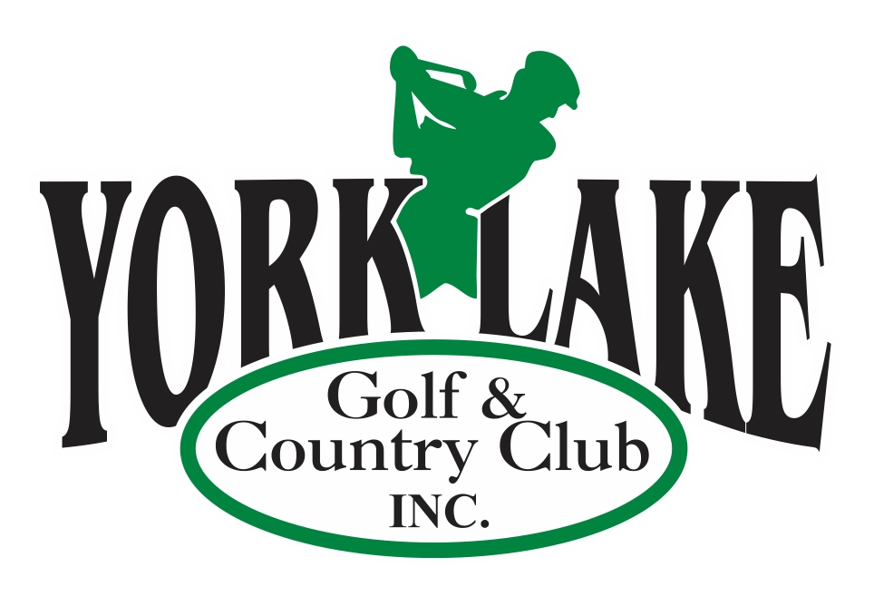

Celebrating 100 years!

York Lake Golf & Country Club has been serving the golf community since May 24, 1926, and is proud of the progress we have made to be able to feature something unique to Yorkton and the surrounding communities. With our 12 Hole Golf course, 12 Hole Footgolf Course, Driving Range, Putting Green, Picnic Area and our Cornerstone Café, we truly have something for everyone.

York Lake is proud to be able to offer a number of Corporate Advertising Packages that can help you promote your business and expand your customer reach.

Along with our ever-growing number of memberships, York Lake Golf & Country Club hosts a large number of corporate and private events which increases your business exposure and allows for greater ROI on your sponsorship investment.

Benefits for your Business when you purchase a Corporate Advertising Package

- Your business name will be prominently displayed on one Hole Sign, Golf Carts and our Corporate Sponsor Board.
- Your logo with hyperlink on the York Lake Golf & Country Club website!
- ‘Golf More for Less’ Advertising and Golf Passes are included in most packages!
- First right to sponsor a York Lake Golf & Country Club event!

2026 Corporate Sponsorship Packages

Premium Package $2500.00
- One Year Large Hole Sign Sponsor on one of the Men’s or Forward Tee Boxes
- Advertising on “24” Power Carts for full year
- Corporate Sponsor Board at Clubhouse for full year
- 20 x 12 Hole Rounds of Golf with ½ Power Cart – Your company logo printed on back of coupon (can use for client promo, Staff appreciation etc.)
- Advertising on York Lake Golf & Country Club web site as Corporate Sponsor with link to your company website

Gold Package $1600.00
- One Year Large Sign Hole Sponsor on one of the Men’s or Forward Tee Boxes
- Advertising on “10” Power Carts for full year
- Corporate Sponsor Board at Clubhouse for full year
- 15 x 12 Hole Rounds of Golf with ½ Power Cart – Your company logo printed on back of coupon (can use for client promo, Staff appreciation etc.)
- Advertising on York Lake Golf & Country Club web site as Corporate Sponsor with link to your company website

Silver Package $1100.00
- One Year Hole Sponsor on one of the Men’s or Forward Tee Boxes (Smaller than Main Sign)
- Advertising on 8 Power Carts for full year
- Corporate Sponsor Board at Clubhouse for full year
- 10 x 12 Hole Rounds of Golf with ½ Power Cart – Your company logo printed on back of coupon (can use for client promo, Staff appreciation etc.)
- Advertising on York Lake Golf & Country Club web site as Corporate Sponsor with link to your company website

Golf More For Less Packages

Golf More for Less $700.00
- One Year Large Sign Hole Sponsor on one of the Men’s or Forward Tee Boxes
2. 8 x 12 Hole Rounds of Golf with Power Cart – Your company logo printed on back of coupon (can use for client promo, Staff appreciation etc.)

Golf More for Less $600.00
- One Year Hole Sponsor on one of the Men’s or Forward Tee Boxes (Smaller than Main Sign)
- Advertising on “4” Power Carts for full year
- 8 x 12 Hole Rounds of Golf with ½ Power Cart – Your company logo printed on back of coupon (can use for client promo, Staff appreciation etc.)

Golf More for Less $500.00
- One Year Hole Sponsor on one of the Men’s or Forward Tee Boxes (Smaller than Main Sign)
- 8 x 12 Hole Rounds of Golf with ½ Power Cart – Your company logo printed on back of coupon (can use for client promo, Staff appreciation etc.)

Hole Sign Only $300.00/$100.00
1. One Year Hole Sponsor on one of the Men’s or Forward Tee Boxes
Large Sign - $300 or Small Sign $100 – First year Add $25 for production of signage

We also have many options for Staff and Customer Appreciation Parties, including options to combine conventional and foot golf along with fantastic meal packages. Contact us at admin@yorklakegolf.com for more information.

Thank you for your business!
Golf York Lake! Where good things are happening!!!!
