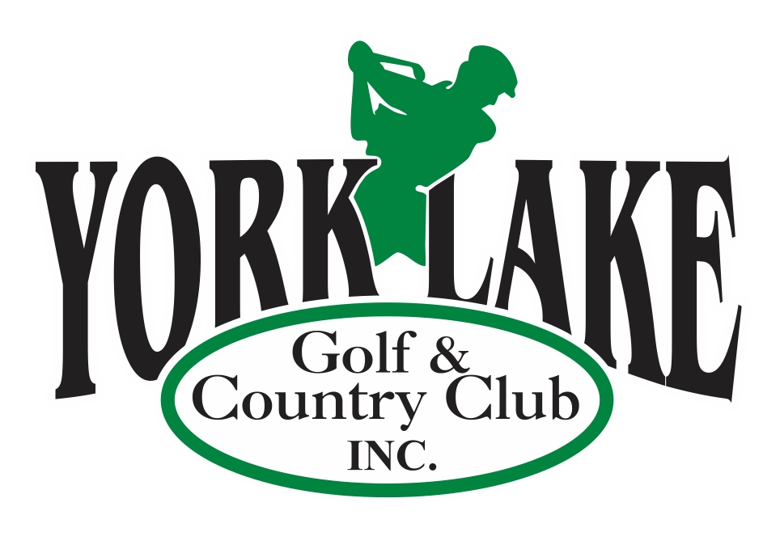
York Lake Golf & Country Club Inc.

EXPERIENCED GOLF COURSE LABOURER

York Lake Golf & Country Club is seeking a qualified grounds person for the 2023 season. Employment will be from May to October; however actual dates are weather dependent. All employment positions with YLG&CC are probationary for no less than 90 days. This position reports to and is supervised by the Golf Course Superintendent. The ideal candidate will have experience in a variety of tasks in golf course and grounds equipment and maintenance.

Duties will include but may not be limited to:
- Operation of grounds maintenance equipment
- Operation of golf course irrigation and repair of same
- Maintenance of cart paths and other grounds repair
- Daily golf course set up including changing greens pins, tee markers, etc.

Qualifications:
- Previous golf course work experience is an asset
- Possess and maintain a valid Saskatchewan Class 5 driver’s license
- Self-starter and able to work with minimal supervision
- Be able to work shifts - days, evenings, weekends and holidays

Term, Salary and Hours of Work:
Seasonal Term: May1st to October 2023
35 -40 hours/week at $14.00 - $15/hour depending on experience

Application:
Please email resume to admin@yorklakegolf.com. While we appreciate your interest, only those candidates considered for the position will be contacted.
Application deadline: March 1, 2023

.

