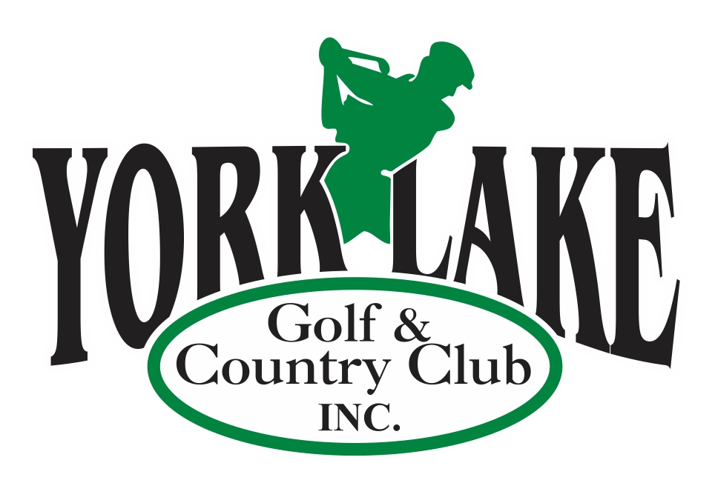

YorkLake Golf & Country Club
Job Posting
Kitchen & Pro-Shop Associate

York Lake Golf & Country Club is accepting applications for qualified individuals to assist with Clubhouse operations for the 2023 season. Preference will be given to individuals 19 years of age or older. Employment will be from May until October but is weather dependent. This position will be supervised and scheduled by the Clubhouse Manager. Sask Liquor and Gaming (SIRS) is a requirement and Safe Food Handling is an asset. Must be willing and able to work evenings and weekends. Access to transportation is required as York Lake is outside of city limits. All positions at YLG&CC are probationary for no less than 90 days

Duties include but are not limited to:
- Performing all aspects of Clubhouse and daily operation including, answering and directing phone calls, reserving tee times, collecting fees, taking memberships, cart rentals etc.
- Operating the Till while ensuring balancing and accuracy of reports
- Cleaning and Sanitizing (tables, bathrooms, rental equipment etc.)
- Food and Beverage service, clearing tables, stocking and cleanup
- Assisting with basic food prep including fast food items and sandwiches

Term, Salary and Work Hours
Seasonal Term – May 1st to October 2023 (negotiable for Students)
35 – 40 hours per week at $13 - $14 per hour based on exp

Application

Please email your resume to admin@yorklakegolf.com. While we appreciate your interest, only those candidates considered for the position will be contacted.
Application deadline: March 1, 2023

