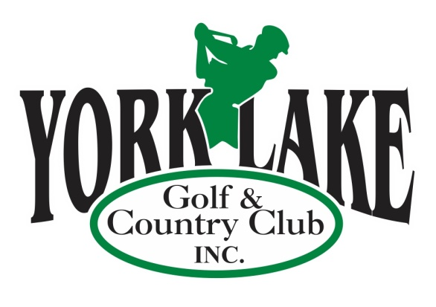
  - Serving the Community for Over 90 Years

York Lake Golf & Country Club is embarking on an exciting new season and we would love for you to be there with us. York Lake has been serving the golf community since May 24, 1926, and in 2019 we will set our mark as the communities first 12 Hole Golf course. Our three new holes are set to open this Spring, and with the combination of our 12 Hole golf course and our 12 Hole Footgolf Course we are continuing to provide unique activities to Yorkton and the surrounding communities. We also have exciting news about an upgrade to our kitchen that we can’t wait to share early this spring.

In 2018 York Lake patrons carded over 8000 rounds. That is how many times someone passes each Hole sign and most riding a golf cart bearing our Advertisers logos.
What better way to promote your business and expand your customer reach than by taking advantage of one of our many Corporate Advertising Packages which include those and many more benefits.

Benefits for your Business when you purchase a Corporate Sponsorship Package

- Your business name will be prominently displayed on the Golf Carts and the Corporate Sponsor Board on the York Lake Golf & Country Club website and in the Clubhouse!
- Your logo with hyperlink on the York Lake Golf & Country Club website!
- ‘Golf More for Less’ Advertising and Golf Passes are included in every package!

2019 Corporate Sponsorship Packages
Premium Package $2500.00
- One Year Large Hole Sign Sponsor on one of the Men’s or Forward Tee Boxes
- Advertising on 8 Power Carts for full year
- Corporate Sponsor Board at Clubhouse for full year
- 30 x 12 Hole Rounds of Golf with ½ Power Cart – Your company logo printed on back of coupon (Can use for client promo, Staff appreciation or other in 2019) (or 25 x 12 Hole Rounds with Full Power cart)
- Advertising on York Lake Golf & Country Club Web site as Corporate sponsor with link to your company website
7. Hole Sponsor Advertising at all York Lake sponsored Tournaments

-2-

Platinum Package $2000.00
- One Year Large Sign Hole Sponsor on one of the Men’s or Forward Tee Boxes
- Advertising on 8 Power Carts for full year
- Corporate Sponsor Borad at Clubhouse for full year
- 25 x 12 Hole Rounds of Golf with ½ Power Cart – Your company logo printed on back of coupon (Can use for client promo, Staff appreciation or other in 2018) (or 20 x 12 Hole Rounds with Full Power Cart)
- Advertising on York Lake Golf & Country Club Web site as Corporate sponsor with link to your company website
- Hole Sponsor Advertising at one of the York Lake sponsored Tournaments (Pairs, Ladies, Seniors)

Gold Package $1600.00
- One Year Large Sign Hole Sponsor on one of the Men’s or Forward Tee Boxes
- Advertising on 8 Power Carts for full year
- Corporate Sponsor Board at Clubhouse for full year
- 20 x 12 Hole Rounds of Golf with Power Cart – Your company logo printed on back of coupon (Can use for client promo, Staff appreciation or other in 2018) (or 15 x 12 hole Rounds with Full Power Cart)
- Advertising on York Lake Golf & Country Club Web site as Corporate sponsor with link to your company website

Silver Package $1200.00
- One Year Hole Sponsor on one of the Men’s or Forward Tee Boxes (Smaller than Main Sign)
- Advertising on 8 Power Carts for full year
- 18 x 12 Hole Rounds of Golf with Power Cart – Your company logo printed on back of coupon (Can use for client promo, Staff appreciation or other in 2018) (or 14 x 12 Hole Rounds with Full Power Cart)
- Advertising on York Lake Web site as Corporate sponsor with link to your company website

Bronze Package $1100.00
- One Year Hole Sponsor on one of the Men’s or Forward Tee Boxes (Smaller than Main Sign)
- Advertising on 8 Power Carts for full year (Approx. 4” x 4”)
- 15 x 12 Hole Rounds of Golf with ½ Power Cart – Your company logo printed on back of coupon (Can use for client promo, Staff appreciation or other in 2018) or (11 x 12 Hole Rounds with Full Power Cart)
- Advertising on York Lake Web site as Corporate sponsor with link to your company website

Would you rather have more Cart Advertising or more Golf Passes – Ask us to create a package that is right for you!
We also have many options for Staff Parties, including options to combine conventional and foot golf along with fantastic meal packages. Contact us at finance@yorklakegolf.com for more information.

Thank you for your business!
Golf York Lake! Where good things are happening!!!!

