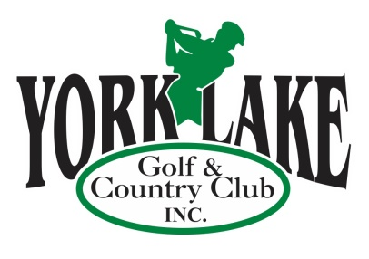

Serving the Community for Over 90 Years

**2019**

**‘GOLF MORE FOR LESS’**

**ADVERTISING PROMOTION**

2019 will be an exciting year for the York Lake Golf Course and golf enthusiasts alike. This Spring our 3 new holes are scheduled to open, making York Lake the first 12 Hole Golf Course in the Community. 12 Holes are proving to be very popular following the success of the Greenbryre Golf Course in Saskatoon. So many individuals find that 9 Holes are not enough, yet don’t have the time or the stamina for 18 Holes. We are excited to be filling that niche in Yorkton and would like to offer you the chance to ***take advantage of our best deal of the year!***

What better way to promote your business and expand your customer reach than by utilizing our **‘Golf More for Less’ Advertising and Golf Passes** at York Lake Golf & Country Club from **t**he **Season Opening in May 2019** to **Season Closing in October 2019.** This is also a great opportunity to show your appreciation or say thank you to your VIP’s, staff, customers or vendors! These Passes have great value……offering more than 20% discount on your golf.

Each **‘Golf More for Less’ Advertising and Golf Pass** has York Lake Golf and Country Club on the front and your Business Logo and Name on the back.

Order now and be ready for the **Season Opening!!!**

**One 12 – Hole Round with 1/2 Power Cart $35.00**

**One 12 – Hole Round with Full Power Cart $45.00**

**\*Minimum order of 10 passes\***

Call **Donna** at **306.621.5694** or Email: [**finance@yorklakegolf.com**](mailto:finance@yorklakegolf.com) to purchase your **‘Golf More for Less’ Advertising and Golf Passes.**

-2-

**‘GOLF MORE FOR LESS …. PLUS’**

**ADVERTISING PROMOTION**

For even higher exposure, consider adding a **Hole Sign Sponsorship**. Your advertisement will be displayed on one of our 12 Hole Yardage signs for **the entire year**. (See samples attached)

In 2018, York Lake patrons carded over 8000 rounds. That is how many times someone passes each Hole sign, providing great exposure for your business.

**Large Sign (2’ x 6’) Sign Only $325 Year one, $300 subsequent Renewal**

**2019 Signage with 10 Passes (1/2 cart) $675.00 $650**

**2019 Signage with 10 Passes (full cart) $775.00 $750**

**Small Sign ( approx. 20” x 4”) Sign Only $125 Year one, $100 subsequent Renewal**

**2019 Signage with 10 Passes (1/2 cart) $475.00 $450**

**2019 Signage with 10 Passes (full cart) $575.00 $550**

Each **‘Golf More for Less’ Advertising and Golf Pass** has York Lake Golf and Country Club on the front and your Business Logo and name on the back.

**Advertising and Golf Passes @ $35 x ______ = $________**

**Advertising and Golf Passes @ $45 x ______ = $________**

**Large Hole Sign** (yr 1/renewal) **= $________**

**Small Hole Sign** (yr 1/renewal) **= $________**

***Please make cheque payable to York Lake Golf & Country Club Inc. or request***

***Invoice to: ____________________________________________ __________________________________________***

***Business Name Business Address***

________________________________ _______________________ ___________________

**Signature Phone/Cell # Date**

________________________________

**E-Mail**

***Looking for options for Staff Parties: Customize your party by combining conventional and foot golf, along with one of our fantastic meal packages. Contact us at*** [***finance@yorklakegolf.com***](mailto:finance@yorklakegolf.com) ***for more information.***

**Thank you for your business!**

Hole Sponsor Advertising Samples

**Large Hole Sponsor Sign**

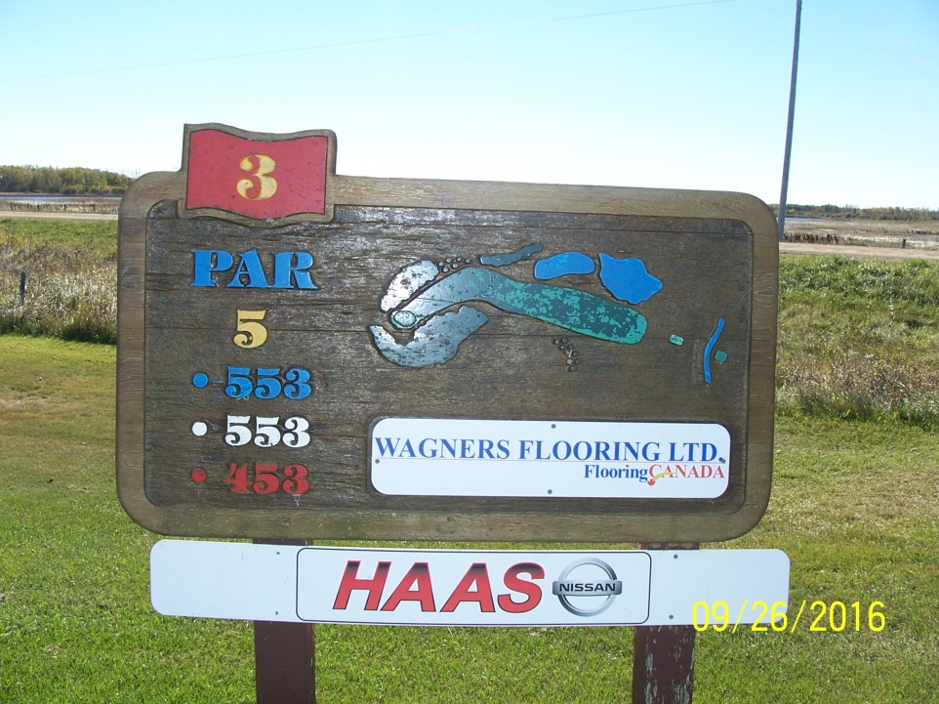

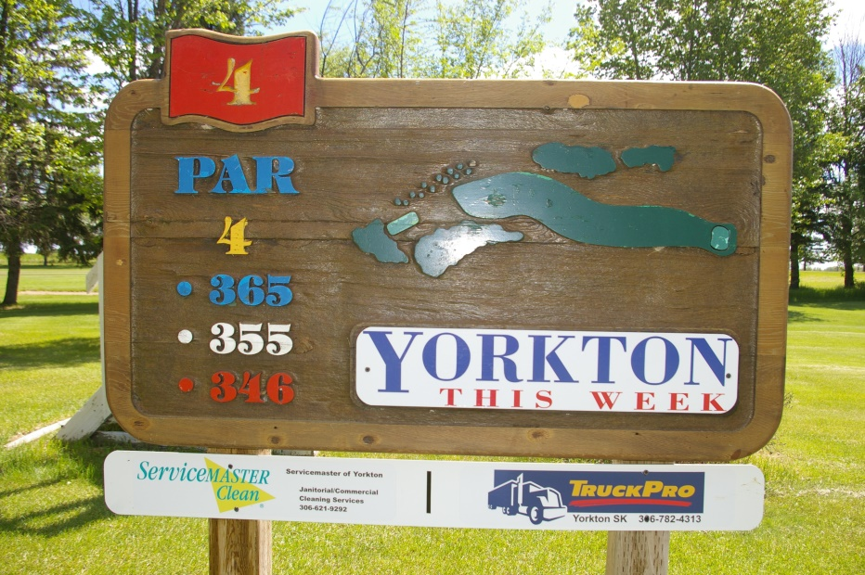

**Small Hole Sponsor Sign**