  - 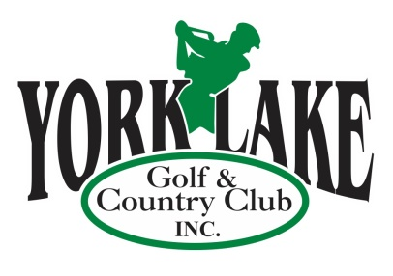
  - Serving the Community for Over 90 Years

‘GOLF MORE FOR LESS’
ADVERTISING PROMOTION

What better way to promote your business and expand your customer reach than by utilizing our ‘Golf More for Less’ Advertising and Golf Passes at York Lake Golf & Country Club from the Season Opening in April to Season Closing in early October. This is also a great opportunity to show your appreciation or say thank you to your VIP’s, staff, customers or vendors! These Passes have great value……offering more than 20% discount on your golf.

Each ‘Golf More for Less’ Advertising and Golf Pass has York Lake Golf and Country Club on the front and your Business Logo and Name on the back.

Order now and be ready for the Season Opening!!!

One 12 – Hole Round with 1/2 Power Cart $35.00
One 12 – Hole Round with Full Power Cart $45.00
*Minimum order of 10 passes*

Call Donna at 306.621.5694 or Email: finance@yorklakegolf.com to purchase your ‘Golf More for Less’ Advertising and Golf Passes.

-2-

‘GOLF MORE FOR LESS …. PLUS’
ADVERTISING PROMOTION

For even higher exposure, consider adding a Hole Sign Sponsorship. Your advertisement will be displayed on one of our 12 Hole Yardage signs for the entire year. (See samples attached)
York Lake patrons average over 8000 rounds annually. That is how many times someone passes each Hole sign, providing great exposure for your business.

Large Sign (2’ x 6’) Sign Only $325 Year one, $300 subsequent Renewal
2019 Signage with 10 Passes (1/2 cart) $675.00 $650
2019 Signage with 10 Passes (full cart) $775.00 $750

Small Sign ( approx. 20” x 4”) Sign Only $125 Year one, $100 subsequent Renewal
2019 Signage with 10 Passes (1/2 cart) $475.00 $450
2019 Signage with 10 Passes (full cart) $575.00 $550

Each ‘Golf More for Less’ Advertising and Golf Pass has York Lake Golf and Country Club on the front and your Business Logo and name on the back.

Advertising and Golf Passes @ $35 x ______ = $________

Advertising and Golf Passes @ $45 x ______ = $________

Large Hole Sign (yr 1/renewal) = $________

Small Hole Sign (yr 1/renewal) = $________

Please make cheque payable to York Lake Golf & Country Club Inc. or request

Invoice to: ____________________________________________ __________________________________________
Business Name Business Address

________________________________ _______________________ ___________________
Signature Phone/Cell # Date

________________________________
E-Mail

Looking for options for Staff Parties: Customize your party by combining conventional and foot golf, along with one of our fantastic meal packages. Contact us at finance@yorklakegolf.com for more information.

Thank you for your business!
Hole Sponsor Advertising Samples

Large Hole Sponsor Sign

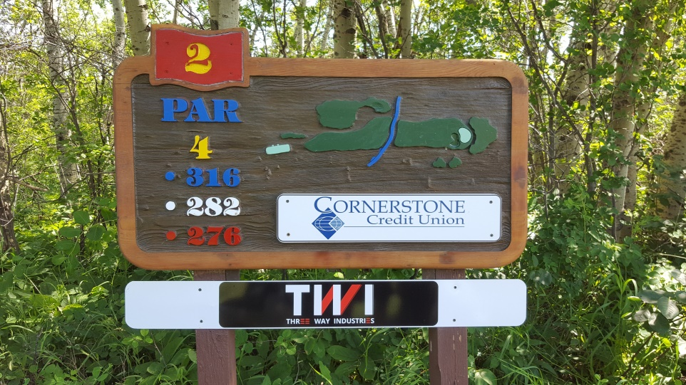

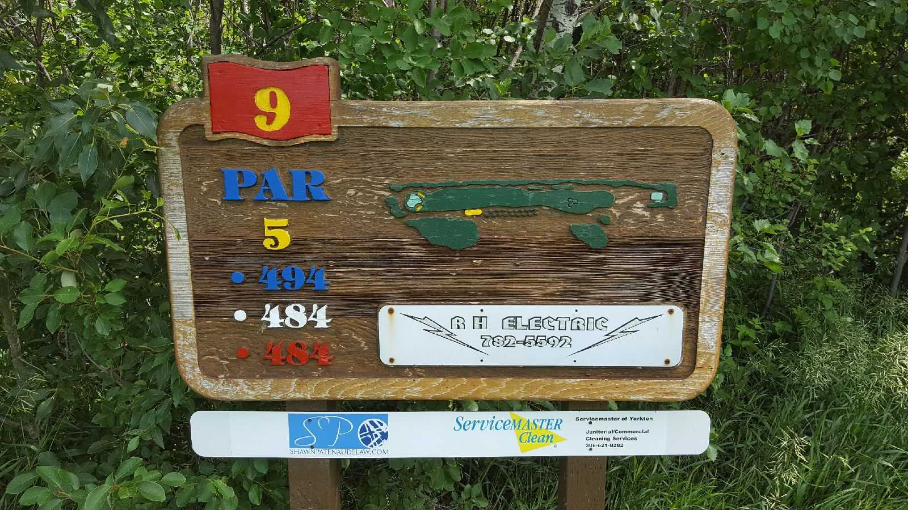
Small Hole Sponsor Sign

