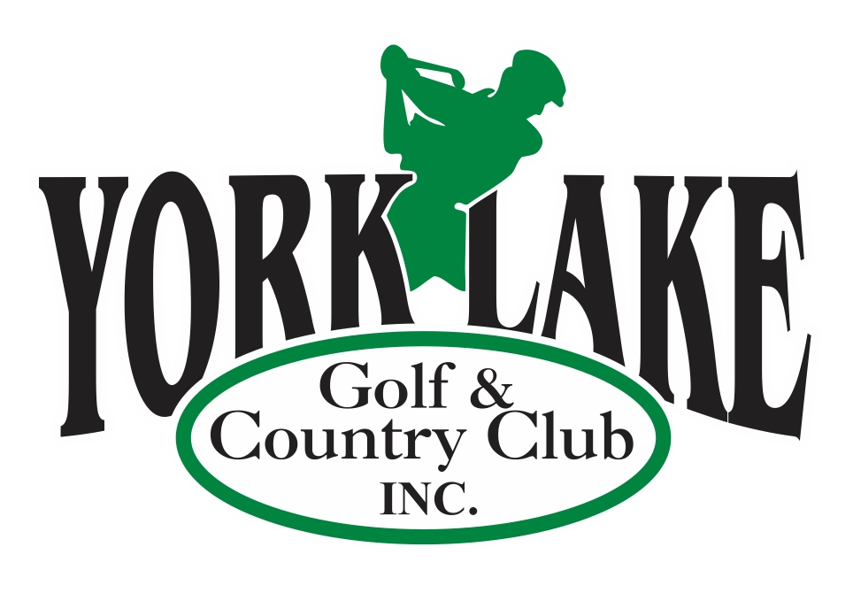
York Lake Golf & Country Club
Tournament/Event Menu Options
(Only one Menu Plan per Tournament or event)
(All Prices are Per Person )

Meat Selections: Potato Selection

8 oz Striploin Steak $12 Baked Potato $2.00
½ Rack of Ribs $10 Rice $2.00
Chicken Breast $9 French Fries $3.00
Potato Salad $3.00

Salad Selections: $3.00 Specialty Salads $3.50

Tossed Salad Spinach/Strawberry/Pecans
Cole Slaw Cucumber & Onion
Caesar Salad Cauliflower & Broccoli
Greek Salad
Watermelon/Basil

Vegetable Selections: Dessert

Mixed Vegetable $1.50 No Bake Cheesecake $3.00
Corn (Kernel or ½ Cob) $1.50 Black Forest Cake $3.00
Pork & Beans $1.50 (with Vanilla Bean Sauce)
Baked Beans $2.00 Skor Cake $3.00
(with Pineapple & Bacon) Ice Cream Sundae $1.50

Additional Options Additonal Sides:

Loaded Burger or HotDog Mushrooms $2.00
Home Made French Fries
Or Potato Salad Garlic Toast $1.00
$12.00 / $10.00

Perogies with Butter and Onions
Smokies/Sauerkraut
$12.00

For a custom Menu please contact the Club House for Prices -306-783-8424

*** All Prices – Plus GST & PST
Gratuity Not Included

