MPG e-Wallet Setup Instructions – 4 Dec. 24

Connecting MPG with your Bank for Transfers
Start in your Back Office Home Page.
To start the set up of your e-Wallet  Go to your Back Office Home Page.  Locate the MPG E-Wallet widget icon and click the go to details button.  If the button does not work you might have to allow the POP-UP WINDOW option in your browser settings or use a different browser. | 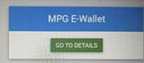
For some ppl: Two Factor Authentication  Depending on settings you may be asked for Two Factor authentication: | 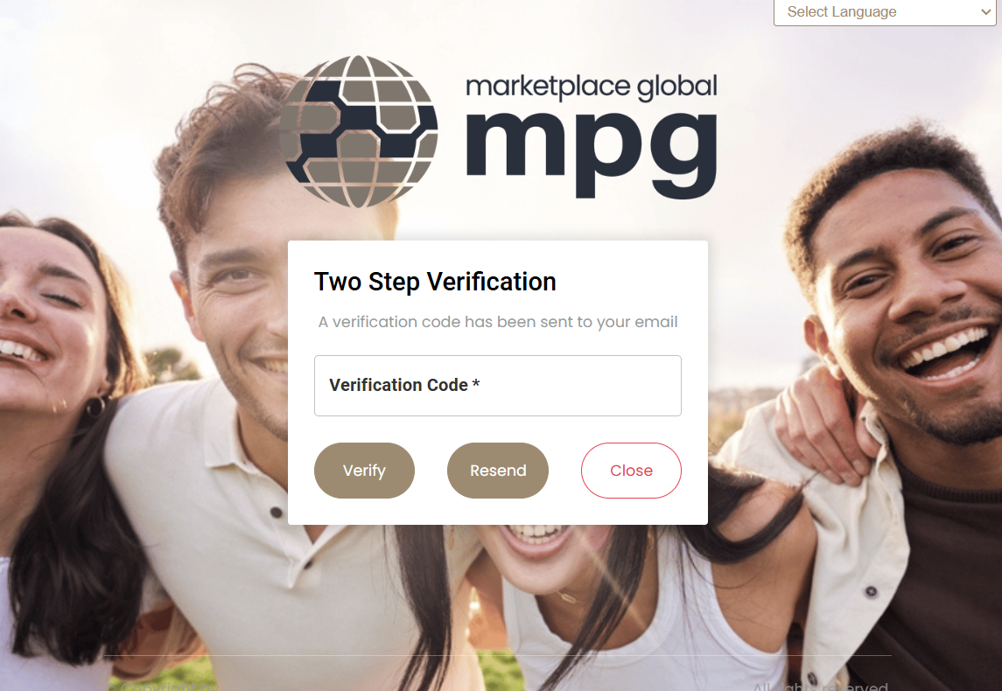
You will be asked to set up a new password. Please write down the password and keep it in a secure place.  Notes:  Two factor email if needed will be sent is to the email address provided to the phix company.  Email is from: ‘Paymenture’  https://mpg.paymenture.com/dashboard | 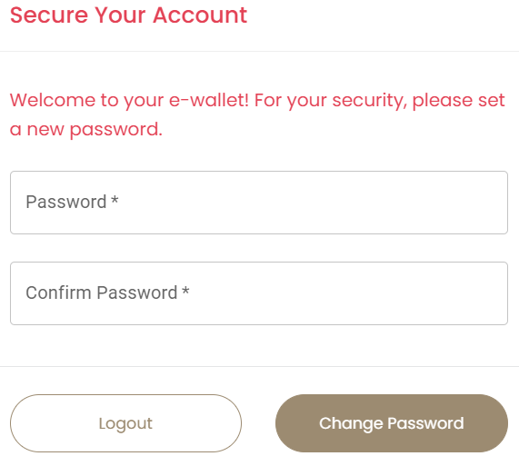
Your wallet account won’t be created until you have received your first commission payment, but you can set up your crypto or bank account you want your payments to be transferred to. | 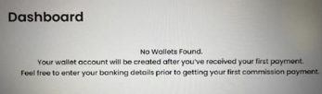
To set up your bank account for transfers out of your wallet go to BANKS logo / tab. | 
Bank Account  On the BANKS tab.  Enter  Account Holder Name  and select:  Destination Bank Country: (drop down list)  Currency: $ etc (Auto fills)  Method of Payment: Wire or iACH  Choose iACH ($3 transfer fee) or WIRE ($15 transfer fee). It’s recommended to use iACH. Click NEXT | 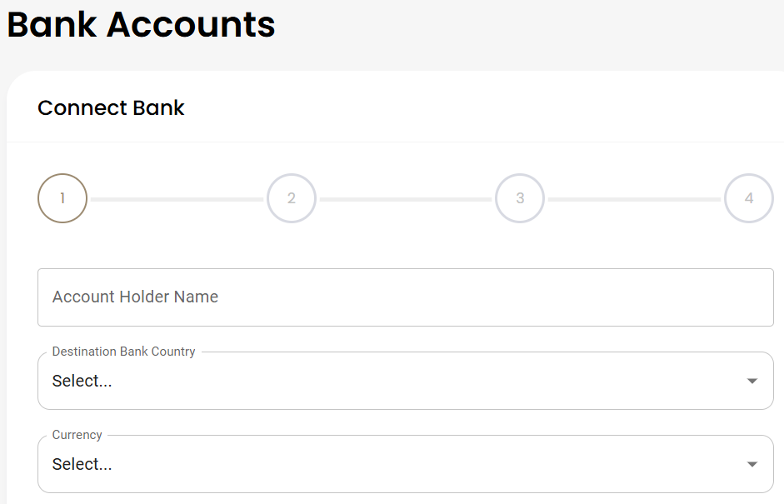
Personal Address  Enter your personal address. PO Box is not allowed. Click NEXT. | Enter your personal address. PO Box is not allowed.
Bank Accounts Screen  Connect Bank 1.  In ABA/Routing number, bank name/address window type your BSB number (without the dash) and click the search icon.  Your bank name should appear, if it’s correct Select the bank branch.  (Type in the BSB number)  Press SELECT | 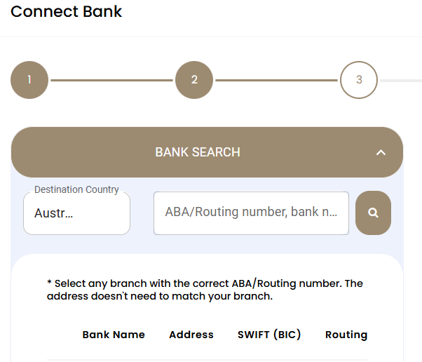
Bank Accounts Screen  2. Bank Search Screen  Confirm your account number (iACH)  Re-enter in next box  Press NEXT | 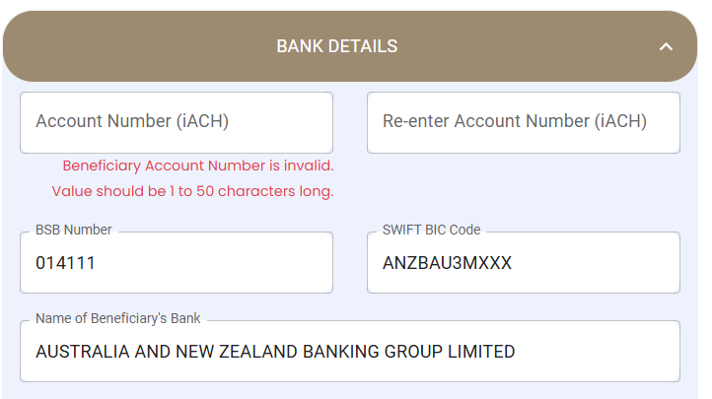
Bank Accounts Screen  3. Payment Confirmation Screen  Enter your email address  Tick the box Send Pay Tracker if you want to receive email notifications about your transfer.  Add extra email accounts if you wish  Tick the ‘I Confirm ...’ box  Press Submit | 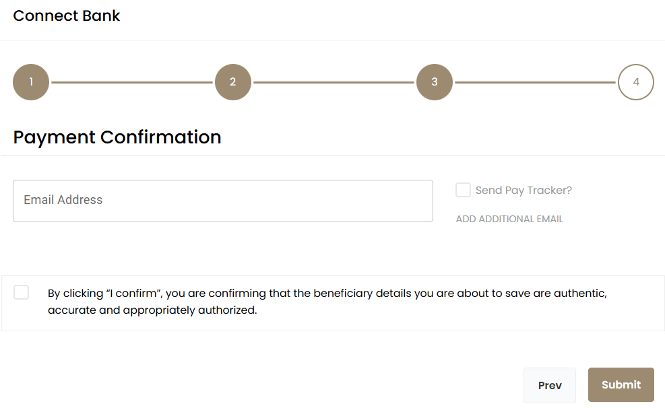
Bank is set up: You now have a confirmation screen showing details

To transfer money  From your e-wallet to your bank account go to the WALLETS icon and tab. | 
You will see your e-wallet balance.  Scroll down past PSP Transfer  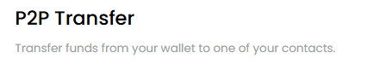 | 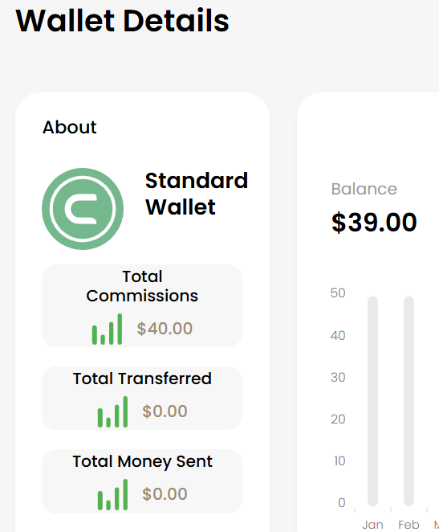
Scroll down to BANK TRANSFER.  Click  To Account: (drop down shows your banks(s))  Amount: type $ amount  Fees: show iACH ($3 transfer fee) or WIRE ($15 transfer fee).  Total: (to appear in your bank)  Click TRANSFER NOW | 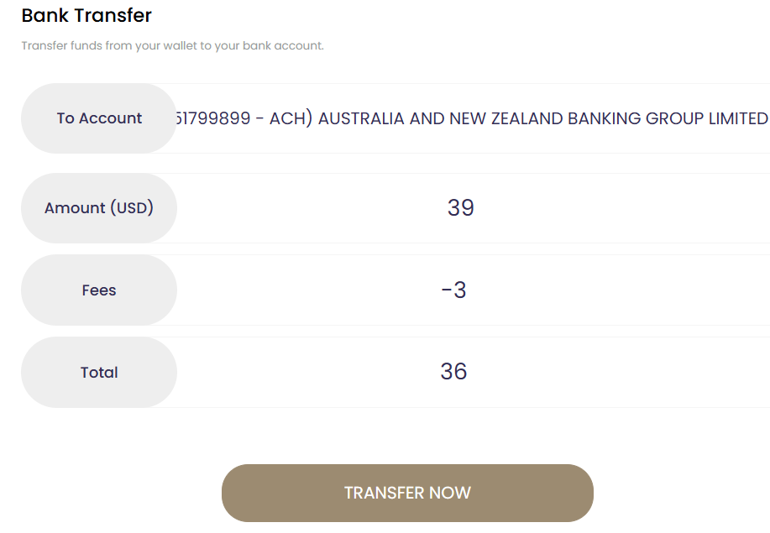
Confirmation Pop up | 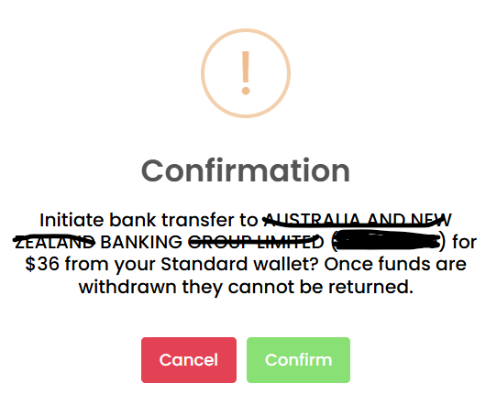
If you have Tow Factor set up  you will be asked for this step | 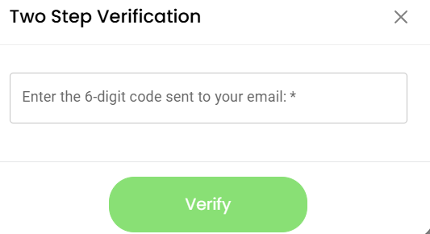
The funds should appear in your bank account within a day or two. | Success Screen
SUPPORT:  Please note for any E-Wallet related issues contact E-Wallet SUPPORT team NOT the MPG main support. The team is accessible via the Support icon in the left-hand side menu.  Search FAQ or submit a ticket. |   