**PHIX in other countries (besides Australia).**

November 18th 2024.

1. **What other countries is Phix available in?**

You can view which countries Phis is available in by checking the MPG website xtremempg.com/YOUR-USER-NAME. Check the country flag in the right top hand corner.

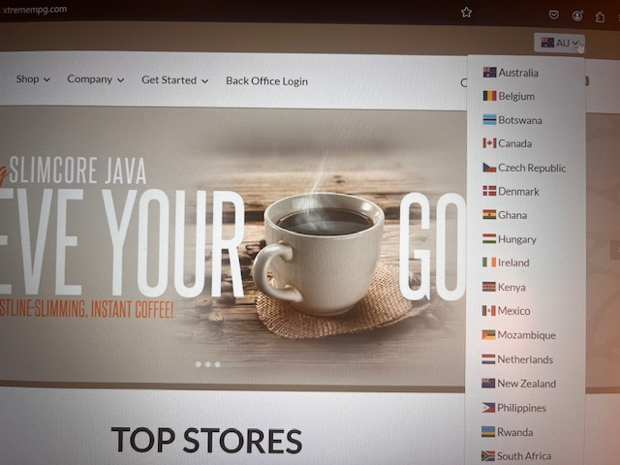

Some of the countries listed do not have Phix available for sale as yet. However, you can sign up as a member of MPG and purchase other products their offer to secure a position in that country. When pHix is available over there, you will be ablet to purchase it and sell it to others.

As of 13 Nov 2024 the countries MPG is available in but not able to sell Phix yet are:

* Belgium
* Czech Republic
* Denmark
* Ghana
* Hungary
* Irland
* Keyna
* Mexico
* Mozambique
* Netherlands
* Philippines
* Rwanda
* Tanzania
* Uganda
* Zambia

1. **Countries open to purchase pHix (prices and packs might differ to the Australian ones).**

|  |
| --- |
| **Australia**  Business Fee $9.95 USD  Enrolment Kits: $199.95 |
| **Botswana & South Africa**  Business Fee $9.95 USD  Enrolment Kits  $99.95(30) & $199.95(60) USD |
| **Canada & USA**  Business Fee  $29.95 USD  Enrolment Kits  $199.95 USD  Customer sign-ups are available in those two countries. See instructions in Step 3. |
| **Philippines**  Business Fee  $9.95 USD  Enrolment Kits  $99.95(30) & $199.95(60) USD |
| **NZ**  Business Fee  $9.95 USD  Enrolment Kits  $99.95(30) & $199.95(60) USD |
| **UK**  Business Fee  $29.95 USD  Enrolment Kits  $169.95 USD |
| **All prices don’t include tax or postage cost.** |

1. **How to crate sale link to the above countries.**

Log in to MPG website xtremempg.com/YOUR-USER-NAME. Or go to xtremempg.com and log in with your username and password (DO NOT LOGIN INTO YOUR BACK OFFICE!).

**To sign up ISR:**

Choose the country from the drop-down flag menu in the top right-hand corner (see Step 1). Go to Get Started option in Menu and choose Start with pHix.

Copy the URL and send to your client.

**To sign up a Customer (US and Canada):**

Choose the country from the drop-down flag menu in the top right-hand corner (see Step 1). Go to Customer Shopping option in Menu. Choose Order pHix option. Follow the steps.

Copy the URL and send to your client.