COMPENSATION PLAN OVERVIEW
  - COMPENSATION PLAN BASICS (13 Slides)
FREE REGISTRATION:  Eligible to earn from 3 levels in the unilevel plan.  RANK ADVANCEMENT UNLOCKS MORE LEVELS:  Difference Maker: Earn from 5 levels  Winner: Earn from 10 levels  Leader: Earn from 15 levels | UNILEVEL COMMISSION EXAMPLE:  20% of node earnings and 50% of service fees go into the plan  Example: $10 Node earning → S2 in plan → You earn 10% of $2 = $0.20 | TRANSACTION FEES:  50% of service fees (like card usage) are commissionable  Example: S3 fee (Cost $1) Commissionable Fee S2→ $1 plan (50%) if earning from 9th level at 10% = $0.10  ADDITIONAL SERVICES:  New services will contribute to the 15-level unilevel plan

  - UNLOCK YOUR POTENTIAL
HIGHER RANKS UNLOCK MORE EARNINGS IN THE 15 LEVEL PAYOUT PLAN
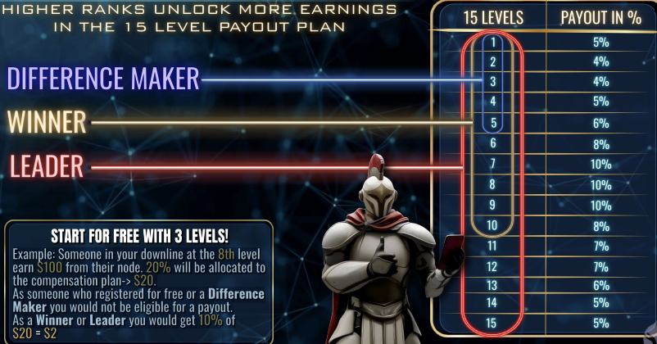
Start for Free with 3 Levels:
Example: Someone in your downline at the 8th level earn $100 from their node. 20% will be allocated to the compensation plan-> $20. As someone who registered for free or a Difference Maker you would not be eligible for a payout.
As a Winner or Leader you would get 10% of $20 = $2.

  - FIVE WAYS TO EARN
- 15-Level Pay Plan: Earn from daily node earnings and services
- Direct Commission: Based on product pricing and point values
- Team Binary Profit: Paid on lesser volume leg
- Matching Bonuses: Earn from referrals' binary profits
- Rank Advancement Bonuses

  - 2. DIRECT COMMISSIONS
1 CPU NODE: $225 | 3 CPU NODES: $700 | 5 CPU NODES: $1,175
7 CPU NODES: $1,715 | 10 CPU NODES: $2,480 | 25 CPU NODES: $6,275
 | 50 CPU NODES: $12,750

BINARY BASE POINTS | BINARY PROFITS Lesser Leg | Ways to Increase Binary Profit
Full Node: 400 BP  Mini Node: 200 BP  3-Pack: 1,200 BP (3 X 400)  7-Pack: 2,800 BP (7 X 400) | Starts at 10% | Personal Sales Volume  12%: $10,000  14%: $20,000  16%: $30,000  18%: $40,000 20%: $50,000
EXAMPLE SALE PSV $30,000 | TEAM SALES | EX: PSV $30,000 | TO EARN BINARY PROFIT
3-Pack (1,200 ВP)  Direct: $700  Binary (16% of 1,200 BP): $192  Total: $892 | 2 Sales = 2,400 ВР  16% Binary Profit = $384 | Must achieve Difference Maker Rank  Higher daily caps require higher rank

  - RANK QUALIFICATIONS & DAILY CAPS
DIFFERENCE MAKER | $100 Cap | Buy $1,200 Node package (OR SELL 4)  One Full Node sold on each leg, not self-purchased (OR SELL 4)
WINNER | $200 Daily Cap | Personally sponsor 3 Difference Makers
LEADER | $1,000 Daily Cap | 3 Winners in 3 separate legs
CHAMPION | $5,000 Daily Cap | 3 Leaders in 3 separate legs
LEGEND | $25,000 Daily Cap | 3 Champions in 3 separate legs

  - CHECK MATCHING BONUS
CONDITION 1: Rank-Based Matching % | CONDITION 2: Node-Based Matching Cap
Difference Maker: 5% | 1 Node: Up to 15%
Winner: 10% | 3-Pack: Up to 20%
Leader: 15% | 7-Pack: Up to 25%
Champion: 20%
Legend: 25%
EXAMPLE:
Legend with 7 Nodes: Referral earns $10,000 → $2,500 (25%)
Legend with 1 Node: $1,500 (15%)

  - FREE START & PROGRESSION
- Register free and earn 3 levels deep
- Sell and earn direct commissions
- Sell 4 nodes to four people and go active (COMING SOON)
- Others refer others and you earn binary profit

  - BELLATOR FARM COMPENSATION PLAN
The Bellator Farm Program is a stepping stone into Bellator Life, offering a low-entry opportunity to build income, earn rewards, and work toward full participation in the Bellator ecosystem.
DIRECT SALES COMMISSION  $99 SuperMini Node.  $25 Direct Commission  Paid immediately to the referring affiliate  Node pays 1/14 of the full node payout | FARM POINTS (FP)  Each sale generates 33 FP Used for binary structure and rank tracking
BINARY BONUS  6% on weaker leg volume $1.98 binary commission per $99 sale | DAILY BINARY PROFIT CAP  Max daily binary payout: starting at $25  Increase daily payout Cap (coming soon)  Excess does not roll over | AUTOMATED SAVINGS FOR BELLATOR LIFE  25% of commissions go into Savings Wallet  Applied toward $1,200 Bellator Life package

  - BELLATOR FARM PAYOUT SUMMARY
This system enables global accessibility and progression, supporting members at every stage of their Bellator journey. | - Product Price: $99  - Direct Commission: $25  - Farm Points (FP): 33  - Binary Profit 6%: $1.98 on a $99 sale (After one personal sale on the right and one of the left)  - Savings Wallet: $24.75 (25%)  - Daily Binary Cap: S25/day  - Farmers Earn 2.5% of Bellator Life CPU Node sale

  - CARD SALE COMPENSATION PLAN DIRECT
INTERNATIONAL FINTECH FINANCIAL BUSINESS
$99 CARD  DIRECT - $22  LEVEL 2 - $7  LEVEL 3 - $6  LEVEL 4 - S5  LEVEL 5 - $4  LEVEL 6 - $3  LEVEL 7- S3 | $450 CARD  DIRECT - $75  LEVEL 2 - $24  LEVEL 3 - $20  LEVEL 4 - S17  LEVEL 5- $14  LEVEL 6 - $10  LEVEL 7- $10 | $550 CARD  DIRECT - $96  LEVEL 2 - $30  LEVEL 3 - $26  LEVEL 4 - $22  LEVEL 5- $18  LEVEL 6 - $14  LEVEL 7- $14

BELLATOR
WE DECLARED WAR ON OUR OLD LIFE, FREEDOM LIFE

0xb35b40e47beba482e4663b46Ed7FB4a25441c16e

