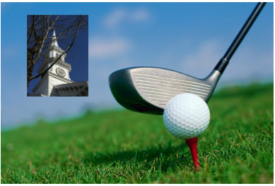
Charity Golf Event Woods Hole Golf Club
Nine-Hole Round,
Putting Contest,
& Dinner
Thursday,
October 3, 2024

Sponsored by:
First Congregational Church
of Falmouth

Woods Hole Golf Club:
Since 1899, player accuracy has been a premium requirement of the game at this purposefully links-style golf course.
Fescue-lined fairways and subtly undulating greens create a golf course that can play differently every round, regardless of handicap.
The rolling scenic views of the original pastures overlooking Buzzards Bay and Quissett Harbor have been pristinely preserved and carefully restored.
Woods Hole Golf Club
130 Quissett Avenue
Woods Hole, MA 02543
The event is limited to 36 players. Please complete your Registration Form and payment to be included in this fun experience.
Event Details
3:00pm Registration and Golf Warm-up
4:00pm Golf Shotgun Start, nine holes
5:00pm Putting Contest
6:00pm Cocktails (cash bar)
6:30pm Buffet Dinner and Award Ceremony
To participate in the Charity Golf Event, please complete the Registration Form and mail it with your check to:
First Congregational Church of Falmouth
Attn: Golf Event
68 Main Street
Falmouth, MA 02540

Or email the completed form to:
Carol J. C. Mills, Treasurer
Carol.J.C.Mills@gmail.com
And send your check to the address above.
Registration Form: (Golf includes cart)
__ Individual Golfer and dinner: $175
__ Golf Twosome and dinner: $330
__ Golf Foursome and dinner: $600
__ Putting Contest, Individual, & dinner $100
__ Buffet Dinner only $75 per/person
$ Total Amount
Name:
Phone:
Email:
Address:
City/State/Zip: ____________________________________
For Multiple Attendees, additional names for Golfers or Dinner Only.
Name:
Name:
Name:
Golf Sponsorship Opportunities
_ Gold Sponsor: $3,000 — Includes: 1 foursome (4 players) for nine holes of golf (or putting contest) and dinner; Company name & logo prominently displayed on sponsor board; One company banner displayed at event (sponsor provides).
_ Silver Sponsor: $2,000 — Includes: 1 twosome (2 players) for nine holes (or putting contest) of golf and dinner; Company name & logo prominently displayed on sponsor board.
_ Bronze Sponsor: $500 — Includes: Company name & logo prominently displayed on sponsor board.
Sponsor Name:
__

Sponsor Contact Name and Email:
__
__

Email Sponsor Logo to:
Carol J. C. Mills, Treasurer
Carol.J.C.Mills@gmail.com

Current Programs of the
First Congregational Church of Falmouth:
* The Good Shepherd Project — providing meals for those in need.
* The Children’s Clothing Project —providing free children’s clothing available on a twice-monthly basis.
* Covenant to Care for Foster Families – supporting the families with foster children in their care.

Local/Worldwide Charities Supported Include:
- Belonging to Each Other
- Cape Cod Council of Churches
- Habitat for Humanity
- Heifer International
- Housing Assistance Corporation
- Falmouth Service Center
- Recovery Without Walls
- Rise Against Hunger
- Salvation Army
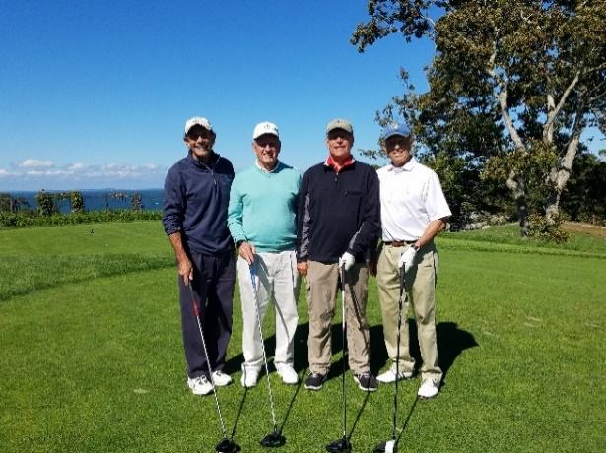
Happy Golfers from a previous Annual Golf Event
Dear Friends,
The First Congregational Church of Falmouth is pleased to announce our 2024 Charity Golf Event, hosted by the Woods Hole Golf Club. Proceeds from this event will enable the church to provide services to needy individuals and families in Falmouth and other local, national and international communities. Through your generous support, you can help make a difference in the lives of Cape Cod residents and beyond.

We look forward to seeing you!
Rusty Warren, Golf Event Chair
PWarren3rd@gmail.com
Carol J. C. Mills, Treasurer
Carol.J.C.Mills@gmail.com

A Brief History of Our Congregation Over the Past Three Centuries
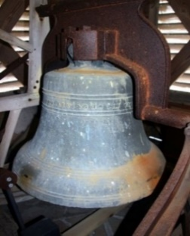
The First Congregational Church of Falmouth was gathered on October 28, 1708. Our original church building was a meeting house from the 1690s near the Old Burying Ground off today’s Mill Road. As the church’s congregation grew, larger meeting houses were erected during the 1700s. The last of these was constructed in 1796 on the site of the current Village Green. In its belfry was placed a bronze bell cast by Paul Revere. In 1857 the frame of the church building was moved across the street to its current location on Main Street, facing the Green. Our Paul Revere bell was mounted in the new steeple, where it continues to ring hourly.

