Ten ways to prevent school refusal
Are you struggling with getting your child to school? Here is some advice on what you should do as a parent – and what you should not do.
Del artikkel:
Make sure the child gets out of bed as usual if he or she stays home from school. Get your child to do his or her school work and try to follow the class' curriculum is Trude Havik’s advice. Photo: iStock
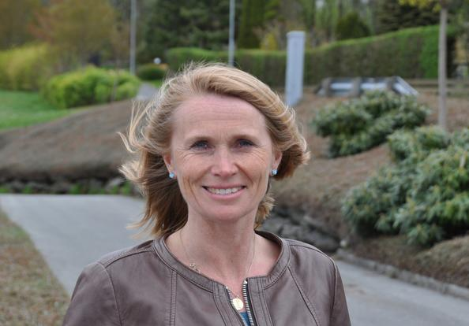
“Staying at home from school should not be an attractive option”, says Havik. Photo: Ida Gudjonsson
Not attending school for longer periods can have negative effects on the child’s psychological, social and academic development. Post-doctoral researcher Trude Havik at the Norwegian Centre for Learning Environment and Behavioural Research in Education at the University of Stavanger has been studying the phenomenon of school refusal. She gives us ten ways to prevent it and help pupils back to school.

1. Talk with your child
Try to find out why he or she refuses to go to school. Has something happened? Ask if your child has any friends at school. Take your time and be specific when asking questions.

2. Contact the school as soon as possible
“Ask if they have noticed any change of behaviour in your child, both regarding school work and in social interchange”, says Havik.
Parents should contact the school, and they should together find out why the child does not want to or is unable to attend school.

3. Make an agreement
Complaints about stomach pain or headache are often among the first indications of school refusal. In case of such complaints, you should make an agreement that your child will attend school, but can return home if the pain gets worse during the day. The teacher must also be informed about the agreement.
“Going to school rarely worsens the child’s condition. Making sure that children go to school is important because non-attendance leads to more of the same”, says Havik.
“The longer a pupil is absent, the harder it is to come back.”

4. Exert mild pressure
Stay firm.
“However, parents can’t be expected to force their children if the school does not follow up. This might apply if a child is subjected to bullying, feels unhappy or does not get the follow-up he or she needs.
If the teacher does not respond to your concerns, you should ask for a meeting with the headmaster”, says Havik.

5. Don’t make staying at home an attractive option
“If children are allowed to sleep in and for example bake together with their mothers, staying at home during school time might be too enjoyable,” says Havik.
“Make staying at home resemble a normal school day to make it less tempting. When the school day is over, you can enjoy yourselves.

6. Take your child to the doctor
A child that complains about stomach pain or headache should undergo a medical examination. However, he or she should still try to attend school during the examination period”, Havik believes.

7. Business as usual
If your child stays at home, it is important to get up at the usual time and prepare for a new day in the same way as when she or he goes to school. Get your child to do his or her school work, and try to follow the class' curriculum.

8. Be positive about school
When at home, focus on the positive aspects and what your child likes about school, teachers and classmates.

9. Good routines
It is important that the same thing happens every night at bedtime and in the morning. Your child should go to bed at a regular time and get enough sleep. Children should not be allowed to spend a lot of time on their mobile phones or digital tablets before bedtime.

10. Don’t feel guilty
“When a child refuses to go to school, this is never down to one person or one simple reason. It is often a complex matter. Feelings of guilt will not make things better, neither for the adults nor the child”, says Havik.
Parents of children who refuse to go to school need to know that they are not the only ones in this situation.
“They also need to know that early help, working together with the school and being open about difficult issues, including conditions at home, is important for getting the child back to school as soon as possible.”
Text: Ida Gudjonsson

References:
Trude Havik: Skolevegring. A chapter in the book Psykisk helse i skolen Oslo: Universitetsforlaget AS. 2016.
Trude Havik: School non-attendance. A study of the role of school factors in school refusal. Doctoral thesis at the University of Stavanger. 2015.
Published 21.12.2017

