**Milcopex 2026 One-Page Postal History Exhibits - Instructions**

* These one-page exhibits should have a postal history subject or theme, are non-competitive and separate from our competitive single and multi-frame exhibits.
* Participation is open to all at no charge.
* Exhibited materials should be the property of the exhibitor or the exhibitor should provide a citation and credit to the source(s) of the item(s) shown.
* Exhibitor grants Milcopex the full rights to present and share the material shown on the Milcopex website. Printed copies of the exhibit will be on public display at the exhibition.
* Exhibits must be submitted using the official online form.
* No more than 6 exhibits may be submitted by the same exhibitor.
* Exhibits must be submitted electronically in pdf or jpeg format. 300 dpi resolution or greater preferred.
* Exhibits should be in 8 ½ x 11-inch page format or A4 page format (21 x 29 cm.).
* Each exhibit is limited to a single page.
* Milcopex reserves the right of acceptance, and their decision shall be final.

**Format & Content Requirements**

* A title for the exhibit should appear at the top of the page.
* The exhibitor may show their name(s) or a pseudonym on the exhibit page if they wish.
* The exhibit must include at least one postal history related item.
* For layout and content ideas please see: <https://ataexhibits.com/exhibit-gallery/>

**Optional Format & Content Features**

* Exhibits may be in portrait or landscape format.
* There are no restrictions on page margins.
* Exhibits may be constructed from scanned images electronically assembled, from a scan of a completed exhibit page, or a combination of the two.
* Cropping of images is permitted.
* For images that are enlarged / reduced, exhibitors are encouraged to indicate the percentage of enlargement or reduction. This calculator tool may be of help: www.percentagecalculator.net
* The exhibitor’s email address on the exhibit is optional but is encouraged to promote discourse with viewers.
* Web links may be included to direct viewers to additional relevant content.

**Last Day to Submit an Entry: 1st June 2026**

**SAMPLE LAYOUTS:**

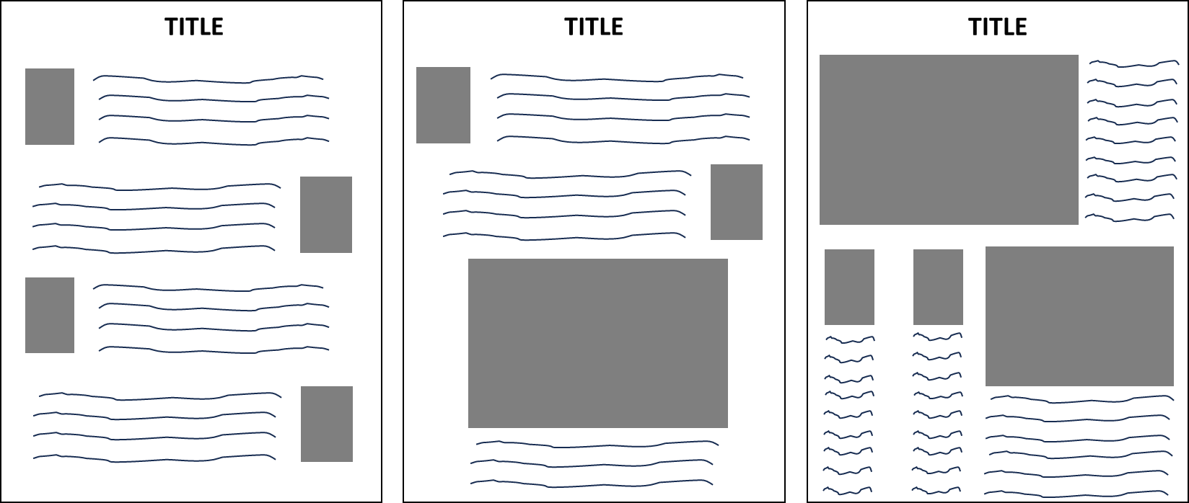

**Submission of Exhibit**

Use the form below to submit your exhibit **and** application for the Milcopex One-Page Exhibition.

* **By submitting your exhibit, you are acknowledging that you have read and understand the instructions.**
* **Entries that do not comply with the instructions or that contain inappropriate wording or material, are of a primarily commercial or advertising nature will be disqualified from participation at the sole discretion of Milcopex.**
* **If you plan to submit more than one exhibit, you must submit this form for EACH entry. Please do NOT attempt to submit multiple exhibits on a single form.**
* Entries should be submitted electronically with the Entry Form to the Committee at:

[milcopex@gmail.com](mailto:milcopex@gmail.com)

## Exhibit Entry Form - 2026

First Name:

Last name:

Mailing address:

Telephone Number Cell:

Telephone Number (alternate):

Email Address:

Title of the One-Page exhibit: