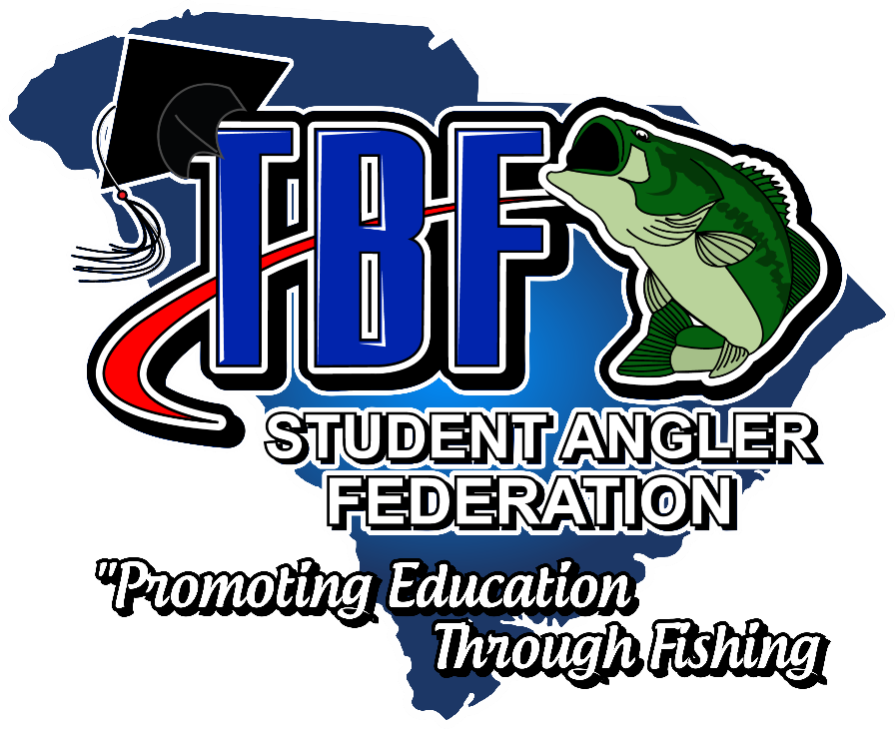
2022-2023 SC TBF/SAF YOUTH TOURNAMENT TRAIL SCHEDULE
** ALL Tournaments are points tournaments towards season end Trail Championship**
NOVEMBER 20, 2022 LAKE GREENWOOD – GREEN WOOD STATE PARK
FEBRUARY 4, 2023 LAKE HARTWELL – GREEN POND LANDING ”2023 HIGH SCHOOL DIVISION STATE CHAMPIONSHIP”
FEBRUARY 19, 2023 CLARKS HILL – DORN FACILITY
MARCH 12, 2023 LAKE MURRAY - TBD
MARCH 26, 2022 SANTEE COOPER – JOHN C LAND
APRIL 16, 2022 LAKE GREENWOOD – GREENWOOD STE PARK “2023 JR. DIVISION STATE CHAMPIONSHIP INCLUDED”
**$20 TOURNAMENT ENTRY FEE PER TEAM**
JR. & HIGH SCHOOL DIVISIONS AVAILABLE
$25 National TBF/SAF Student Angler Membership REQUIRED JR. & HS Division

