Filling out the forms without creating a User Profile:

- Go to OFA.org website.
- Click Applications

- Select your applications you wish to test for. You will not be able to register for OFA Eyes this way. You will have to create a profile and register on-line.
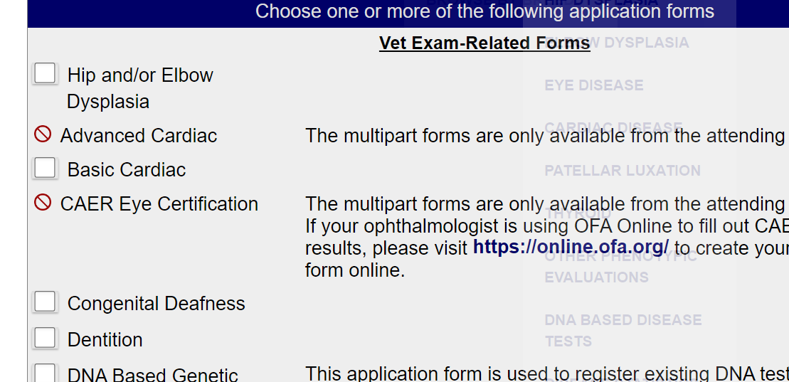

- Begin to fill out your applications for the animal.
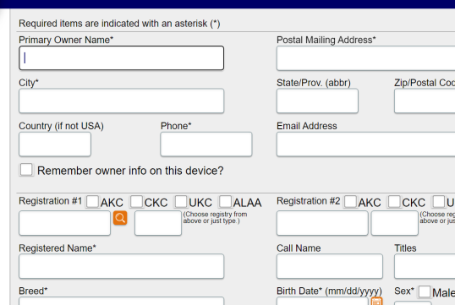
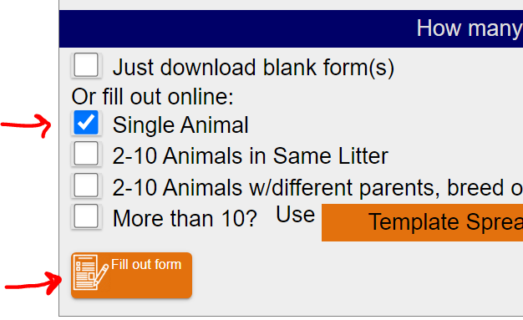

- Then Download your forms and print them out to bring to the clinic.

