Steps for filling out the OFA forms On-line:
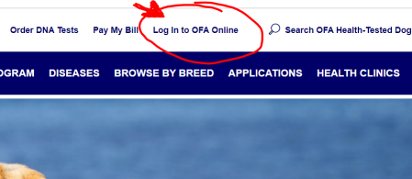
- Go to OFA.org and “Login to OFA Online” under your user profile.

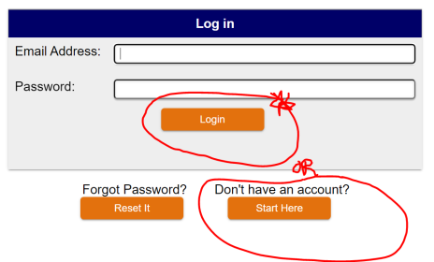
- If you do not have an account, create a profile:

- Create an Application:

- Search for your dog that you want to create an application for.
The easiest way I have found is by searching the AKC registration number.
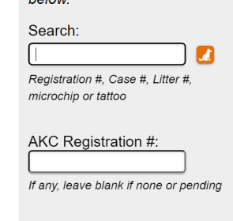

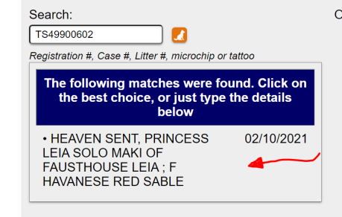
- When the system finds dogs, you will have to select the one you want. There may be multiple dogs found, depending on your searching method. Once you select the dog you want, the form will pre-populate with that dog’s information.

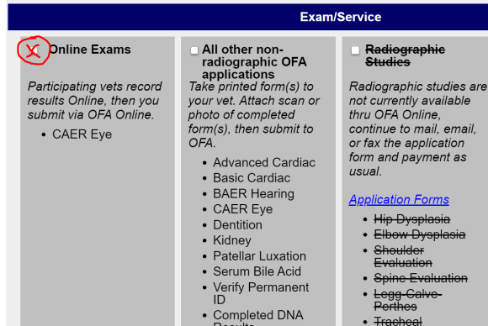
- Scroll down and choose your exam/service. If you are wanting to register for eyes, click the box on the left. If you are wanting patellas, cardiac, dentition or BAER hearing, click the box in the middle.

- When choosing All other applications, fill in the boxes as promted. You can search for the doctors so their information will pre-populate. For Dr. Hughes, search Hughes. For Dr. Kathleen Brown, search Brown.
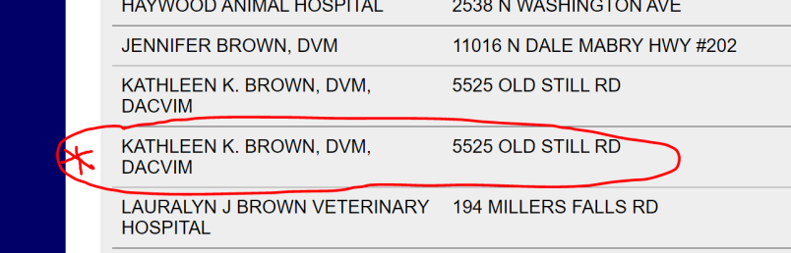
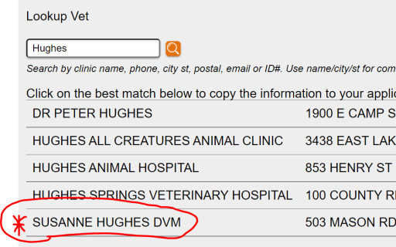

It will then pre-populate with their information. Then, choose that you only need the application. That will allow you to get an email that you can print to bring with you to the clinic.
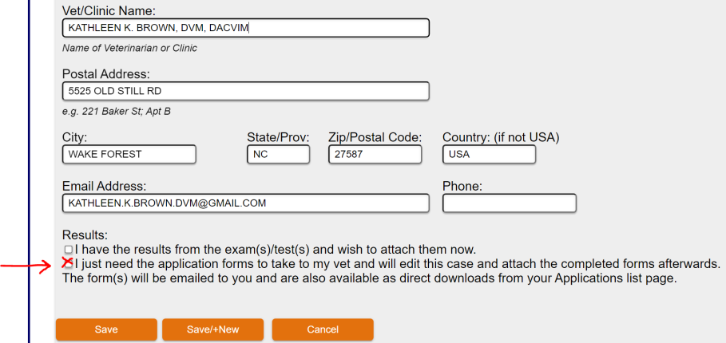

- If you are filling out the OFA Eyes portion, choose the

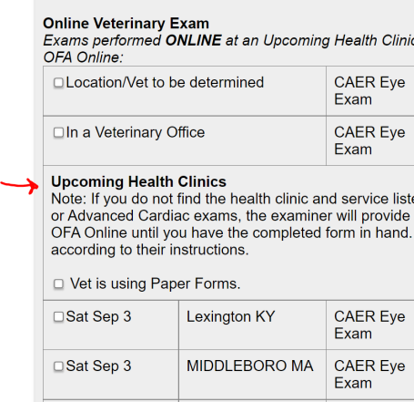
- Then scroll down to the Upcoming Health Clinics. Find Saturday Sept. 17th. Jennifer Fontenelle.

- Then hit Save, if you only want to register that one dog.
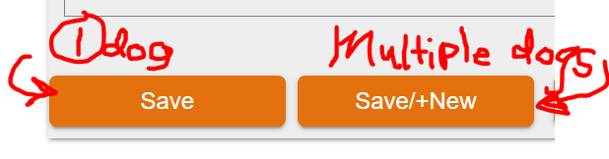
Hit Save, /+New, if you want to enter another dog for the eye exams.

- Print out your applications for the doctors to sign. You will need 2 printed OFA eye forms for each dog. This is a backup plan in the event the WiFi goes down and we have to do manual submissions for your tests.

When It’s time to register your tests with a discount code: The code is only good after the day of exam for 30 days. You may upload your scanned or JPEG completed document and attach it to your application on-line for fast service. You may also pay your bill online through your profile on OFA.org.
YOUR CLINIC DISCOUNT CODE FOR THAT DAY IS
EVYA

