**Little Bears Durham Welcome Pack.**

Thank you for your interest in Little Bears Childminding. I aim to provide professional care for children from 3 months to 5 years of age, in a nurturing, stimulating environment.

My number one priority is to keep your little one safe and secure, whilst offering an engaging, homely environment in which we can foster positive relationships, belonging, togetherness and self-esteem. I believe when children are comfortable and happy, they are best placed to learn.

I follow the **Hygge** approach at Little Bears, providing a warm, homely and cosy environment for all children. I aim to create a psychological safe space for the children. Ways in which we support wellbeing:

* Focus on a child’s right to play. Play is essential for well-being – it gives children time to think for themselves, reflect and use their imagination
* Focus on presence, spending time with children, focusing on their current interests in the present moment
* Being a small setting, allows us to spend time as part of a family group, promoting a sense of togetherness
* Aim to promote happiness and wellbeing, providing a positive role model for children. My objective is to be nurturing, caring, kind, and friendly.
* Children are listened to, and they know that their ideas are important. I reflect these ideas in our environment and planning
* An ethos of sharing, kind words and actions for all
* Twinkly lights and soft glow lamps provide an ambient atmosphere for the children to explore and investigate in. These are used alongside the natural light that shines through the windows and doors
* We spend long periods of time outside with access to natural gardens and open ended resources
* Children will have access to spaces indoors, outdoors and out in the community every day.



**About me:**

I am a 38 year old mum of two (Lucie 10 years and Kathryn 20 months), I live with my partner Peter, in West Rainton and have been here since 2013.

I have worked as both an Ofsted registered nanny and childminder, since 2016. Childminding between the years of 2017/2018. As a nanny I have had various roles (full time, part time, weekend/ after school nanny, part live-in and travel nanny), I have worked with children aged from 5 months to teenagers.

During covid, many of the families I worked alongside were furloughed so I accepted a training position as a pharmacy technician in Sunderland Hospital (whilst remaining to work occasional weekends/evenings as a nanny). After having my second child (Kathryn) in January 2023 knew I didn’t want to return to the hospital, but to work full time with children once again.

**Training and qualifications –**

* Teaching assistant level 3
* Maternity Nurse Level 4
* DBS check
* Hygge in the early years
* Paediatric first aid
* Common core skills (childcare)
* Safeguarding level 2
* Mental health in the early years level 2
* Degree (podiatry)



**Fees Policy.**

I am self-employed and set my own terms & conditions, including fees. It is important that you read through my Fees Policy and understand exactly what is expected of you. If fees are not paid, I am within my rights to immediately suspend childcare (I also have legal insurance to help me recover any unpaid fees). Please remember that the contracted hours are paid regardless of late arrivals, early collections, child/parent illness, and occasional days off.

**Retainers –** A retainer keeps a place open for a child, if you want to send your child to Little Bears but do not require the space immediately. I charge half normal fees during the waiting period. Retainer fees are not payable when I am on holiday or unable to work.

**Deposits –** A **deposit of two week’s normal fees will be taken to reserve your child’s place**. If you cancel your child’s place you will lose your deposit. The deposit will be credited against your FINAL bill. The deposit may need to be adjusted if you change your child’s days/hours. I require one months’ notice to reduce/cease hours – if I don’t get the required notice the deposit will be retained by me as you will have broken the terms and conditions of the contract.

**Settling in Sessions** - Settling in sessions are an important part of your child’s transition into my care. All hours booked are paid in advance. Contracts can be terminated by either party during the two week settling in period. If you decide Little Bears is not suitable, any unused booked sessions will not be refunded.

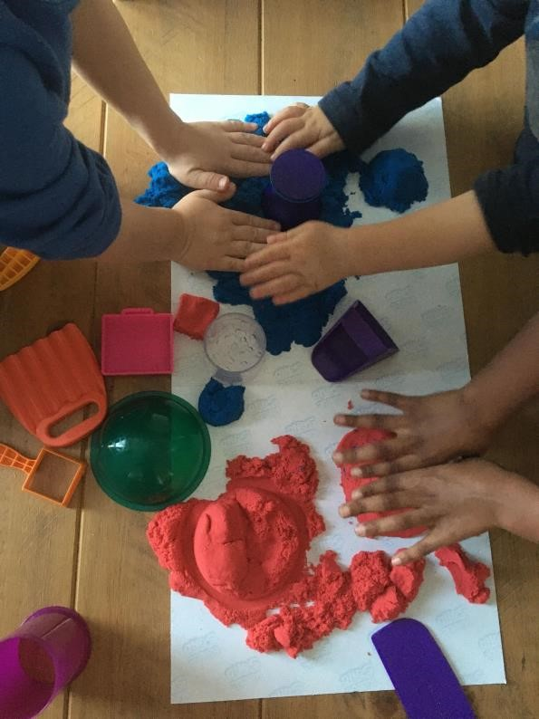

**Fees Payable**

**Session Times/Fees –**

* **£65 per day** (8am- 5pm )
* **£7.50 per hour**. Minimum of 7 hours per day.
* **Tem time only agreements (Ad**-hoc basis during holiday periods agreed one month in advance)

* Registration Fee – I charge a registration fee of £10 per child. This covers paperwork involved to have your child in the setting (ofsted requires relevant information to be recorded).
* If I am unwell **NO CHARGE**.
* Child/family holiday in contracted hours**– FULL FEE**
* Child/family illness – **full fee**
* Bank holiday – **NO CHARGE** as I do not work.
* **Late Collection fees** – Children should be collected promptly at the agreed time (if you are collecting before the agreed time, please inform me by telephone as soon as possible as we may be in the garden/out for a walk etc). If children are late to be collected there will be a **late collection fee of £2.50 every extra 10 minutes.**
* You are not able to bank unused days/hours for any reason.
* **Outings -** Any special outings will require additional payment. If you do not wish your child to attend the special outing i.e Down at the Farm as you are not happy with the entry fee please let me know and I can organise an alternative. No charge for routine outings.
* **Dropping off -** I cannot take your child in any earlier than the allocated start time, if you require them to be dropped earlier this is chargeable and must be requested prior to the day.

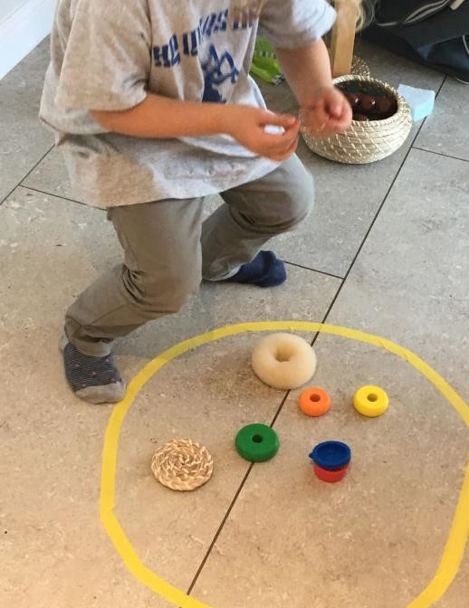

**Food Provision.**

Food costs are £4 per day (including half day sessions). I will provide breakfast, snacks, lunch and a light dinner at 4pm. I want to provide a healthy menu, fresh fruits/vegetables, home cooked meals.

Children are welcome to bring in food for their day - any items that are not allowed into the setting clearly communicated (in case of allergies).

**TV Policy**

We aim for the children to be engaged in learning activities with high quality resources, spending time in nature and out in the community. Though sometimes, I do feel a little bit of downtime during the day is required. I will therefore allow some TV time in moderation.

**Illness and infection control.**

This policy is put in place to protect all children at the setting and myself. If your child is unwell, please do not send your child into the setting as I will contact you to collect them (to keep others in the setting safe). Also, if I become unwell then I am not able to care for any of the children in the setting and will have to close. (I work from the spotty book – public health England document)

Please keep your child at home if they are experiencing any of the below:

* Any **signs of hand, foot and mouth** - most likely to spread to others in the first 5 days after symptoms start. Please keep child at home at least 5 days after noticing symptoms.
* **Temperature requiring medication** o **Wheezing or shortness of breath** o **Constant runny nose with green/yellow tint** o **Lethargy (**unable to take part in usual activities)
* **Diarrhoea or vomiting** (Must be 48 hours free of D&V before returning) o **Sore throat with swollen glands** o **Undiagnosed rashes**
* **Contagious illnesses such as chickenpox**

If children have mild/infrequent cough, minimal runny nose or any minor ailments, they are ok to come into the setting.

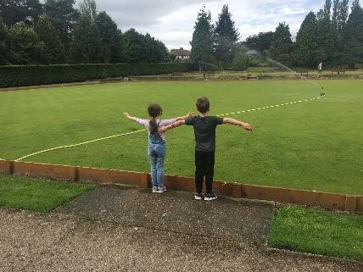

**Medication Policy**

All medication provided by parents MUST be in its original packaging and labelled correctly. The label must have the child’s name, name of medication, dose, frequency, dispensing date and be in date. Medication will of course, be stored out of reach of the children (and in line with the manufactures guidance).

You will be required to give written permission for each dose – stating the time it is required. You must inform me of last dose received by your child. I will record each dose given on a written record and parents are to sign at the end of the day.

Any children with asthma **MUST** attend with their inhaler/spacer if they have one.

Any children with an Epi pen **MUST** attend with their pack. Children without epi pen or inhalers will not be able to stay at the setting.

Any child that requires paracetamol to get through their day, is not well enough to come into the setting. Please discuss this with me if you need further clarification.

**Accident & Emergency Policy.**

The safety of the children in my care is paramount and I will take every measure I can to prevent and accident/injuries occurring. However, unfortunately accidents can occur.

In order to prevent unnecessary accidents/injuries from occurring in my setting, I will ensure that all equipment/resources in my setting are suitable for the age/stage of development of each child (they will also be checked/cleaned regularly)

In the event of a child being injured, I will comfort and reassure your child. I will assess the extent of injuries and call for medical support/ambulance if required. I will carry out any first aid procedures that are necessary (I undertake an Ofsted approved training that is constantly kept up to date).

Once the situation has been dealt with, I will notify the parents/carers at the earliest opportunity.

Minor incidents such as a scratch or graze will not require the parent to be informed by telephone . Any accidents/injuries will be recorded as soon as possible and the parent is required to sign on collection to say they have seen this information.

I require emergency contact details of parents/carers and a second emergency contact.



**Safeguarding Policy.**

The Children Act 2004 and Working Together to Safeguard Children 2015, define safeguarding and promoting children and young people’s welfare as:

* Protecting children from maltreatment
* Preventing impairment of children’s health or development
* Ensuring that children are growing up in circumstances consistent with the provision of safe and effective care
* Taking action to enable all children to have the best outcomes

Child protection is the activity undertaken to protect specific children who are suffering, or likely to suffer significant harm. Safeguarding action may be needed to protect children (or parents) from:

* Neglect
* Physical abuse
* Sexual abuse
* Emotional abuse
* Bullying (including online, racist, homophobic, transphobic or disability)
* Radicalisation/extremism
* Child sexual exploitation
* Honour based abuse (including female genital mutilation and forced marriage).
* Domestic violence
* Poor parenting (particularly in relation to babies and children)
* Substance misuse
* Any other issues not listed which may pose a risk to children, young people and venerable adults

My first responsibility and priority is safety for the children in my care. If I have any cause for concern I will report any issues.

Where there is an immediate risk to a child I will ring **First Contact** on **03000 267979** or ring **999** and speak to the Police if risk of harm is imminent. I undertake regular safeguarding training as part of my role.

Alternatively I will make a Safeguarding Referral to) or make a **Request for Early Help.**

Confidentiality will be assured in all cases. I am aim to share all information with parents but in some instances, I may have to refer without discussing with you.

Parents must notify me with any concerns they have about their child and any accidents, injuries or incidents affecting the child outside of the setting, which will be recorded. I will work together with parents to make sure the care of your child is consistent.

If an allegation is made against me I will report if to Ofsted and also to the **Local Authority Designated Officer (LADO).**

**Complaints**

As a registered childminder I am to work in close partnership with parents/carers to meet the needs of all children. Maintaining good communication between both parties will aid this. I welcome suggestions and constructive criticism from parents/carers to help me improve my provision.

If you find it necessary to make a complaint, get in touch with Ofsted **at enquiries@ofsted.gov.uk** or **0300 123 4666.** I am required to display my complaints procedure poster in the setting, so details are available there.

**Collections /arrivals Policy.**

It is important that you arrive at the contracted time to collect your child. Even very young children learn our routine and know when parents are due. I know sometimes delays are unavoidable. If you are delayed, for any reason, please contact me and let me know your expected time of arrival.

It is also important to let me know if you will be later than expected as we may have plans to be out of the setting and may not be home.

If a child is not collected within 30 minutes of the collected time, I will call emergency contact numbers. After one hour, if I have not heard from you, I will have to contact the local authority duty social worker and follow their advice.

Collection is from the door step and will need to be swift as I often have other children to look after. If you need time to chat with me about something please text/email me and we can make a suitable time. This is the same for dropping off on a morning, I have others to care for so am unable to stand at the door for longer than necessary.

Only people names on the contract are able to collect the children. If there is an emergency situation and a known person cannot collect the child, I operate a password system and I must have a photograph of the person collecting.

I do not have the right to prevent a divorced parent from picking up their child, if they have parental responsibility and no court order is in place.

