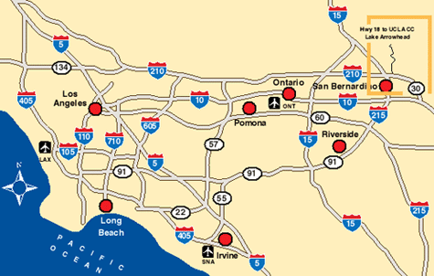
35th Annual Dr. Paul and Max O.
Couples Communication Workshop
(For couples with at least 1 person in a 12-Step program)
UCLA Conference Center at Lake Arrowhead
June 15, 16, & 17, 2018
www.couplesworkshop.us
Spend a joyful weekend together sharpening your communication skills in beautiful surroundings.
This is a workshop of daily topic/discussion meetings plus speaker and participation meetings Friday
and Saturday nights. Also enjoy swimming, tennis, hiking, loafing, reading and sleeping.
12-Step Model – Couples Sharing Experience, Strength and Hope – No “Experts”
Check-in after 4:00 pm Friday & Check-out by 12 noon Sunday
Early bird meeting Friday at 4:30 pm, Dinner at 6:30 pm
Important activities: Friday evening continuing through Sunday lunch
$985.00 per couple
Including all (excellent) meals
$400 deposit holds reservation until Dec. 12th
Balance is due then and deposit is not refundable thereafter because of our
Arrangement with the Conference Center
We accept registration after Dec 12th until date of the event.
Room assignments are done by the date of full/final payments are received
UCLA Conference Center, 850 Willow Creek, Lake Arrowhead, CA 92352
www.uclaconferencecenter.com (909) 337-2478
DIRECTIONS from Southern California
From Los Angeles take I-10 East to I-215
From Orange County take I-91 East to merge into I-215 North
Once on I-215 North, stay north past the 10 and bear right to the 210
(Mountain Resorts)
From San Fernando Valley/Pasadena take I-210 East
From Long Beach take I-605 North to I-210 East
Exit Waterman/Hwy 18 go left and Waterman turns into 18
From San Diego take I-215 North to 210 East
Exit Waterman/Hwy 18 left lane and go left on Waterman
Once on Hwy 18 drive north for 20 miles to Lake Arrowhead turn-off (Hwy 173)-
-Left on Hwy 173 for about 2 miles to stop sign –turn right
--This is Continuation of Hwy 173 for 4 ¾ miles to Willow Creek Road on left
--(If you pass North Shore Road you went too far)
--Left on Willow Creek Road ½ mile to entrance
--850 Willow Creek Road – Across from the Lake
Send check or credit card to:  Couples Communication Workshop  P. O. Box 96  San Juan Capistrano, CA 92693  (949) 488-7720  Cell (949) 291-06715  Fax (949) 489-0265  Email: info@couplesworkshop.us | Please charge my credit card $______________ for the Couples  Communication Workshop, June 15, 16, 17, 2018 at the  UCLA Conference Center ___ VISA ___ Master Card ___ AMEX  Name (print) ___________________________  Date __________  Acct # ___________________________Exp. Date ______ Sec#_____ Signature____________________________________

Names _________________________________________________________Phone_____________________

Address _____________________________________________________City __________________________

State ________ Zip _________ Email ___________________________________________________________

Scholarship donation _______________Room requests_____________________________________________

Medical / Dietary Needs______________________________________________________________________
