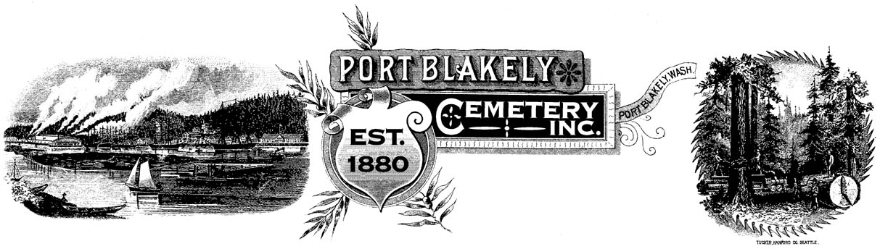
A HISTORICAL CEMETERY Located at 4375 Cemetery Road N.E.

PO Box 10001 ♦ Bainbridge Island ♦ WA 98110

Dear Friends of the Port Blakely Cemetery;

We held our annual board meeting via zoom this year in February. Hiro Hayashida informed us that he is resigning for family reasons. Hiro worked tirelessly with the board for over 30 years. We will miss his help and support. We have several openings on the board and will be seeking new members in the following year.

Even during this challenging year the Cemetery continues to move closer to our goal of financial independence. We continue to carefully work to make every donation dollar count in taking care of and preserving this special place. I am again asking for every family to make a donation they can afford. The cemetery continues to look great with the tremendous work of our groundskeepers. Our annual expenses are close to $20,000 a year for maintenance and minor improvements. As always all our board members are unpaid volunteers.

Please remember that glass containers are not allowed. Any perishable items left will eventually be removed by volunteers during cleanups at the end of every month. We have trash cans, mutt mitts and a compost area for use when you cannot take away materials yourself. The less these are used the less they cost the cemetery to maintain.

We are hoping to host Memorial Day at the cemetery this year but we will wait until mid April to post our intention on the website.

Thank you for your continued support. If you have a question please call me at 206-842-1893.

Sincerely,
Barry Sacks
President Port Blakely Cemetery

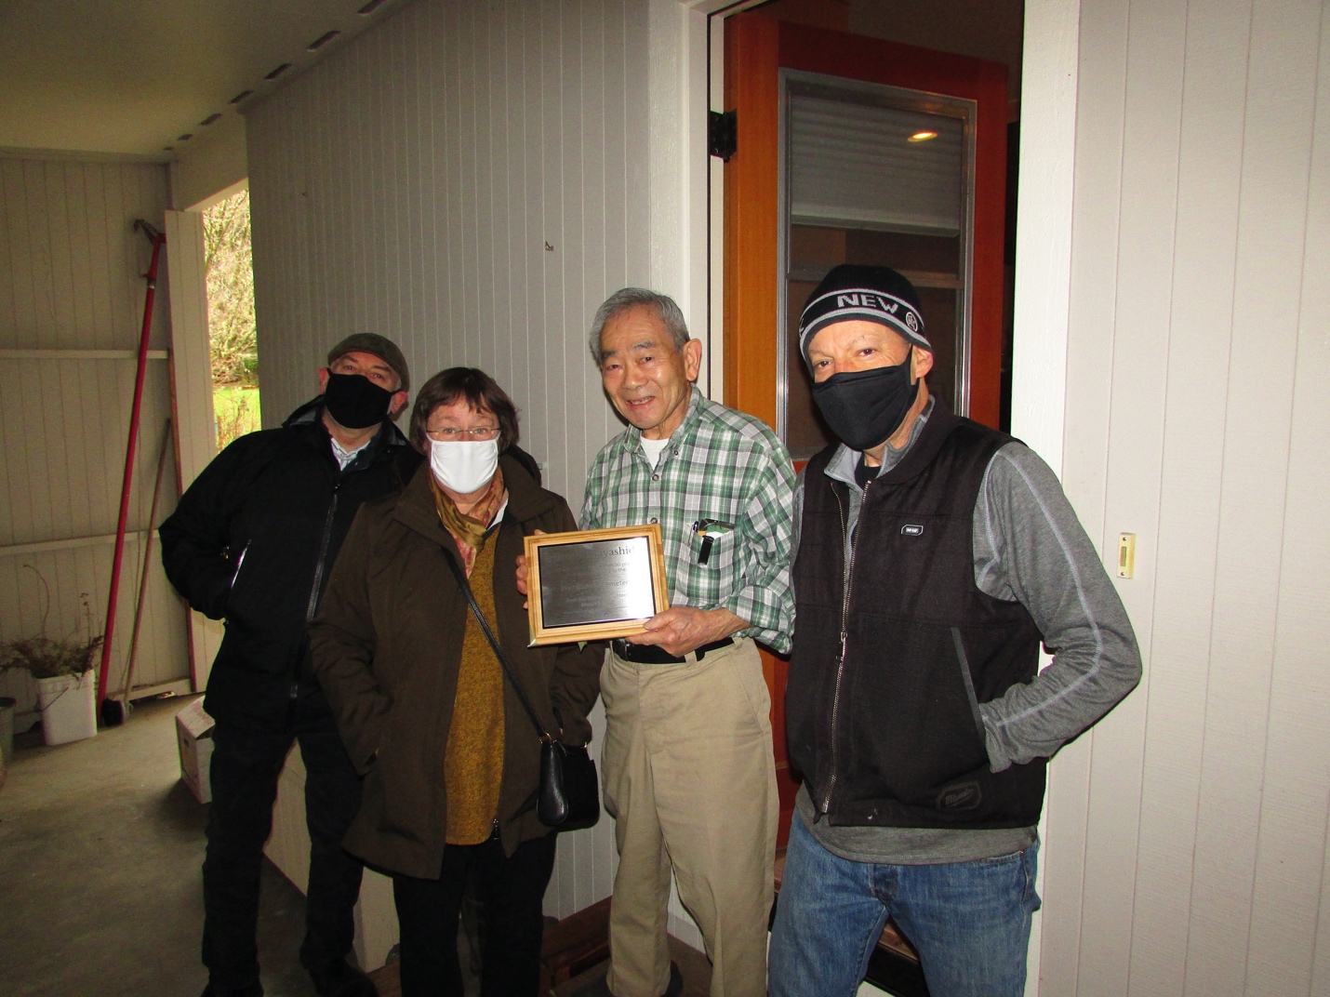

Port Blakely Cemetery board members President Barry Sacks (right), Jane Martin and Secretary Jim Rohrscheib present Hiro with a plaque commemorating his 30 years of service to the cemetery.

