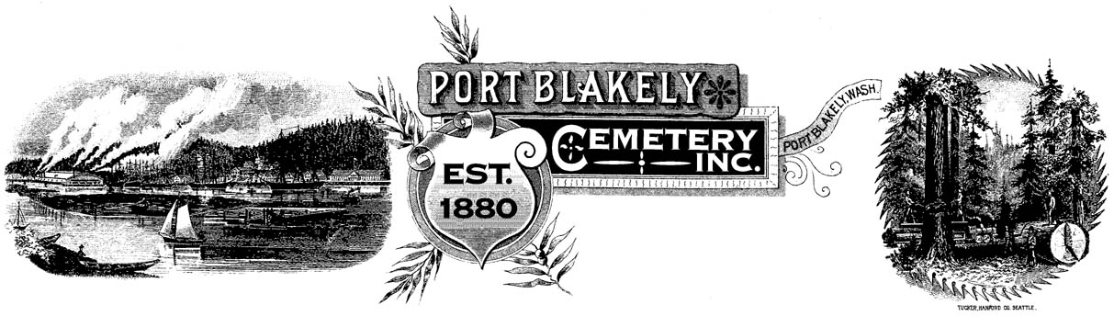
A HISTORICAL CEMETERY Located at 4375 Cemetery Road N.E.

PO Box 10001 ♦ Bainbridge Island ♦ WA 98110

Dear Friends of the Port Blakely Cemetery,

I hope you and your families are well during these challenging times. The Cemetery held its annual meeting via Zoom in February. We now have 10 board members. If anyone is interested in volunteering, please let me know. We continue to work toward a financially independent Cemetery and have made progress during 2021. Our investment policy remains successful and as of 2/28/22 we have averaged 7% since 2014 when we started our investment plan. Soon the cemetery will face two main challenges; the end of available plots for sale with the associated loss of revenue, and our dedicated group of donators, which hopefully includes you, will continue to shrink as time goes on.
For 2022 we will spend over $20,000 to just maintain the cemetery. The board will continue to do our best to make every dollar count and to only carry out minimal projects for improvements for the foreseeable future. I am asking you to please consider a donation in the amount of $200 annually. While we send out over 400 appeal letters our number of actual donors is close to 100. The math is simple, for us to cover just our maintenance expense we need to collect nearly $200 per family. I am fully aware that this is a huge increase in what I have asked you to consider in the past. I want to make sure that I accurately portray the financial position of the cemetery and I will always answer any questions you have. Thank you in advance. We consider every donation valuable and fully understand that each family will budget what they can for the cemetery.
Starting this year at Memorial Day we will only be hosting on Sunday. This event has slowly, over time, had fewer attendees and we are tailoring our efforts to the interest shown.
I would like to thank each of our board members for their continued volunteerism and support. Without these people the cemetery would not exist as the unique place it is.

Take care,
Barry Sacks
President
206-842-1893
watermusic@gmx.com

