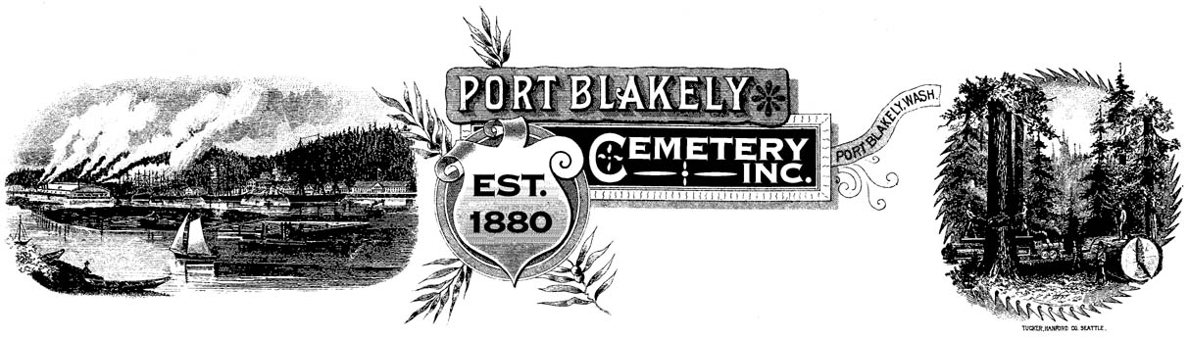
7/30/2021
PO Box 10001 ♦ Bainbridge Island ♦ WA 98110

INTERNAL GUIDELINES FOR BURIALS

1. Plot Purchases. A previous or current property owner on Bainbridge Island, or a person with an immediate family member buried at Port Blakely Cemetery, may purchase a maximum of three full sized or six half sized plots in the cemetery. Half sized plots may only be used for the burial of cremated remains. In the new section of cemetery, all plots purchased in blocks 43, 47, 48, 51 and 52 will be full sized 4' x 9' plots, and plots in blocks 45, 46, 49, 50 and 53 will be half sized 4' x 4' plots. In blocks 45, 46, 49, 50 and 53, a buyer may purchase two halves to make a whole 4' x 9' plot. In the old section of the cemetery, all plots are either reserved for burials or an interment has already taken place. The Port Blakely Cemetery Board of Trustees reserves the right to make exceptions to this policy on a case-by-case basis.

2. Verification of Plot Vacancies. In order to ensure that only unused plots are sold to purchasers, no plot sale will be final for 24 hours. This time will permit the plot sales representative to re-verify the accuracy of cemetery burial records and mark the exact location of the vacant plots(s).

3. Grave Liners. A complete grave liner (top, bottom and side walls) is required for all new adult casket burials. This grave liner policy may be modified on a case by case basis by the Board.

4. Digging Policy. Private individuals will not be permitted to dig casket size graves. This policy may be modified on a case by case basis by the Board. Private individuals will be permitted to dig and bury urns containing cremated remains. The urn should be buried to a depth of 18 inches. Private individuals burying cremated remains must notify the Board of the plot location and pay a $10 county filing fee.

5. One Casket per Grave. Not more than one casket containing the remains of an individual person may be placed in a grave.

6. Cremated Remains. There is no limit to the number of cremated remains which may be buried in one plot. Cremated remains may be added to a plot containing a casket burial.

7. Burial of Human Remains Only. Cemetery plots shall be limited to the internment of human remains only.

