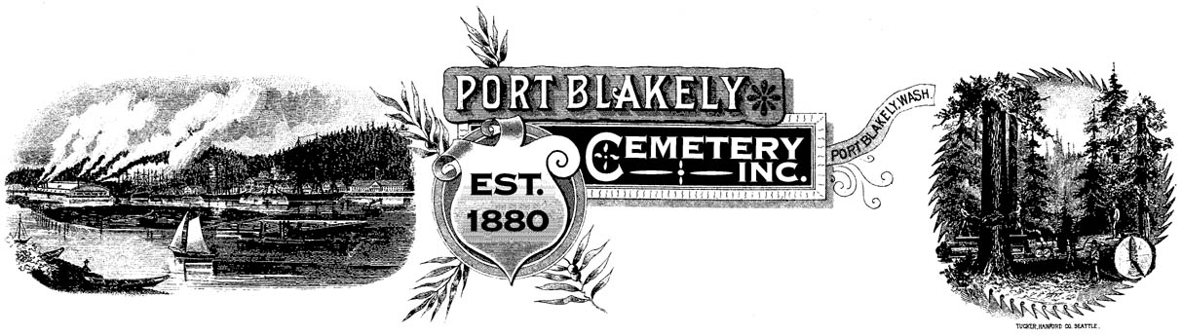

PO Box 10001 ♦ Bainbridge Island ♦ WA 98110

Port Blakely Cemetery, Incorporated, is a Washington Non Profit Cemetery whose purpose is to operate a cemetery on Bainbridge Island, Washington and to do all things necessary and incident thereto. A current or previous property owner on Bainbridge Island, or a person with an immediate family member buried at Port Blakely Cemetery, may purchase a maximum of three full sized or six half sized plots in the cemetery. Half sized plots may only be used for the burial of cremated remains. The Port Blakely Cemetery Board of Trustees reserves the right to make an exception to the maximum number of plots purchased by a person.

The following Rules and Regulations are designed for the protection of possessors of burial rights as a group. All possessors of burial rights, visitors and contractors performing work within the cemetery shall be subject to said Rules and Regulations, amendments or alterations as shall be adopted by the Board of Trustees from time to time.

The Basic Fees as fixed from time to time, shall apply to all purchasers of burial rights, and shall be paid in full at the time of purchase. No interment will be permitted in any plot which has not been paid in full. Not more than one casket containing the remains of an individual may be placed in a grave. A complete grave liner (top, bottom and side walls) is required for all new adult casket burials. Private individuals will not be permitted to dig casket size graves. Private individuals will be permitted to dig and bury urns containing cremated remains. The urn should be buried to a depth of 18 inches. There is no limit to the number of cremated remains that may be buried in one plot. Private individuals burying cremated remains must notify the Board of Trustees the full name of the deceased, dates of birth and death, place of birth, the plot location and pay a $10.00 to cover the state of Washington tax. The $10.00 check for the state taxes should be made payable to Port Blakely Cemetery and mailed, along with the notification of the burial of cremated remains, to the cemetery post office box address listed above. Each cremains burial must have the permission of the existing family of the plot holder. Cremated remains may be buried in plots containing casket burials. Use of cemetery plots shall be limited to the interment of human remains. Graveside services may be held at no additional charge. The Board of Trustees may modify rules and regulations on a case by case basis.

Sale, Transfer or Conveyance of any cemetery land unit shall be limited to resale to the Port Blakely Cemetery, Incorporated. The seller is entitled to a refund of original purchase price only.

Space permitting, Plot Exchanges are permitted at no cost to the owner of burial rights. Exchanges may take place anywhere within the cemetery grounds (i.e., between the old and new sections, between the new and old sections and within the old and new sections).

Grave Markers shall be provided by the plot purchaser, or assignee, and the same shall be responsible for maintenance and repair as required. Port Blakely Cemetery will notify the plot purchaser of any repairs as needed and shall take reasonable precaution to protect plot purchasers and their property rights from loss or damage. The cemetery distinctly disclaims all responsibility for loss of damage from causes beyond its reasonable control, and especially from damage caused by the elements, an Act of God, common enemy, thieves, vandals, strikers, insurrection, riots or order of any military of civil authority, whether the damage be direct or collateral, other than as herein provided.

No Permanent Border/Curb will be permitted around a plot without a plot sales representative first marking the exact location of the plot, and the border/curb must be entirely within the plot markings. Loose stones used as a border must be stable, i.e., set into the ground. Any loose gravel or small decorative stones as a site covering must be contained within a border in such a way that they will remain there and not interfere with grass mowing. The Board of Trustees reserves the right to ask the owner to repair damaged or dangerous borders or to correct the existing condition.

Floral regulations allow no glass containers. The Board of Trustees reserves the right to remove any floral arrangement, weed, shrub, tree or plant as soon as it becomes unsightly, dangerous, detrimental or diseased. The Board of Trustees assumes no responsibility for such floral arrangements or plantings. The cemetery is not responsible for theft or damage for anything placed on graves. Family members are encouraged to remove their own floral arrangements or to use the garbage cans located by the water pump.

All Plantings of shrubs or trees must be of dwarf or semi-dwarf variety. They shall not exceed ten feet in height when mature. Plantings may not exceed the width of the borders at any time. If any tree shrub or plant becomes detrimental to adjacent plots or avenues, or if for any reason its removal is deemed necessary, the Board of Trustees shall have the right and duty to ask the owner of the burial rights to remove such plantings, or as an alternative the Board of Trustees will correct the existing condition as in its judgment seems best, including root pruning, removal of plants, shrubs, etc or any part thereof.

The General Maintenance of the cemetery grounds is funded by donations. Port Blakely is not a perpetual care cemetery and all plot purchasers are encouraged to respond, as able, to an annual donation appeal.

The above foregoing Rules and Regulations of Port Blakely Cemetery were approved and adopted by the Board of Trustees of Port Blakely Cemetery on August 11, 2014. These Rules and Regulations supersede those adopted by the Board of Trustees on March 20, 2001.

James Rohrscheib
Secretary
Board of Trustees

