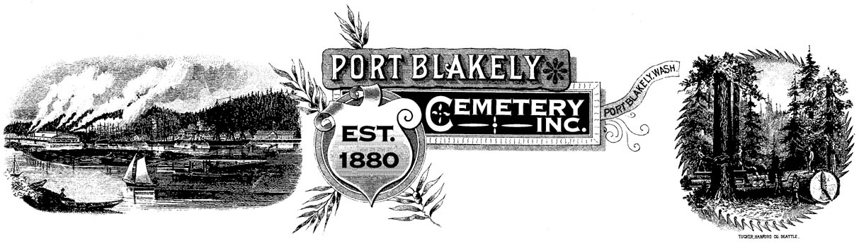
A HISTORICAL CEMETERY Located at 4375 Cemetery Road N.E.

PO Box 10001 ♦ Bainbridge Island ♦ WA 98110

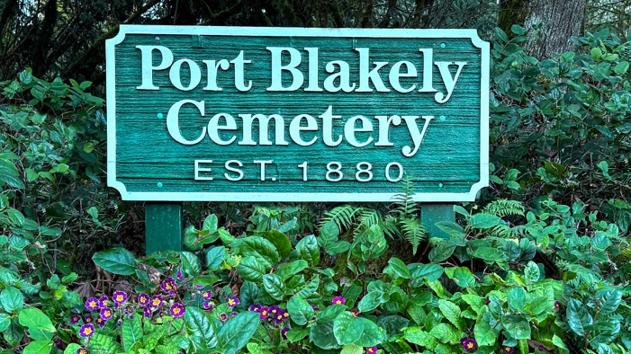

March 10, 2026

Dear Friends and Neighbors,

It is hard to believe another year has already gone by. As we look across the grounds of our historic cemetery—established all the way back in 1880—we are constantly moved by just how quiet and peaceful this sanctuary remains for all of us.
Our goal has always been simple: to keep this place as beautiful for our grandchildren as it was for our grandparents. We take that responsibility to heart, but we truly cannot do it without your help.
Mother Nature has been keeping us on our toes lately! With the changing weather patterns, we’ve found ourselves out mowing much earlier in the spring and later into the fall just to keep the grounds looking their best. While we are doing everything we can to keep our costs down, these extra-long growing seasons add up. So far, your kindness has covered these extra expenses, and for that, we are so grateful.
Memorial Day weekend is always busy as families attend to their family plots. We’ll make sure the mowing and weedeating are freshly done right before the weekend. We warmly encourage you to come by, spend time with family, and tend to your loved ones' plots just as you always have.
To keep our historic home-away-from-home looking its best, we are asking for a $100.00 donation again this year. Because we are a registered 501c13 non-profit, every single penny you give goes straight back into the soil and the grass of the cemetery. For your convenience, a Port Blakely Cemetery Venmo account has been created to make your donation even easier.

With warm wishes and many thanks,

Norm James, President

