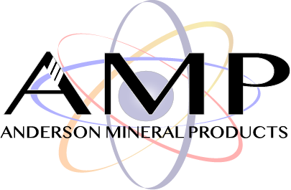
Technical Data & Specification Sheet
MSI 40-70 Silica
AMP

MSI 40-70 is a high purity silica sand. The sand is mined from the Hartselle Sandstone and Pride Mountain Shale formations. High purity quartz sand is mined, washed, attrition-scrubbed, dried and screened to size.
Advantages
- Greater than 99% SiO₂ content.  - No impurities that diminish the performance of the well | - The high purity SiO₂ is compatible with hydraulic fracturing chemicals  - Quality ensures better porosity and permeability of the well

Physical and Chemical Properties
ISO 13503 API RP 19C
 | Crush Resistance (K-Value) |  | 5K
 | Krumbein Shape Factors | Sphericity: | 0.7
 |  | Roundness: | 0.5
 | Acid Solubility |  | 0.4%
 | Turbidity |  | 110 NTU
 | Density | Bulk: | 1.32 g/cm³
 |  | Particle: | 2.66 g/cm³
 | Median Diameter |  | 0.261 mm

Particle Size Distribution
U.S Sieve Size
 | US Sieve Size | Retained (%) | Cumulative (%)
 | 30 | 0.0 | 0.0
 | 40 | 0.0 | 0.7
 | 45 | 4.1 | 18.9
 | 50 | 15.2 | 37.9
 | 60 | 34.9 | 51.9
 | 70 | 40.9 | 72.5
 | 80 | 4.8 | 87.0
 | 100 | 0.0 | 98.4

Disclaimer: The statements made on this technical data sheet are believed to be true and accurate and are intended to provide a guide for specified applications. As such, the manufacturer warrants only that the material conforms to product specifications, and any liability to the buyer or user of this product is strictly limited to the replacement value of the product only. The manufacturer expressly disclaims any implied warranties of merchantability or fitness for a particular purpose. Further, Safety Data Sheets (SDS) containing additional product information and safety handling instructions will accompany the product described herein.

