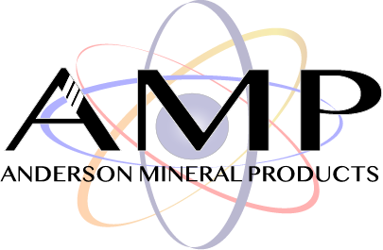

**Technical Data & Specification Sheet**

**MSI 40-70 Silica**

MSI 40-70 Silica is a naturally-occurring high grade, whole-grain quartz sand. The sand is mined from the Hartselle Sandstone and Pride Mountain Shale formations. High purity quartz sand is mined, washed, attrition-scrubbed, dried and screened to size.

Advantages

|  |  |
| --- | --- |
| * High purity, greater than 99% SiO2 * Silica has been scrubbed and attritioned providing a very clean raw material | * Dried to less than 0.25% moisture * Versatile size and characteristics provide use in multiple industries |

Physical and Chemical Properties

|  |  |  |  |
| --- | --- | --- | --- |
|  | | |  |
|  | **Mineral** |  | **Alpha Quartz** |
|  | **Color** |  | **Light Tan** |
|  | **Silicon Dioxide (SiO2)** | **Minimum** | **99%** |
|  | **Trace Elements** | **Maximum** | **0.40%** |
|  | **Moisture Content** | **Maximum** | **0.25%** |
|  | **Loss of Ignition (LOI)** | **Maximum** | **0.20%** |
|  | **pH** |  | **7** |
|  | **Water Soluble** |  | **N/A** |
|  | **Density** | **Bulk:** | **1.32 g/cm3** |
|  | **Specific Gravity** |  | **2.66** |
|  | **Hardness (Mho)** |  | **7** |
|  | **Melting Point** |  | **1713 ºC** |

Particle Size Distribution

|  |  |  |  |
| --- | --- | --- | --- |
| **U.S Sieve Size** | | |  |
|  | **US Sieve Size** | **Retained (%)** | **Cumulative (%)** |
|  | **30** | **0.0** | **0.0** |
|  | **40** | **0.0** | **0.7** |
|  | **45** | **4.1** | **18.9** |
|  | **50** | **15.2** | **37.9** |
|  | **60** | **34.9** | **51.9** |
|  | **70** | **40.9** | **72.5** |
|  | **80** | **4.8** | **87.0** |
|  | **100** | **0.0** | **98.4** |

Disclaimer: The statements made on this technical data sheet are believed to be true and accurate and are intended to provide a guide for specified applications. As such, the manufacturer warrants only that the material conforms to product specifications, and any liability to the buyer or user of this product is strictly limited to the replacement value of the product only. The manufacturer expressly disclaims any implied warranties of merchantability or fitness for a particular purpose. Further, Safety Data Sheets (SDS) containing additional product information and safety handling instructions will accompany the product described herein.