The By-Laws of the Army Cadet League of Canada, (Newfoundland and Labrador) establish every Cadet Corps as a Branch of the League with membership comprising of:
- All members of the Sponsoring Committee;
- All Cadet Instructor Cadre Officers of the Cadet Corps;
- Active supporters of the Cadet Corps recommended by the Branch and approved by the League.

Each Branch is assigned to a Region. Regional Vice-Presidents of the League chair regional committees and are responsible for co-ordinating the activities of the Branches within their region and promoting the objectives of the League.
There are four regions in Newfoundland and Labrador:

- St. John's;
- Avalon;
- Central;
- West/Labrador.

Sponsors
Every Cadet Corps must be sponsored by a responsible local organization with good standing in the community. This sponsorship is usually undertaken by a Branch of the Royal Canadian Legion, a Service Club, a School Board, a Community Group, a unit of the Canadian Armed Forces, or a combination of the above.
Branches
The League shall be organized into Branches:
Every Cadet Corps shall constitute a Branch of the League and shall elect annually one Cadet Instructor Cadre Officer and one other member as delegates to vote at the Annual General Meeting of the League.
There shall be a Provincial Branch of the League and every person who has been admitted to membership of the League, in accordance with this By-Law, and, who is not a member of a Cadet Corps Branch shall be a member of the Provincial Branch and shall be entitled to vote at the Annual General Meeting of the League.
If interested in volunteering contact

Army Cadet League of Canada
(Newfoundland & Labrador)
P.O. Box 837
Mount Pearl, NL A1N 3C8
www.armycadetleague.ca
email: NLACLBranch@gmail.com
Army Cadet League of Canada
(Newfoundland & Labrador)
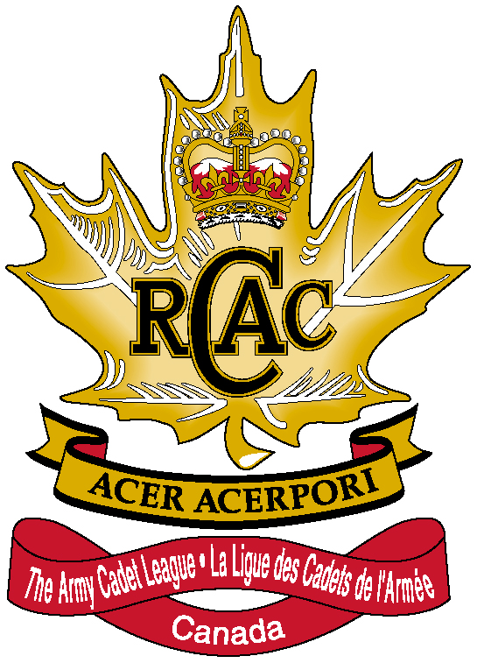

Mission:
The Army Cadet League of Canada, a civilian nonprofit organization, commits to support the Army Cadets by working in partnership with local communities and the Canadian Forces in the development of policies and methods for achieving the aims and objectives of the Canadian Cadet Movement in general, and the Royal Canadian Army Cadets in particular.

The Army Cadet League of Canada was formed on 1 April 1971, to carry out the following tasks:
- To encourage and promote public interest in and support of the Royal Canadian Army Cadets;
- to ensure that Army Cadet units are formed wherever appropriate and practicable and that each Army Cadet unit is effectively sponsored and supported within the community;
- to consult with and advise the Department of National Defence and its appropriate subordinate headquarters in respect of development of policies and methods for achieving the aims of the cadet movement in general and the Royal Canadian Army Cadets in particular;
- to make recommendations to military authorities on the enrolment, promotion, and release of officers of the Cadet Instructor List;
- to collect, receive, hold, and invest funds and property from contributions, gifts, grants, subscriptions or legacies, and to use such funds subject to donors’ directions for the benefit of the Royal Canadian Army Cadets;
- to establish branches of the corporation in various parts of Canada, and to do all those things that are lawful and appropriate to accomplish the objects of the Corporation. The operation of the Corporation may be carried out throughout Canada and elsewhere.



AIMS OF THE CANADIAN CADET MOVEMENT
- develop in youth the attributes of good citizenship and leadership
- promote physical fitness; and
- stimulate the interest of youth in the sea, land and air activities of the Canadian Forces
Motto
The motto of the Royal Canadian Army Cadets is “Acer Acerpori” which means when translated “ As the Maple, so the sapling”
RESPONSIBILITIES OF THE LEAGUE
- making recommendations to the CDS for the formation, organization or disbandment of a cadet corps;
- recommending suitable persons for enrolment in the CF and employment as cadet instructors;
- recruiting suitable persons to be cadets;
- making recommendations to the appropriate region commander regarding the appointment; promotion, transfer or release of Cadet Instructor Cadre Officers;
- providing appropriate training and stores accommodation not provided by the CF;
- arranging cadet recreational programs other than environmental training programs;
- providing training aids and equipment, including band instruments, not supplied by the CF;
- providing financial support as required;
- providing and supervising local sponsors
- providing transportation, when not available from the CF, for the local training exercises; and
- providing advice and assistance to local sponsors and cadets corps

Royal Canadian Army Cadets undertake a variety of adventurous training including lessons in map and compass, camping, rock climbing, abseiling, kayaking, rope climbing, trekking, mountain biking and military parachute. Army cadets also learn about army traditions and participate in a variety of national and international expeditions that focus on adventure training such as whitewater rafting, horseback riding and voyageur canoeing.

