Property Manager Report
September, 20th 2025
Cottage 4:
Work on C4 is ongoing. The contractor has removed a lot of the rotten
wood on the posts and replaced with pvc trim board. Roofing and window work will take place once all the deck supports are fixed. These pictures illustrate some of the challenges.

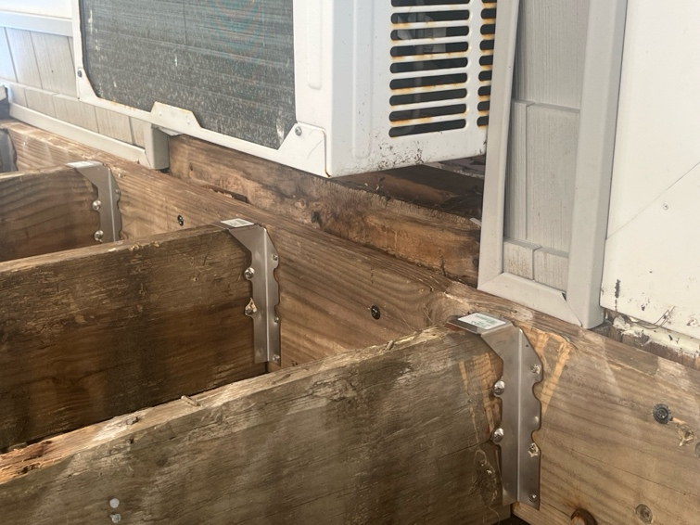

Fasteners holding the deck to the cottage wall are insufficient. The air conditioner unit was installed with minimal structural and weather tight integrity.

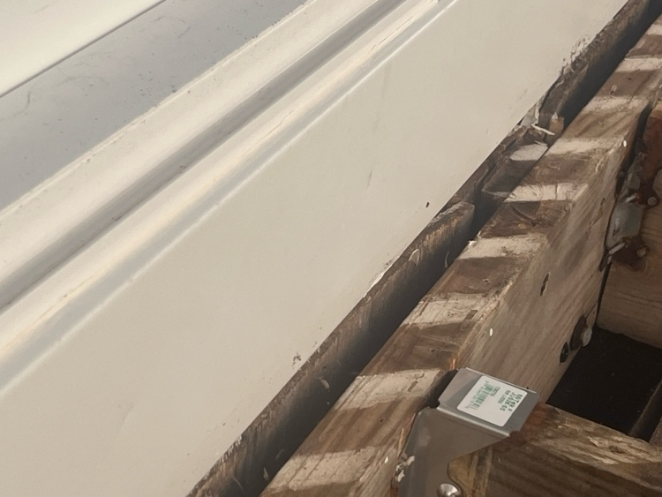

The decking ledger board was not fastened directly onto the cottage structural. Placing the ledger board onto shims and exiting siding is not an appropriate construction practice.

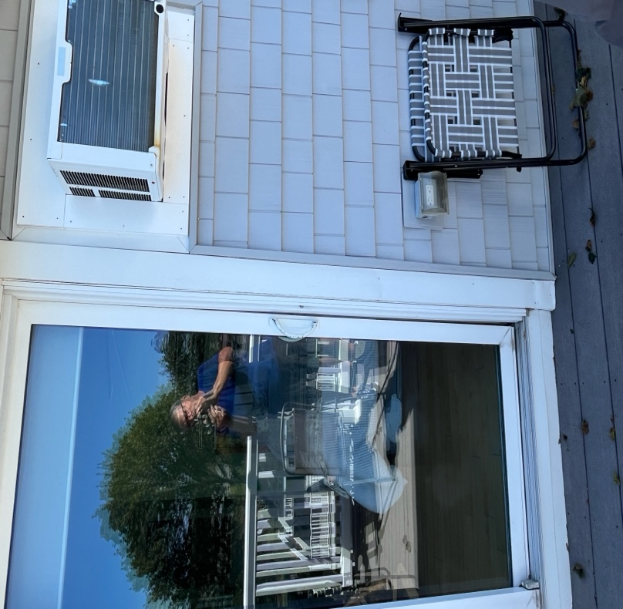
Due to the above issues, it appears that weather has penetrated the exterior siding of the cottage and has compromised the structure. The slider door has a ¾” gap at the bottom and is tight at the top.

Elevator:
Otis fixed the elevator issues which took place in early August. A slow down switch was found to be the issue and was replaced. Otis has also informed us that the elevator is in need of a modernization due to its age there are a limited amount of replacement parts available and that the modernization will conform to current code requirements. Estimated costs for modernization is $140,000.

Storage Unit Electrical:
Storage units that had multiple outlets inside them have been reduced to 0 to 1 outlet in most cases, depending on lighting needs. There are still a few storage units that need to be addressed that had inaccessible outlets at the time of work.

Boiler - Heat/Hot Water
Garrett Pillsbury is installing a boiler monitoring device on 9/5. This monitoring device will send out an alert to GP’s office letting them know of any issue. This should expedite any downtime in the heating months and lessen the chance of any freeze ups by addressing the problem earlier.

Oil Tank:
Gaftek is scheduled to clean the underground oil tank on 9/15. A few days prior they will add the concentration to the tank that assists with the cleaning. Gaftek has advised that there will NOT be any disruption to heat and hot water service during this time.

Alarm Monitoring:
Everon is no longer our alarm monitoring vendor. They were charging the association an exorbitant amount of money for their service. We are now being monitored by American Security out of Springvale, Maine. With this move the association is estimated to save about $4,000 annually for alarm monitoring.

Parking lot sealing:
Due to scheduling conflicts the parking lot sealing, striping and crack filling may not get done before cold weather. If it does not happen, the work will be scheduled for the spring.

Parking Lot Signs:
New replacement signs were installed on 9/9/25 Pool, handicap and parking all included.

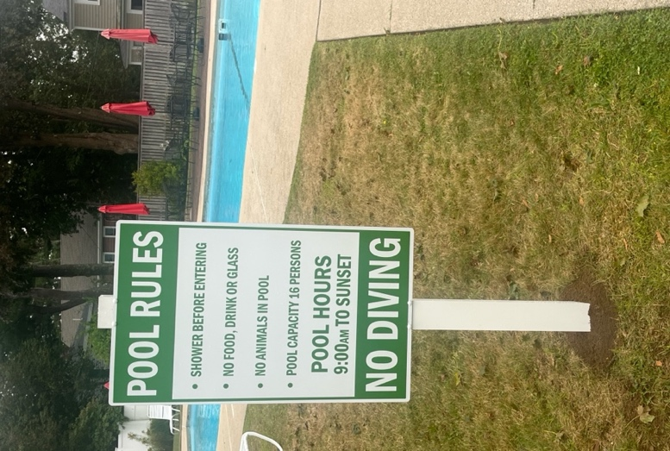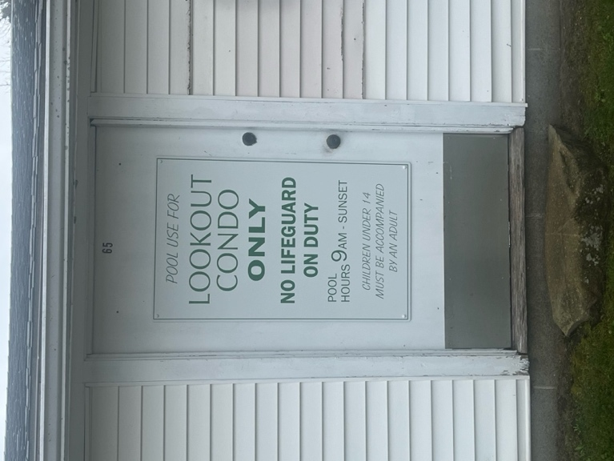

Leak in 104:
The building water will possibly need to be shut off for a small domestic hot water leak in unit 104. The plan is to have this repair completed by mid September.

Deck canopy request, 411
The Property Manager and the Board has reviewed a request from Unit # 411 to install a canopy on the deck of Unit 411.
The awning policy only allows awnings to be installed on the side and rear units of the main building.
The main issue for the Board is related to building construction on the street side of the building. The installation and presence of the canopy will create the potential for water damage to the unit and all others below during severe weather conditions, as it will restrict the flow of water off the roof. Snow and ice buildup and subsequent melting will create additional water penetration issues. For these reasons the Board has not approve the request.

The rules regarding awnings / canopies were established many years ago. The rules were developed to mainly ensure esthetics. They wanted to minimize the color options. In addition, concerns regarding the mounting of the awning and the impact this would have on the integrity to the building was important.

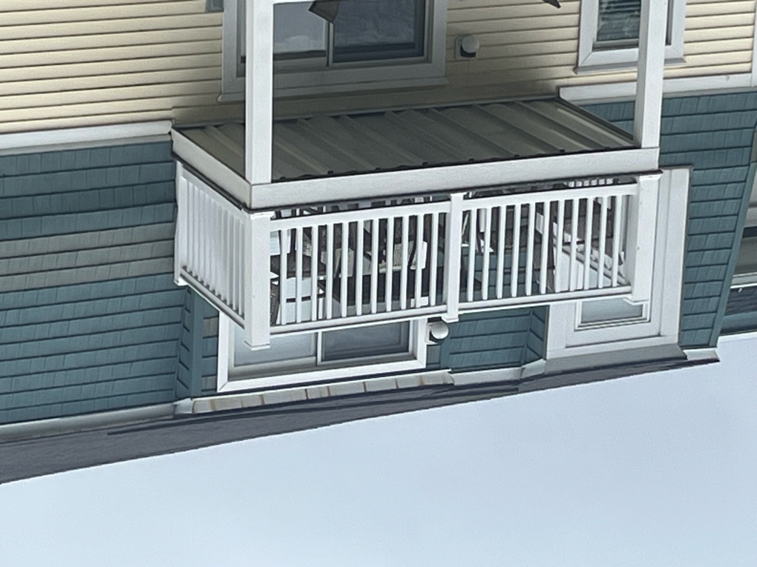

The Board did revise the rule at a meeting on May 26th 2024 to remove the required manufacturer and to remove the abutter notification.

ITEM II. Owner Requests
● Cottage 6 Unit G3 requested to install a Sun Setter awning on the back deck of Cottage 6.
Discussion ensued regarding apparent past practice of only one company being approved for awning installation. Having no record of this requirement, the Board voted to implement a new awning policy, which will be posted to the website:
○ Abutters to the requesting owner will be given notice of the request. In the main
building, abutters are defined as those directly adjacent on each side, directly above, and
directly below. In the cottages, abutters are defined as all other units in the cottage
requesting the awning.
○ Abutters will have 14 days to provide commentary.
○ After 14 days, the Board will take a vote on the requested awning.
○ Awning installation must follow the established Contractor Rules.

The current rule:
AWNINGS
Applicability
The following units shall be allowed to install awnings, in accordance with this policy:
● Side and rear units of the main building
● All cottage units

Awning Standards
It is recommended, though not required, that awnings be furnished and installed by Canvas Works, located in Kennebunkport, ME. The color of the awning must reasonably match the surrounding exterior color. The Board shall have final approval on the awning color.

Awning Approval Process
A unit owner seeking to install an awning must seek approval by the Board in advance of installation. Abutters to the requesting owner will be given notice of the request. In the main building, abutters are defined as those directly adjacent on each side, directly above, and directly below. In the cottages, abutters are defined as all other units in the cottage requesting the awning. Abutters will have 14 days to provide commentary. After 14 days, the Board will hold a special meeting to take a vote on the requested awning.

Installation
Awning installation must follow the established Contractor Rules. The owner is responsible for making necessary arrangements with the contractor for the installation of the awning, and notice must be given to the Property Manager one week in advance of the scheduled installation. The owner or his/her designated representative shall be present during the installation.

Once installed, the following apply:
● Awnings may not be left open and unattended when the unit is not occupied.
● Unit owners are responsible for all repairs and maintenance to the awning.
● Unit owners are responsible for removal and reinstallation of the awning if building
maintenance so requires.

Tennis Court:
Owners have raised concerns regarding the condition of the tennis court noting the cracks that have developed in the court surface creating further damage to the court and a safety liability. The Property Manager has been working with a company that specializes in court maintenance. Based on this information the current costs to repair the court is estimated at $20,000.
There are three options that need to be considered.
- Do nothing
- Fill cracks to extend life of the court - $500.
- Long term surface and court repairs - $20,000.
The Board will consider all 3 option and make a determination.

Building Analysis:
The Board of Directors has retained the services of SPS to undergo an in-depth analysis of the building envelope (roofing, exterior siding, and underlying construction) to aid in further developing a long-term plan for the community. SPS, Inc. is a specialist in condominium building envelope consulting and construction; see https://sps.solutions/

On Tuesday, September 9th & Wednesday, September 10th, SPS was onsite to perform an invasive (i.e., more than a simple visual inspection) investigation of our buildings. The object of this investigation is to determine the existing condition of the entire exterior building envelope (exterior roofing, decks, siding, and underlying construction). A sampling of roofing, siding, sheathing, house wrap, flashing, and trim will be opened for inspection purposes. Any components removed for inspection will be restored to their current condition. SPS will be using ladders to access the buildings' exterior and perform the inspections.

Please note: This is a sampling based on conditions observed, and not every home will be evaluated.

The Board of Directors will use the results of this SPS inspection to better understand the current condition of our buildings and thus anticipate and prioritize the need for future expenditures to preserve and protect them.

Fire Suppression System:
Maintenance to the fire suppression system is planned for Q4 of this year. Leak testing and repairs of the distribution pipes should be conducted. Access to individual unit will be required. The Property Manager will coordinate this task.

