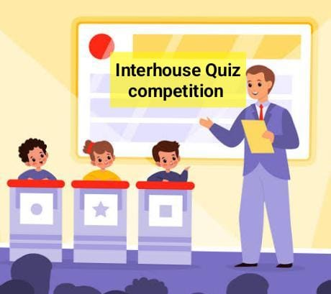
Inter House Quiz Competition

Our school is going to organize Inter house Quiz Competition in August from classes (UKG - Vlll) . There will be screening test on the 1st /2nd August. All the students can participate. Two students from each house from each class will be selected.
Syllabus for selection- Gk (chapters for 1st and 2nd Assessment).
Categories & Date
▶Classes Vl,Vll,Vlll - 5th August ,Saturday
▶Classes IV,V - 5th August ,Saturday
▶ Classes ll,lll- 12th August, Saturday
▶Class 1 (Classwise) - Following week
▶UKG ( classwise) - Following week
👉Topics for Quiz:

Gk , science , Maths, computer, s.st , English .

